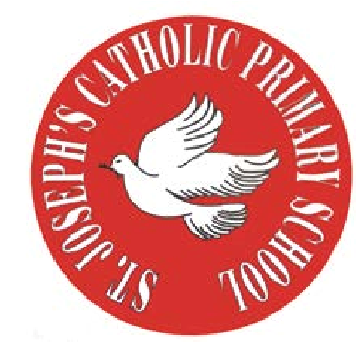
RE Newsletter – Summer 1

St Joseph’s Catholic Primary School
Woodchurch Road, Birkenhead CH43 5UT
Headteacher.
Mr A. Turner

Dear Parents,
The Church is celebrating the great feast of Easter – Jesus risen from the dead. This celebration goes on until the solemnity of Pentecost (Sunday 5th June), the birthday of the Church. At Pentecost we celebrate the outpouring of the Holy Spirit who empowers and enables us to follow in the footsteps of Jesus. During this term the Church dedicates the month of May to Mary, Jesus’ mother.

We hope you find this newsletter of interest and as always, please keep us in your prayers as we continue to support your child in their religious education.

Year 6 - The Work of the Apostles

Year 6 will learn about and reflect upon the Ascension and the
transformation produced by the Holy Spirit at Pentecost. They will
learn about and reflect on the lives of St. Peter and St. Paul and
learn that the Pope is the successor of Peter.

At home
You could help your child by:
• reading the stories of the Ascension and Pentecost with your child
• reading about St. Peter and St. Paul and exploring together why they are so important to Christians

RE Newsletter – Summer 2

St Joseph’s Catholic Primary School
Woodchurch Road, Birkenhead CH43 5UT
Headteacher.
Mr A. Turner

Dear Parents,
We welcome you and your children back to school after the half term. We begin in the month of June which is dedicated to the Sacred Heart of Jesus. The devotion to the Sacred Heart of Jesus reminds us of the never ending and merciful love that Jesus has for us.

We hope, as always, you find this newsletter interesting and informative. Please keep us in your prayers as we support your children in their Religious Education.

Below you will find what your child is learning about in RE this half term.

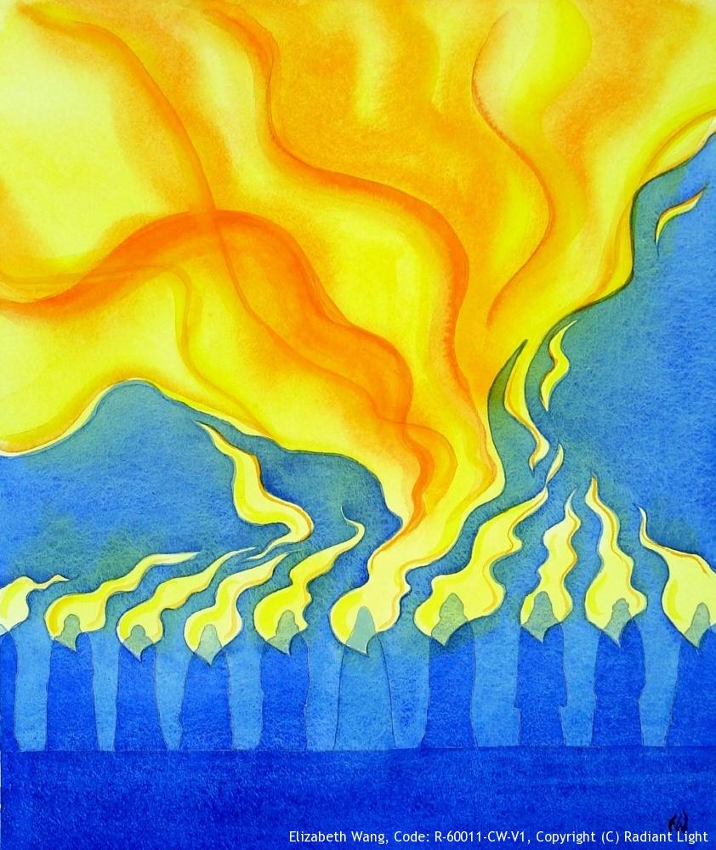
Year 6 - Called to Serve

The children will learn about Jesus’ teaching and example of
service of others. They will develop their ability to recognise
that God has given us all gifts and talents to use in the service
of him and his people. They will learn about the gifts of the
Holy Spirit and understand that we receive these gifts in a
special way through the Sacrament of Confirmation.

The children will have an opportunity to:
• reflect on the Sacrament of Confirmation and the commitment
necessary of a Christian
• reflect on a life of service

At home
You could help your child by:

- discussing the importance of the gifts of the Holy Spirit and the Sacrament of Confirmation
- discussing the many ways in which we can be called to serve God and our neighbour
- chatting about their gifts and talents, both obvious ones and hidden ones

