St Joseph’s Catholic Primary School
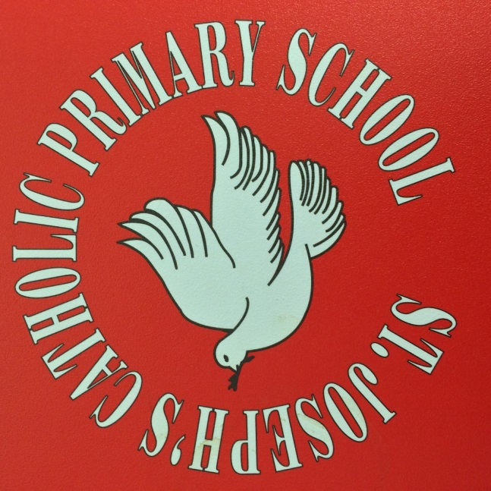

School Uniform
Information for Parents
Department for Education guidance states :
It is for the governing body of a school to decide whether there should be a school uniform policy and if so what that should be. This flows from the duties placed upon all governing bodies by statute to ensure that school policies promote good behaviour and discipline amongst the pupil body.
It is also for the governing body to decide how the uniform should be sourced. The Department strongly encourages schools to have a uniform as it can play a valuable role in contributing to the ethos of a school and setting an appropriate tone.
Here at St Joseph’s we strongly encourage the wearing of our school uniform. We believe having a school uniform promotes good behavior, discipline and pride in our school. We want our children to be proud members of our school community and understand that by wearing our uniform, they identify themselves as a member of school, and represent our vision and ethos. Members of the public and visitors often comment on how smart our pupils look
Wearing of the uniform at Primary School also sets a good grounding for Secondary schools, where uniform policies tend to be more rigid and sanctions can be issued for breeches of the policy, as well as preparing them for future, where the wearing of a ‘uniform’ may be compulsory, such as in employment or for certain conventions.

We thank you for your support in assisting us implement our uniform policy.

Our School Uniform from September 2018 onwards (KS2)
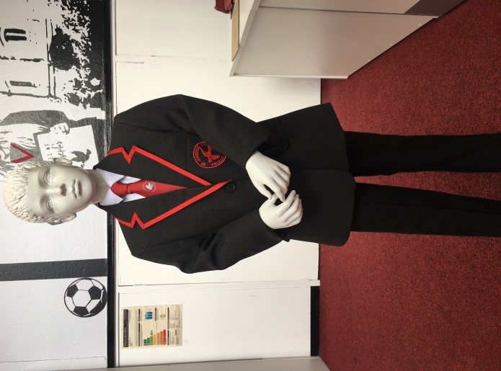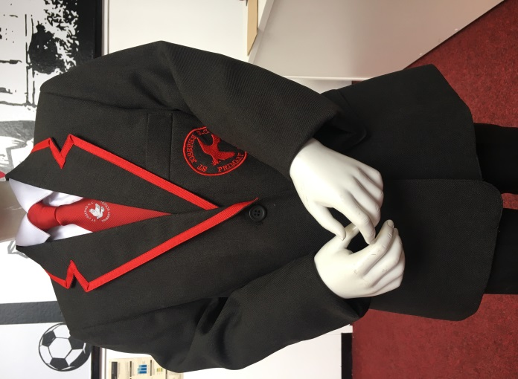
For children in Y3 upwards, a school blazer is available for your child to wear.
Alongside the blazer, a school tie featuring our dove logo is also available, as a ‘clip on’ for safety reasons. The shirt is a plain white shirt. Also available (not pictured) is a grey sleeveless tank top or a charcoal grey jumper featuring our school badge for the colder months. Black or charcoal grey trousers or skirts can be worn. We also request that black shoes (not trainers or boots) be worn.
The children do not have to wear a blazer, but may instead opt for a combination of skirt/trousers, white shirt/blouse, tank top or school jumper (Charcoal jumper as opposed to the red sweatshirt worn in KS1). If you choose not to wear the blazer, I would strongly encourage the wearing of the tie with the shirt and grey jumper. The children do not have to wear the blazer all day and of course may take it off if they get hot or to play outside.

Our School Uniform from September 2018 onwards (KS1)
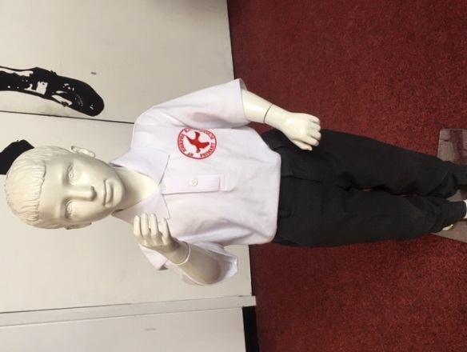
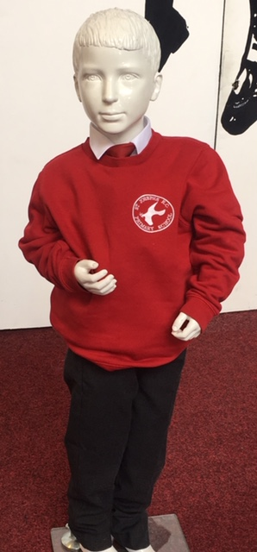

For the children in infants (Y2, Y1, Reception), the uniform consists of – black or grey trousers, shorts or skirts, black shoes, then the options of: white shirt or polo shirt (with school badge) and a red sweatshirt (with school badge). The children may also wear the school tie.

PE kit (all year groups)
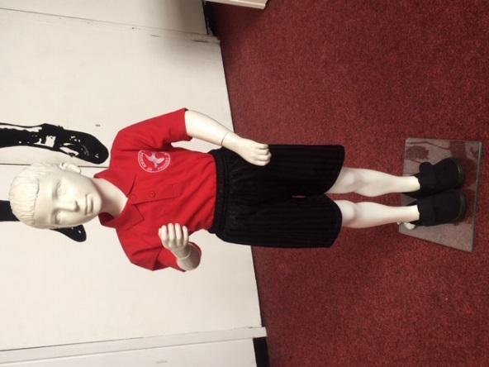

For PE, please can all children wear black pumps or trainers and a red polo shirt and black shorts. These can be embroidered with the school logo, but do not have to be.
Jewellery
Certain items of jewellery are permitted, including watches, and small stud earrings. Headbands may be worn, but we ask that these are kept to a reasonable size. All jewellery must be removed for PE lessons. In the case of pierced ears, ideally earrings are removed by the children, so when getting ears pierced, please do so over the 6 week summer period so that they can be removed in September. If children cannot remove earrings, we may provide tape to cover them, but this will be decided by the nature of the activity.

Please can you ensure all items of uniform are clearly labelled with your child’s name and class.
Purchasing the uniform
All items of uniform, including blazers, ties, tank tops and PE kits are available from the Uniform Shop in Birkenhead. They operate a ‘click and collect’ to avoid queues
https://www.wirraluniforms.com/
Other items such as School bags, PE bags and water bottles are also available.
We have also added our details to Tesco so that uniform can be purchased from them – however, they do not stock blazers or ties - just sweatshirts, polo shirts and PE kits (as well as standard items such as trousers, skirts etc)
If your child is in receipt of Pupil Premium, we can assist in the buying of school uniform. If this applies, please let the office know and which items you require. If you are unsure if your child is eligible, please follow the link below, enter your details and we will then be informed if you qualify.
https://www.wirral.gov.uk/schools-and-learning/funding-and-financial-support/free-school-meals-pupil-premium

Once again, many thanks for engaging with us in implementing our school uniform policy. We are proud to be St Joseph’s and receive such wonderful feedback regarding the presentation of our pupils. Thank you for ensuring our pupils wear our uniform with pride.

Summary Table of available combinations
The following is a summary table of available options for each year group from September 2018 onwards

Y  3  4  5  6 | Blazer | White shirt | Red tie | Black/  grey trousers or  skirts | Grey jumper | Grey tank  top | Grey cardiga-n
Y  1  2  F2 | White shirt | White polo shirt | Red Sweat  shirt | Black/  grey trousers/skirts | Red tie | Red cardiga-n

For all – black school shoes
For PE – Red polo shirt, black shorts, trainers/pumps

