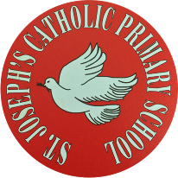

St Joseph’s Catholic Primary School - LEARNING AT HOME PLANNING
YEAR EYFS Foundation 2
Date wb 1.6.20
Weekly Mathematics Tasks  (Aim to do 1 per day) | Weekly Reading Tasks  (Aim to do 1 per day)
- Practice counting in 2’s, 5’s and 10’s (use You Tube to watch some catchy songs)  Subtraction/Take away  - Watch this video to support counting back from 10. https://safeyoutube.net/w/aNW5  Ask your child to start at 10 and take away 1. Repeat until they get to 0. Do they recognise the amount is getting smaller?  - Generate your own subtraction number stories. Use real life objects at home to show this e.g. ‘I have 4 bananas. I eat one. How many are left?’  Challenge- Can they write some subtraction number sentences?  - Use a teddy and count backwards making deliberate mistakes. Can your child spot the mistakes? Miss out numbers, repeat them or say a number in the wrong place. Can they spot the mistake when the numbers are written down?  - Check the attached sheet, this has lots of ideas of home learning all about subtraction.  - Have a look online for some maths subtraction games  https://www.topmarks.co.uk/subtraction/subtraction-to-10  https://www.arcademics.com/games/mission  - Use this online tens frame and counters to help your child add counters and then take them away  http://www.ictgames.com/mobilePage/tenFrame/index.html | - Continue using the Oxford Owl website, choosing age appropriate books  - Ask your child to write a mini diary about what you did over the bank holiday weekend, can they write their sentence/s and read it back to you?  - Help your child to look through cookery books for a recipe involving cocoa/chocolate. Can they write their own version of the instructions and read them out carefully? If you have the ingredients, make the sweet treat!  - Using the sounds, they weren’t sure on last week make a phonics game. First write words containing those sounds on paper and play a splat game. Then say a word and ask your child to read and splat the word.
Weekly Phonics / Spelling Tasks  (Aim to do 1 per day) | Weekly Writing Tasks  (Aim to do 1 per day)
- Ask your child if they can think of a fruit or vegetable for each letter of the alphabet i.e. a=apple, b=banana.  Can they have a go at sounding out and writing each fruit or vegetable that they think of ? Can they write a list?  - When teaching phonics, we use real and alien words (nonsense words) when supporting children with sounding out. Remind your child about these real and alien words and then have a go at play Odd and Bob here. https://www.phonicsbloom.com/uk/game/odd-and-bob?phase=2  Children sort real words and nonsense words by sounding out.  - Continue to practice sounds they were not sure on last week. Also continue working on reading and writing phase 2-4 tricky words.  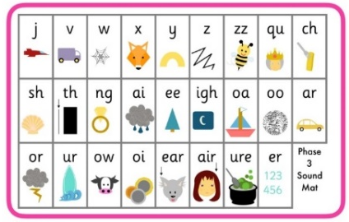 | - Begin a diary with your child. Can they write in it each day/week about what they have been up to? What they have eaten/drank? Which games they have played, etc.  They could draw some pictures first to give them some ideas.  Can they remember capital letters, finger spaces and to check their work makes sense?  - Can your child choose a sound from the sound mats and write as many words they can think of that contain that sound?  - Choose a colour and write a list of as many thingsthat are that colour that you can think of
Foundation subjects and Learning Project - to be done throughout the week
Well-Being JarUse these craft instructions to create your own wellbeing jar. Having things to look forward to can make you feel happier and improve your wellbeing. As a family each time you think of something you would like to do in the future, write it on a piece of paper and place it inside your decorated jar.

Natural bracelets
Either in your garden or out on a walk, can you make a natural bracelet? Use some sticky tape or cut up a toilet/kitchen roll and see what lovely things you can find to stick on it! I would love to see what you make so please post on our twitter or PTA Facebook page.
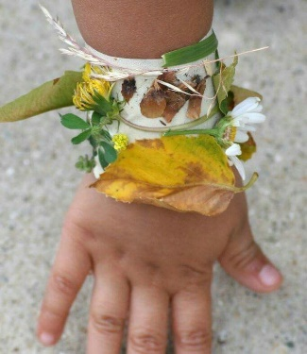 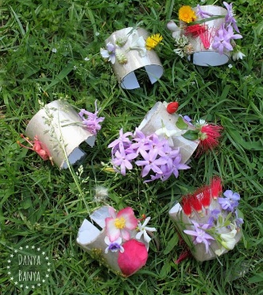
Sunflower
Check on your sunflower each day- does it need watering? Has it started to grow?
Maybe you could have a go at writing about what is happening!
Thinking about sunflowers- can you look up some sunflower art? Which artists have painted pictures of sunflowers, can you find out? Have a go at painting your own sunflower picture!
Music
Don’t forget about our fantastic music package (You can find your log ins on the school website planning page). Log into YUMU and have some musical fun!
Let’s get physical!
Have a go at some of these exercise videos-
https://www.youtube.com/watch?v=DqAOMrZkht0&list=PLoOc9M0VgduMnQiJ56Gw5TX7wsGIF7kmv&index=4
YouTube- Go Noodle
YouTube- Just Dance

Try and do some exercise outdoors, this may be a play in your garden or a walk around your local area. Get as much fresh air as you can!
Also remember to keep practicing your funky finger skills to make your fingers and hands strong allowing you to do some brilliant drawing and writing. (Grown-ups- have a google for some fun funky fingers activities, there are a lot of lovely and easy things you can do)

Pray together
“Lord in heaven, hear my prayer, Keep me in your loving care. Be my guide in all I do. Bless all those who love me, too.”
Additional learning resources parents may wish to engage with
Doyogawithme.com/yoga-class
youtube.com
historystorytime.podbean.com
mathletics.com/uk
oxfordowl.co.uk
Teacher Tips
Don’t worry about trying to complete all of the activities, do what you can but please try and complete a reading, writing and number task.
Please keep checking our twitter page for updates and any videos/communication from staff members.
We hope you are all safe and well. Miss Langley, Mrs Lester, Mrs Langan and Miss McNeil

