St Joseph’s Catholic Primary School - LEARNING AT HOME PLANNING
YEAR EYFS Foundation 2
Date wb 18.5.20
Weekly Mathematics Tasks  (Aim to do 1 per day) | Weekly Reading Tasks  (Aim to do 1 per day)
- Our number of the week is 20. Can you write the number 20? Make sure you get it the correct way around!  Can you count all the way to 20? Can you count backwards from 20 all the way to 0?  Set a timer of 20 seconds- what can you do in that time? Maybe you could try doing star jumps or another exercise.  Challenge- Can you work out what numbers we add together to make 20? Have a go at writing some number sentences to show this!  - Last week you had a go at doubling! Now it is time to try some halving.  - Watch this number jacks halving episode (half time) on Youtube-  https://www.youtube.com/watch?v=azVL530KCgA  - Now it’s time to have a go! Use the halving sheet attached and see if you can give the ladybirds half each! Remember when we are halving we have to be fair and give them the same amount.  Challenge- Can you use your knowledge of doubles to help you with halving? If you know what double a number is you can find half of it!  Double 5 is 10 (5 + 5 = 10) so half of 10 is 5!  Can you work out half of some other numbers?  - Have a go at some of these games/activities-  https://www.twinkl.co.uk/resource/T-GO-05-halves-up-to-10  Twinkl halving to 10 game (Jungle Maths: Halves up to 10 Game)  https://www.topmarks.co.uk/maths-games/hit-the-button | - Have a go at reading all of these tricky words!  Maybe you could make it into a game. Write the tricky words on some post it notes or paper and ask an adult to hide them around your house. Put on a timer and see how many you can find then read them out!  - Talk to your child about some words used in sports such as throw, hit, catch, ball. Go on a word hunt around the house to find these words in books, magazines or newspapers. Can you read them all?  - Develop listening skills by encouraging your child to listen to the BBC School Radio episode about sports. https://www.bbc.co.uk/teach/school-radio/eyfs-listening-skills-sports/zkfy6v4  - Read a range of stories at home- enjoy reading them together. Talk to your child about their likes and dislikes in the story.
Weekly Phonics / Spelling Tasks  (Aim to do 1 per day) | Weekly Writing Tasks  (Aim to do 1 per day)
Now that we have worked our way through each sound in Phase 3, we would now usually consolidate some of the trickier sounds such as the tri-graphs (3 letters that make 1 sound) ear, air and ure.  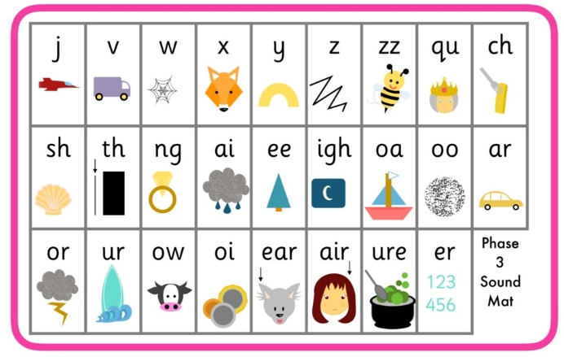  Please spend this work recapping these 3 sounds try writing and reading some words containing them. Some examples are below.  ear ear fear tear near air chair lair pair hair ure pure cure secure mixture | - Can your child talk about all the different sports they know? Can they have a go at writing them (i.e. run, jump, skip)?  - Listen to interactive stories linked to sport, including Peppa Pig. Talk about how the characters are feeling when they win/lose. Draw a picture to show how the characters are feeling. Write sentences to explain what has happened and how you think they feel.  - Ask your child to draw a picture of themselves doing something sporty. i.e. running, jumping, a cartwheel. Can they label the picture or write a simple sentence e.g. I can hop on one leg.  - Think about your favourite sport, it might be football or ballet. Can you design a kit for your favourite sport? Draw a picture and label it.  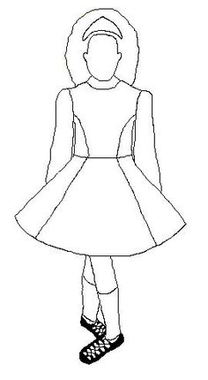
Foundation subjects and Learning Project - to be done throughout the week
Ball Games
● Play a game of catch with a ball - when you drop the ball, you lose a point. You could record points using a tally chart and count up who has the most points at the end. CHALLENGE: See if you can catch the ball standing further apart, catch with one hand or use a smaller ball.

Play Skittles
● If you have a set of skittles, you’re ready to go, if not you can make your own skittles using plastic bottles. Take a plastic bottle and partly fill with soil/ stones or sand to weigh it down. If you don’t have plastic bottles available, you could use tin cans for an alternative version. Ask your child to count how many skittles there are to begin with. Roll the ball at the skittles and ask your child to count how many they have knocked over. Can they work out how many are left? CHALLENGE: You could write this out as a subtraction number sentence e.g. if you start with 5 skittles and knock over 2 your child would write 5 - 2. Ask them to count how many are left to find the answer 5 - 2 = 3
Competition Time
● Have a time challenge. Give your child an action to do e.g. hop, skip, jump, clap or star jump. how many can they do in one minute. Keep a record of the scores. Ask everyone in the house to have a go! Share a photograph of your time challenge on Twitter to motivate everyone to get moving using.

Parts of the Human Body
● Ask your child which parts of their body they use to run? To do a handstand? Draw the parts of the body and for a challenge ask them to label them using their phonics knowledge
Sunflowers!
This week you will have received a little surprise pot with some sunflower seeds. Follow the instructions and see what happens to the seeds! Maybe you could write a diary of what happens each day. We would love to see your sunflowers when they start to grow so don’t forget to send some pictures to our twitter page. Good Luck!
Let’s get physical!
Can you have a go at some of these yoga poses?
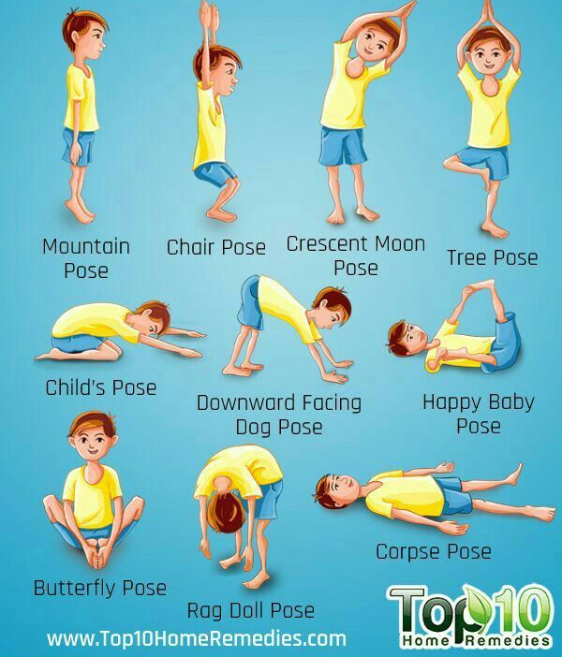

Pray together
Additional learning resources parents may wish to engage with
Doyogawithme.com/yoga-class
youtube.com/user/JamieOliver
historystorytime.podbean.com
mathletics.com/uk
Teacher Tips
Try to have a routine each week day so that the weekend feels a bit different. We don’t expect you to complete all the activities on this sheet but please try to do the phonics, maths and a couple of writing tasks. We would love to see any work you have completed on the school twitter or you can put your work in an envelope and bring it into school. Any work, letters or cards are gratefully received by Mrs Lester and Miss Langley.

