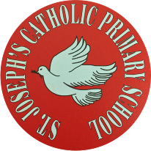

St Joseph’s Catholic Primary School - LEARNING AT HOME PLANNING
YEAR EYFS Foundation 2
Date wb 8.6.20
Weekly Mathematics Tasks  (Aim to do 1 per day) | Weekly Reading Tasks  (Aim to do 1 per day)
Have a go at different ways to measure!  Capacity- Use lots of different pots and pans, which holds the most/least?  Can you fill it to the brim? Can you talk about full, half full and empty?  Now add a measuring jug, can you fill it to the line? How much does each pot hold?  Height/Length- Using blocks or a ruler, ask your child to measure different items around your home. Then compare the length and height of the objects using mathematical vocabulary; longest, shortest, longer, shorter, tallest, taller, etc. | - Read a book called CORONAVIRUS- a book for children. It’s an information book illustrated by the Gruffalo co- creator Axel Scheffler. It’s free to read on screen or to print out. google  bit.ly/2V2w3mM  - Visit BBC sounds. There is more than 100 short stories to listen to for free as well as many books.bbc.co.uk/sounds/category/audiobooks  - Visit OxfordOwl and choose a new reading book to read  - Practice reading some tricky words
Weekly Phonics / Spelling Tasks  (Aim to do 1 per day) | Weekly Writing Tasks  (Aim to do 1 per day)
Can you practice the sounds ch, sh and th - use YouTube to help you with the correct pronunciation.  YouTube-  Geraldine the giraffe/Mr Thorne’s phonics  Alpha blocks  Jolly Phonics phase 3  - Practice writing words that contain this week’s sounds ch, sh and th  Add sound bars and buttons to help you recognise the different sounds in each word.  - Continue practicing writing all phase 2-4 tricky words  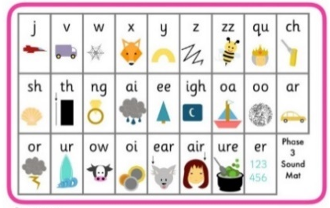 | - Make sure you’re trying to use the correct pencil grip and that you are sitting up at a table.  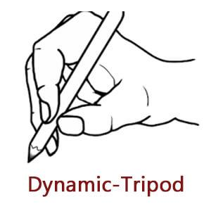  - Continuing writing in your diary each day/week- we are living through history right now!  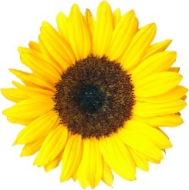  - Visit www.pobble365.com and choose an image to look at. How many sentences can you write about what you can see?  - Go and check on your sunflower- can you write about what has happened to it so far?
Foundation subjects and Learning Project - to be done throughout the week

Well-Being Jar
Continue adding things to your well-being jar! Maybe you could begin adding in different things now- things you want to do that you can’t do right now.
Time Capsule
Make a time capsule to record these unusual times!
Use a jar, box or tube to add your things into.
Write a note or letter about what is happening in the world now
Draw a picture of you and your family or take a photograph
Add a newspaper clipping in to show the date
Write all of your favourite things- to eat, to do and to see in our beautiful world
Music Continue exploring out Yumu packages online- they’re really fun!

Let’s get physical
Have a go at some of these exercise videos-
https://www.youtube.com/watch?v=DqAOMrZkht0&list=PLoOc9M0VgduMnQiJ56Gw5TX7wsGIF7kmv&index=4
YouTube- Go Noodle
YouTube- Just Dance
Pray together
God, my friend, it is time for bed.
Time to rest my sleepy head.
I pray to you before I do.
Please guide me down the path that's true.
Amen
Additional learning resources parents may wish to engage with
Doyogawithme.com/yoga-class
youtube.com
historystorytime.podbean.com
mathletics.com/uk
oxfordowl.co.uk
Teacher Tips
Don’t worry about trying to complete all of the activities, do what you can but please try and complete a reading, writing and number task.
Please keep checking our twitter page for updates and any videos/communication from staff members.
We hope you are all safe and well. Miss Langley, Mrs Lester, Mrs Langan and Miss McNeil

