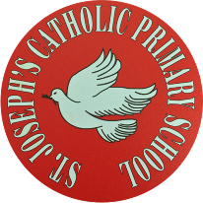
St Joseph’s Catholic Primary School - LEARNING AT HOME PLANNING
YEAR 1
Date wc 4th May
Weekly Mathematics Tasks  (Aim to do 1 per day) | Weekly Reading Tasks  (Aim to do 1 per day)
Numbers to 100  - Roll 2 dice and write the 2 digit number you have made in numbers and words. Repeat this 5 times then put the number in order.  - On your hundred square (in your pack) ask a grown up to cover up some of the number. Can you work out the missing numbers?  - Complete the missing numbers sheet.  - On your daily walk see what numbers you can find on houses, signs or busses- what is the biggest number you found? Can you write it in words?  - What number house do you live in? Write it as a number, then as a word. What is 1 more, 1 less, 10 more, 10 less? Can you write all those numbers as words?  - Play a game of snakes and ladders. Write down all the numbers you land on. Can you say how many tens and how many ones make up each number? | - Share a story with someone in your family. It could be a picture book, or a chapter in a longer story book.  - Listen to the story “Somebody Swallowed Stanley” by Sarah Roberts. Tell someone in your family what the message is that the book is trying to tell you and why this is important.  https://www.youtube.com/watch?v=sF1-ZTRydlM  - Design a poster about the book Somebody Swallowed Stanley. What can we do to help?  - Use an information book or the internet to find out some facts about different creatures that live in the sea.  - Look at the powerpoint and read the words. Decide if they are real or alien words.
Weekly Spelling Tasks  (Aim to do 1 per day) | Weekly Writing Tasks  (Aim to do 1 per day)
- Write your numbers as words, 1-10, 11-20 then 10-100 in tens.  - www.phonicsbloom.com  - www.phonicsplay.co.uk  - http://www.familylearning.org.uk/phonics_games.html  - Ask an adult to choose 10 common exception words each day. How many can you spell? Can you learn them all by the end of the week? | - Keep writing a diary about what you are doing each day - we are making history at the moment - keep a record of it!  - Write a list of as many different sea creatures you can think of.  - Look at the following links about whales. Write down some sentences using and about what whales should eat and other facts. E.g A whale eats squid and fish.  https://www.whale-world.com/facts-about-whales-for-kids/  https://animalstime.com/whales-eat-whales-diet/  - Draw a story map about what happened to Stanley. Try to remember all the different animals he met on the way.  - Write a poem about being in lockdown and ask a grown up to share it on twitter. @stjosephsbh  - If you have any other writing we would love to see it. Post it to the school Twitter account.

Foundation subjects and Learning Project - to be done throughout the week
It has been lovely seeing some of you on Twitter. We want to carry on seeing more of what you’ve been up to. If you have an pictures you would like to share that would be fantastic!

This week we are thinking about the impact of plastic on our planet. Here are some ideas you could try to do with this:

- When you go on your daily walk why not take some gloves and a rubbish bag and collect the litter you see on the eay.
- Our book this week is Somebody Swallowed Stanley. It is set in the Ocean. Using a world map see if you can find the names of some oceans or rivers.
- Try some different objects in the bath and sort out those which will float and those which sink.
- Use some recycled material and make some sea creatures

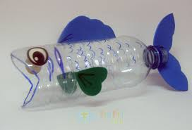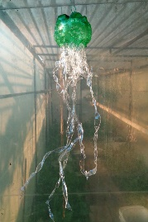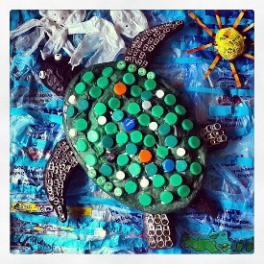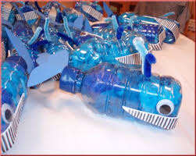

Let’s get physical!
https://family.gonoodle.com/ - use this website for moving and mindfulness

https://www.bbc.co.uk/teach/supermovers/just-for-fun-collection/z7tymfr - get physical

Complete your daily exercise- go on a walk, run, bike, scooter etc.

Cosmic yoga on youtube

Dane with Oti Mabuse
https://www.youtube.com/channel/UC58aowNEXHHnflR_5YTtP4g

Ask your family to make up a dance with you or try and do an exercise routine with them.

Pray together
Here is a link to this weeks Wednesday Word. There is a link to children’s activities.

http://www.wednesdayword.org/stopgap/Special-Edition.pdf

Additional learning resources parents may wish to engage with
- www.phonicsbloom.co.uk phonics games/ activities
- www.phonicsplay.co.uk phonics game
- http://www.phonicsplaycomics.co.uk/comics.html Reading Activities
- www.twinkl.co.uk lots of resources in a variety of subjects.
- www.ictgames.co.uk maths and English games
- www.topmarks.co.uk online games
- www.bbc.co.uk/cbeebies educational games and activities linked to charcters
- www.classroomsecrets.co.uk home learning packs for year 1
- www.oxfordowl.co.uk phonic and reading resources and ebooks.
- https://www.bbc.co.uk/cbeebies/shows/numberblocks sing and learn about numberblocks from cbeebies
- https://mathsnoproblem.com/en/programs/school-at-home/ a guide and examples to the maths scheme we are using in school.
- Joe Wicks Daily PE sessions
Teacher Tips
The work above is an idea of activities you could try at home. The most important thing at the moment is keeping your child happy and healthy. Any learning at home is learning, so if that takes a more practical approach then that’s fine. Bake a cake, play a board game together, build with lego- your child is learning important maths and communication skills doing these things. Take the work at their own pace. If its too much stop, if they want to do more let them. We would really like to see what they’re doing. If you have any photographs then please send them into the school via Twitter @stjosephsbh if its building a den in the garden, creating a banner for the NHS, or spending time with the family we want to see it. Stay safe everyone!

