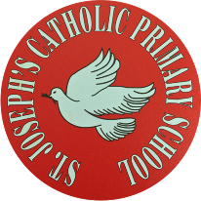
St Joseph’s Catholic Primary School - LEARNING AT HOME PLANNING
YEAR 2
Date - WC 29th June 2020
Weekly Mathematics Tasks  (Aim to do 1 per day) | Weekly Reading Tasks  (Aim to do 1 per day)
- Working on Times Table Rockstars - your child will have an individual login to access this (20 mins).  - Continue to practise daily calculations.  - Use the website below to set the calculations. Remember when adding and subtracting set it to 2-digit numbers on the website.  https://www.topmarks.co.uk/maths-games/daily10  Year 2 Revision - Measure in cms  - This week the children are going to refer back to their knowledge of measure.  - Worksheet on measuring in cms.  - Compare length using < >  12cms > than 10cms | - Your child could read a story/ poem / nursery rhyme to another family member. This could be to a younger sibling before bedtime or they may wish to Facetime an elderly relative (with adult supervision of course).  - Listen to your child read and let them discuss what they have read. Encourage them to read with expression and intonation.  - Get your child to read a book on Oxford Owl, discuss what your child enjoyed about the book.  - Story ending  Using the attached sheet children to fill in the gaps in the story and then think of an interesting ending to finish it.
Weekly Spelling Tasks  (Aim to do 1 per day) | Weekly Writing Tasks  (Aim to do 1 per day)
What is this week’s focus? Suffixe -ful  - fearful  - fearless  - hopeful  - cheerful  - harmful  - graceful  - helpful  - grateful  Write a sentence about each word . Can you find meaning on any words you don’t know?  Can they improve their score each day?  Can you include any of these words in a sentence?  Children could use the ‘pyramid method’ to help learn their spellings  e.g.  b  be  bec  beca  becau  becaus  because  Another method the children could use is ‘rainbow colours’.  e.g the children use a different colour for each letter in the word.  because | - Continue to read our driver text ‘Grandad’s Secret Giant’ https://www.youtube.com/watch?v=yPy9UjarCAQ  - Look at the 2 pictures from the story. What do you think the two people thought about each other?  - Using the suffixes in sentences to describe their feelings  - Parent help at the bottom!!  - http://www.pobble365.com/  Follow the link to Pobble 365 website. Look at the picture for the day and choose one of the suggested activities. Pictures are changed daily.  - Grammar – see sheet below  - Look at conjunctions and how we use them. See guide below.

Foundation subjects and Learning Project - to be done throughout the week
History – Continue to think about the changes that William Hesketh Lever made and the impact these had on the workers lives.

Look at the map of Port Sunlight ad see if you can find that William Hesketh Lever built for his workers. Write about what you can find in the village. What sport could you play?

Maths

English

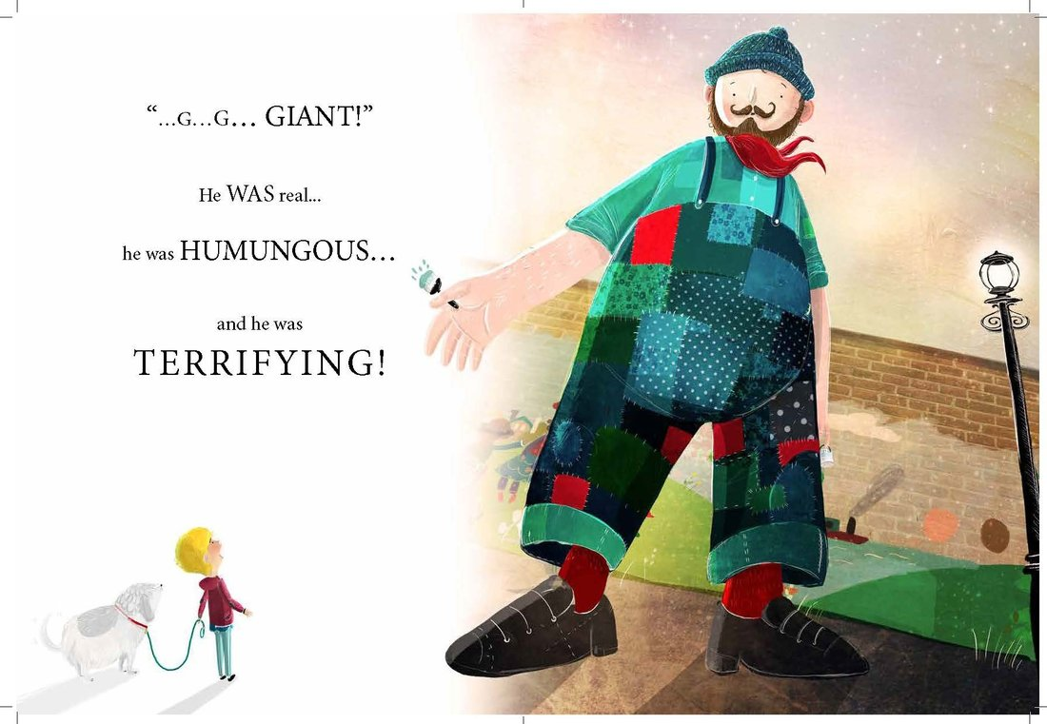

Discuss these suffixes . What is root word for each suffix?
Amazement= amaze + ment amaze is the root word and ment is the suffix.
Can you make 2 lists one for Billy and one for the giant? Which words would you use to describe how Billy felt when he saw the giant? Which words would you use to describe the giant’s feelings?
Billy Giant
Fearful hopeful

When you have found words to describe their feelings can you now put into a sentence?
e.g. Billy looked at the giant in amazement.

Geography - Revision of countries in the UK.
Can you name the seas around UK?
Can you find the main rivers ?
Can you name all the seas around the UK?
What countries is the English Channel between?

http://www.primaryhomeworkhelp.co.uk/rivers/UK.htm
Look and see how many rivers in the UK you can find about looking at this site.

Music – Continue to access the website www.charanga.com/yumu. Remember once you have logged in, there are two sections for you to access and work through. Click on either ‘Friendship song’ or ‘Song Packages’ and follow the instructions.

Art - Don’t forget to enter Mrs Page’s sunflower picture competition. You can draw, paint or make a collage of a sunflower. Take a photo of your picture and upload on Twitter by Monday 29th June. All entries will be put in a prize draw to win a voucher.
Last week we looked at the artist Andy Goldsworthy has created some amazing art using natural materials stones ,shells, flowers, leaves .Can you create your own piece of art in his style? Examples below.

- Can Let’s get physical!
Join in with Joe Wicks – The Body Coach on YouTube each day
or
Do something active with your family once a day- maybe you could learn a new skill/game!

Cosmic yoga - https://www.youtube.com/watch?v=LhYtcadR9nw
Practice your cricket skills with Chance to Shine

https://www.youtube.com/watch?time_continue=6&v=1pUilVjuL0I&feature=emb_logo

Pray Together
Read about St. Peter in the Wednesday word.

https://teachingcatholickids.com/from-persecutor-to-christian-the-conversion-of-st-paul/

Additional learning resources parents may wish to engage with
Classroom Secrets Learning Packs - These packs are split into different year groups and include activities linked to reading, writing, maths and practical ideas you can do around the home.
Twinkl - to access these resources click on the link and sign up using your own email address and creating your own password. Use the offer code UKTWINKLHELPS.
Oxford Owl – eBooks for children aged 3-7 (free but need to register)
EducationQuizzes.com – Lots of different quizzes in all subjects for KS1 (free with no login)
www.ictgames.co.uk - maths and English games
www.topmarks.co.uk - online games
Explorify – Science quizzes (free but need to register).
Headteacherchat - This is a blog that has links to various learning platforms. Lots of these are free to access.

Teacher Tips
- Remember - in a normal school day, there are several ‘break times’ throughout the day, so make sure as well as ensuring they complete their work, you build in ‘relaxation’ time. For you as well as the children!

- If the children are really engaged and interested in something, see what cross curricular links you can make. If they are in to trains, could they design a poster for a train exhibition, build a train out of cardboard, write an adventure story about a train journey, research facts about railways etc Capitalise on their interests and don't worry too much if it ‘fits’ into their weekly learning.

