St Joseph’s Catholic Primary School - LEARNING AT HOME PLANNING
YEAR 2
Date - WC 6th July 2020
Weekly Mathematics Tasks  (Aim to do 1 per day) | Weekly Reading Tasks  (Aim to do 1 per day)
- Working on Times Table Rockstars - your child will have an individual login to access this (20 mins).  - Continue to practise daily calculations.  - Use the website below to set the calculations. Remember when adding and subtracting set it to 2-digit numbers on the website.  https://www.topmarks.co.uk/maths-games/daily10  Year 2 Revision - Shape  - This week the children are going to refer back to their knowledge of shape.  - Use your times tables understanding to solve maths problems.  - Try some mental Math questions. | - Your child could read a story/ poem / nursery rhyme to another family member. This could be to a younger sibling before bedtime or they may wish to Facetime an elderly relative (with adult supervision of course).  - Listen to your child read and let them discuss what they have read. Encourage them to read with expression and intonation.  - Get your child to read a book on Oxford Owl, discuss what your child enjoyed about the book.  - Comprehension below.
Weekly Spelling Tasks  (Aim to do 1 per day) | Weekly Writing Tasks  (Aim to do 1 per day)
What is this week’s focus? Suffixe –ly less  quickly hopeless  badly joyless  slowly fearless  penniless  happily  Write a sentence about each word. Can you find meaning on any words you don’t know?  Can they improve their score each day?  Can you include any of these words in a sentence?  Children could use the ‘pyramid method’ to help learn their spellings  e.g.  b  be  bec  beca  becau  becaus  because  Another method the children could use is ‘rainbow colours’.  e.g the children use a different colour for each letter in the word.  because | - Continue to read our driver text ‘Grandad’s Secret Giant’  - https://www.youtube.com/watch?v=yPy9UjarCAQ  - Watch the video clip up to part where Billy is talking to Grandad. See below.  - http://www.pobble365.com/  Follow the link to Pobble 365 website. Look at the picture for the day and choose one of the suggested activities. Pictures are changed daily.  - Grammar – see sheet below  - Spelling sheet  - Handwriting

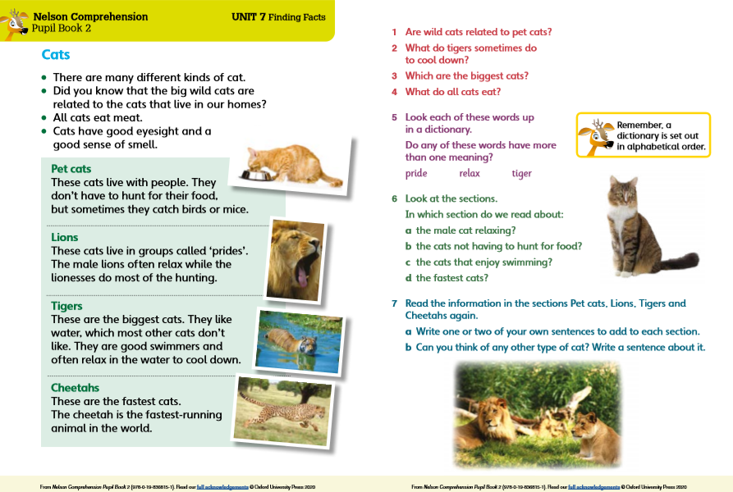

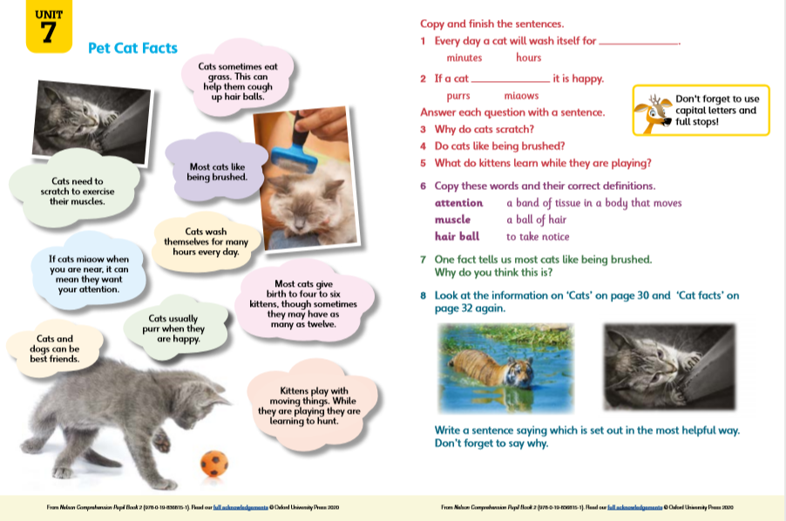

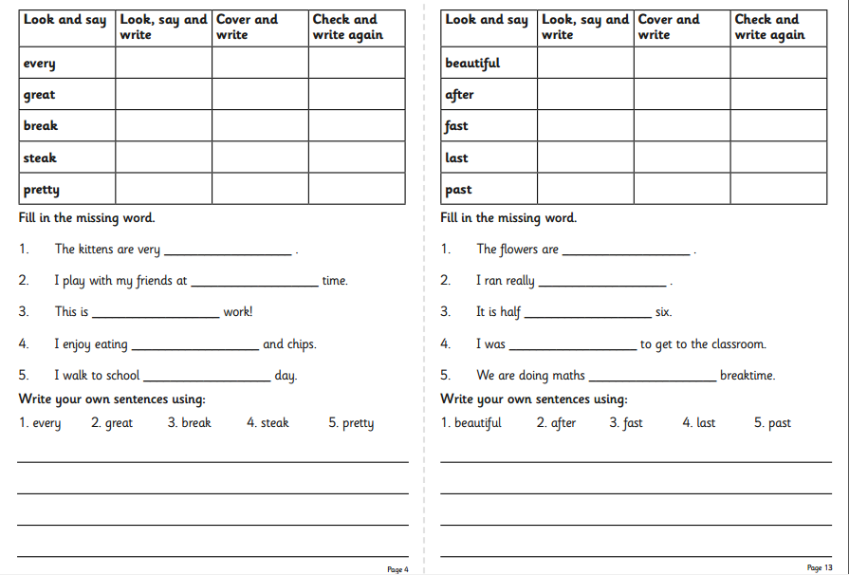

Grandads Secret Giant
English

Think about this part of the story. Should Billy have run away? Have a think about why he ran away?
What would the giant be feeling? How is Billy feeling now? Make a few notes.
Write a letter to Billy telling him what he should do next.

Maths Activities

Geography – We are going to find where the cold and hot places of the world are. Look at the video about different climates around the world.
https://www.youtube.com/watch?v=kHKNcTe6vdU
Look at the sheets and match the pictures to the words. Some words are tricky you may have to look them up.

History of our local area. Let’s look at Birkenhead and the park. Look at the websites as it tells us all about the history of Birkenhead Park and why it was built.
Can you find out about the men who built Birkenhead Park by looking at videos and reading about how they did it and why?
http://friendsofbirkenheadpark.org.uk/park_history.html
https://wirralmemories.co.uk/wm_index.php?wm_page=wm-road-birkenhead-park-birkenhead.php- amazing photographs.

https://www.birkenheadpark1847.com/park-at-war Here is a map from1879.How does it compare with modern map?

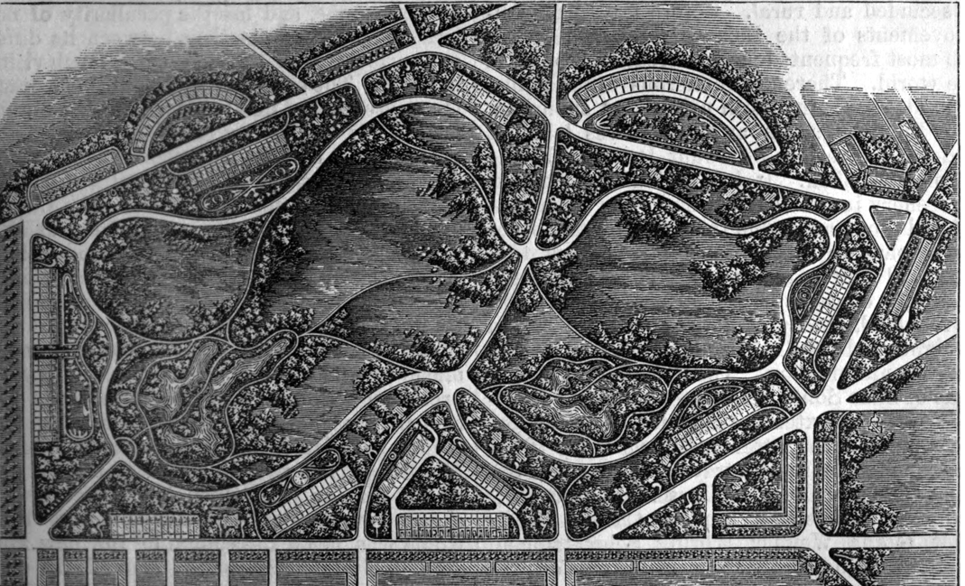

Look at this modern day map of the park. What can you find to do there? If you go for a walk there what will you find? How many different types trees? Use this map to find your way around.

Music – Continue to access the website www.charanga.com/yumu. Remember once you have logged in, there are two sections for you to access and work through. Click on either ‘Friendship song’ or ‘Song Packages’ and follow the instructions.

Art - https://www.youtube.com/watch?v=ZS-mkChV-fQ Watch this video. How many different designs can you make?
Art in the style of Max Ernst: - He uses rubbings of everyday items to
Create pictures.

- Can Let’s get physical!
Join in with Joe Wicks – The Body Coach on YouTube each day
or
Do something active with your family once a day- maybe you could learn a new skill/game!

Cosmic yoga - https://www.youtube.com/watch?v=LhYtcadR9nw
Practice your cricket skills with Chance to Shine

https://www.youtube.com/watch?time_continue=5&v=ceg-9Y_0dfk&feature=emb_logo

Pray Together
R.E.
Read the Wednesday word with your family. Listen to the message Jesus gave to the people.

Prayer to Learn

Additional learning resources parents may wish to engage with
Classroom Secrets Learning Packs - These packs are split into different year groups and include activities linked to reading, writing, maths and practical ideas you can do around the home.
Twinkl - to access these resources click on the link and sign up using your own email address and creating your own password. Use the offer code UKTWINKLHELPS.
Oxford Owl – eBooks for children aged 3-7 (free but need to register)
EducationQuizzes.com – Lots of different quizzes in all subjects for KS1 (free with no login)
www.ictgames.co.uk - maths and English games
www.topmarks.co.uk - online games
Explorify – Science quizzes (free but need to register).
Headteacherchat - This is a blog that has links to various learning platforms. Lots of these are free to access.

Teacher Tips
- Remember - in a normal school day, there are several ‘break times’ throughout the day, so make sure as well as ensuring they complete their work, you build in ‘relaxation’ time. For you as well as the children!

- If the children are really engaged and interested in something, see what cross curricular links you can make. If they are in to trains, could they design a poster for a train exhibition, build a train out of cardboard, write an adventure story about a train journey, research facts about railways etc Capitalise on their interests and don't worry too much if it ‘fits’ into their weekly learning.

Science What do you remember?

