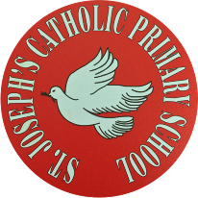
St Joseph’s Catholic Primary School - LEARNING AT HOME PLANNING
YEAR 3
Date WC 29th June 2020
Weekly Mathematics Tasks  (Aim to do 1 per day) | Weekly Reading Tasks  (Aim to do 1 per day)
- Continue to play on Times Table Rockstars! It would be lovely to see some more of you joining in with our sessions. Why not challenge one of your friends to a Rock Slam? You can even challenge your teacher!  Remember we are also looking at the scores and choosing Stars of the week!  - Well done to everybody who completed a challenge on Numbots last week. This is the last week that it will be available to us so please make the most of it and see how many challenges you can complete!  - Complete the next pages from the multiplication and division booklet (attached below).  - This week we will continue to look at fractions.  - Complete the worksheets attached below. | - Read chapter 3 of ‘The Story of Osiris’ attached below (alternatively you can listen to the first chapter being read here  - Answer questions below.  - Let look at the next part of this true story.  https://www.youtube.com/watch?v=bPwtl9x4xww  What is an amulet and a felucca?  How did Atir feel leaving home for the first time and what did he think of the sights he was seeing?
Weekly Spelling Tasks  (Aim to do 1 per day) | Weekly Writing Tasks  (Aim to do 1 per day)
- Look at the pictures of the journey and write down Atirs thoughts and what did he wonder about?
- Write a diary of the first part of his journey. Use the pictures and diary writing ideas to help you with your writing.
- What do you need to write a diary? Use sheet to help you.
Foundation subjects and Learning Project - to be done throughout the week
Science Plants- Investigation into what a plant needs to grow.

https://www.bbc.co.uk/bitesize/topics/zy66fg8/articles/zcmtk2p

We set up an investigation. 2 broad bean plants
Both planted ta the same time in same size pot with same amount of water each day.
However, we are now taking one plant and putting in the sunlight and plant 2 will be put in a dark place. Now look at pictures below and see what happened after 1 week..

Geography:-
Lets learn about countries in the world!
Look at the world map see how many countries you can learn. Now put the following on the blank world map.
England Portugal Poland Germany Denmark Sweden Croatia Poland
Egypt South Africa Nigeria Peru Chile Australia Brazil Japan Serbia Russia India .
Can you find their capitals? Can you find any countries you have been on holiday to?
Could you find and name all the African countries?
History Ancient Egypt

https://www.bbc.co.uk/bitesize/topics/zg87xnb/articles/z4m8pg8
http://www.ancientegypt.co.uk/gods/explore/main.html all about Ancient Egyptian Gods.
Can you fill in the fact cards about the Ancient Egyptian gods and goddesses?

Let’s get physical!
Cricket skills Chance to Shine-

https://www.chancetoshine.org/staying-active-during-the-covid-19-outbreak#h_991011545111587376839180

Pray together
RE - Being a Christian
- Learn about St. Dominic Savio and why he became a saint. https://teachingcatholickids.com/dominic-savio-2/
- Write down three ways you would like to be more like Dominic savio.

Additional learning resources parents may wish to engage with
Teacher Tips
https://world-geography-games.com/

https://www.ltl.org.uk/free-resources/

.

English

Science: I can investigate what plants need to grow well.

Remind yourself of our investigation.
1.Pink plant ….in the dark
2. Orange pot….in light
Week 1

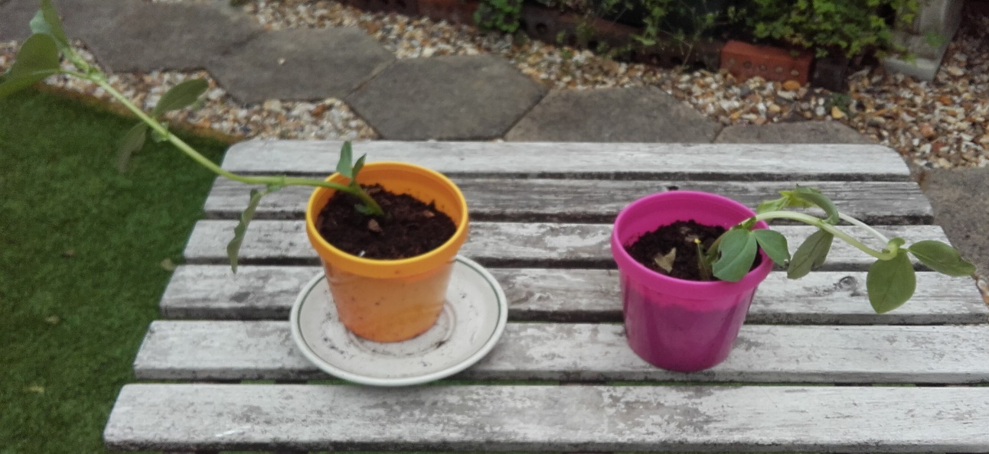
Week 2

What do you notice about the 2 plants ?
What has happened to the plant in the pink pot?
Was your prediction correct?
The broad bean plant in the planter was grown outside at the same time the other 2 plants were planted.
What difference can you see?

Geography:- Name the 15 countries in Europe

Hstory

