

|  |  |
| --- | --- |
| **St Joseph’s Catholic Primary School - LEARNING AT HOME PLANNING** | |
| YEAR 3 | |
| Date- WC 6th April | |
| **Weekly Mathematics Tasks**  **(Aim to do 1 per day)** | **Weekly Reading Tasks**  **(Aim to do 1 per day)** |
| * Work on Times Table Rockstars - your child will have an individual login to access this (preferably 5 mins everyday but they have been set a target of 5 games over the week). * Play Guardians: defender of Mathematica <https://www.bbc.co.uk/bitesize/subjects/z826n39> * How many different ways can you show the number 50 by using facts? e.g. 100 ÷ 2, 25 x 2, 30 + 20 etc. Can you find 50 ways? * Using online shopping, if I wanted to buy a pint of milk, a box of cornflakes, a bag of Crunchie Rocks and a tub of Ben and Jerry’s cookie dough ice cream. How much would I spend? What coins and notes could I use to pay this? * Complete pages 1-6 in “Addition & Subtraction” booklet in your pack. | ● Share a story with a member of your family. This could be a chapter book so you could read and discuss a chapter a day. Maybe you could read a page each? (adults model use of expression and intonation and encourage children to use this too)  ● Complete reading comprehension provided in pack.  ● Watch Newsround on CBBC and discuss what is happening in the wider world.   * Listen to a story on   <https://www.bbc.co.uk/programmes/articles/5lLPPGClCvFQZ41WVC9rxjm/english>  Talk about story and discuss what they liked or didn’t like about the story and characters.   * Listen to David Walliams’ Elevenses at <https://www.worldofdavidwalliams.com/elevenses/>. Write 5 relevant questions about what you have heard. |
| **Weekly Spelling Tasks**  **(Aim to do 1 per day)** | **Weekly Writing Tasks**  **(Aim to do 1 per day)** |
| Practise writing these words. Can you say when each one should be used?   1. there 2. their 3. where 4. were 5. off 6. of 7. no 8. know 9. too 10. two 11. to   Can you think of anymore homophones?  Put each word into a sentence (remember your punctuation!) | * Write a letter to a friend and say what you are doing. Share some activities that you have enjoyed or websites you have found to help with your learning. Remember how to write a letter address /date /Dear…. * Write a character description of a member of your family. What do they look like? How do they behave? etc... * Complete the attached adjective and alliteration sheet. Put some of these into sentences. * Write a set of family rules, could they begin with ‘We always…..’ rather than ‘We do not ………’ * Write a weekly diary to keep track of all of the activities that you are completing and how you are feeling. Has anything special happened this week? |

|  |
| --- |
| Foundation subjects and Learning Project - to be done throughout the week |
| **The book that we were reading this term was ‘Big Blue Whale’ by Nicola Davies.**  **All of the tasks below will be linked with this.**   * Art - look online for the work of Henri Matisse - can you make a picture of the ocean using this style? Maybe you could even include a blue whale! * Geography - learn the names of all the continents and oceans. Label them on the included map. Challenge- can you label the equator and the northern and southern hemispheres? * Culture - which animals are in danger from sea pollution? Find out facts about how they are endangered. * MFL- Can you learn the names of 3 sea creatures in a different language? * RE- Watch the Easter story on Beginner’s Bible on Youtube and then complete the Easter story worksheet attached. <https://www.youtube.com/watch?v=0PSgoPdKQFQ&t=1348s> |
| **Let’s get physical!** |
| Start each day by following Joe Wicks/ Just Dance or Cosmic Kids Yoga on You Tube    Do something active with your family once a day- maybe you could learn a new skill/game! |
| **Pray Together** |
| ***The Gospel for the coming Sunday can be found at*** [***http://universalis.com/mass.htm***](http://universalis.com/mass.htm)  ***It is Palm Sunday on the 5th April which is the beginning of Holy Week.***  ***The CAFOD website has some lovely ideas to help us at this special time.***  ***Holy Week worksheet and link to Topmarks site*** |
| **Additional learning resources parents may wish to engage with** |
| **Classroom Secrets**:- Free Learning Packs - These packs are split into different year groups and include activities linked to reading, writing, maths and practical ideas you can do around the  home.  **Twinkl** - to access these resources click on the link and sign up using your own email address and creating your own password. Use the offer code UKTWINKLHELPS.  **Headteacherchat** - This is a blog that has links to various learning platforms. Lots of these are free to access.  **Topmarks-** access to lots of educational games |
| **Teacher Tips** |
| * Remember - in a normal school day, there are several ‘break times’ throughout the day, so make sure as well as ensuring they complete their work, you build in ‘relaxation’ time. This is important for both adults and children- lots of short bursts of work are much better than trying to do all work in one go! * If the children are really engaged and interested in something, see what cross curricular links you can make. If it’s animals and endangered species could you turn this into a project? E.g. make a poster showing how pollution is effecting the animals, write a letter persuading people to use less plastics, design packaging to replace plastic packaging. |

|  |  |
| --- | --- |
| Think of adjectives that you could use to describe these creatures. Try to find adjectives that start with the same letter. For example **angry alligators** | |
| _____________ alligators  _____________ bears  _____________ crocodiles  _____________ ducks  _____________ elephants  _____________ foxes  _____________ gorillas  _____________ hippos  _____________ insects  _____________ jackals  _____________ kangaroos  _____________ lions  _____________ monkeys | _____________ nightingales  _____________ otters  _____________ pandas  _____________ quails  _____________ rats  _____________ snakes  _____________ tigers  _____________ umbrella birds  _____________ vultures  _____________ whales  _____________ x-ray fish  _____________ yaks  _____________ zebras |

World Map Continent and Ocean Labelling

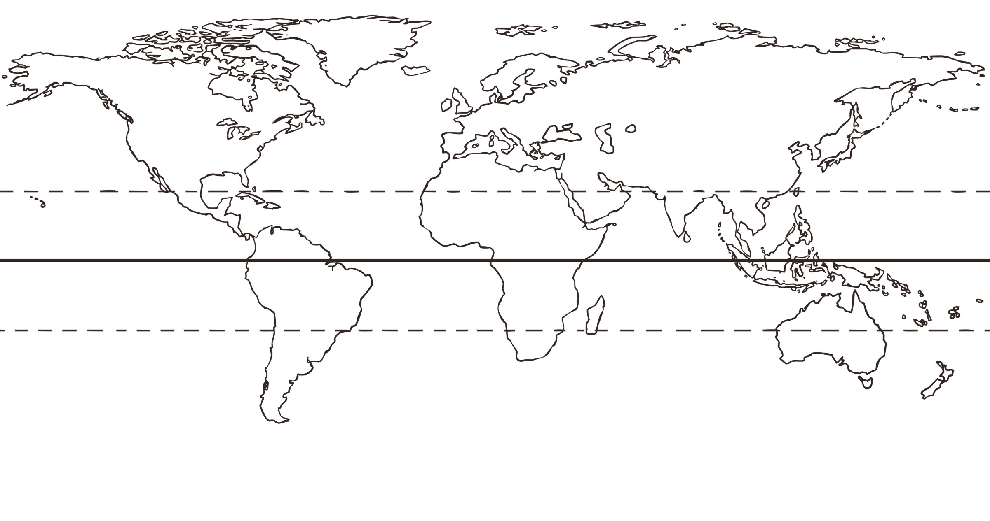



Can you order each event of Holy week and write a sentence about it ?

You can use Topmarks to help you read about this important week.

<https://www.topmarks.co.uk/easter/holyweek.aspx>

