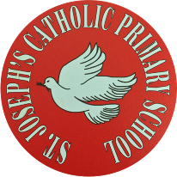
St Joseph’s Catholic Primary School - LEARNING AT HOME PLANNING
YEAR 3
Date WC 6th July 2020
Weekly Mathematics Tasks  (Aim to do 1 per day) | Weekly Reading Tasks  (Aim to do 1 per day)
- Continue to play on Times Table Rockstars! It would be lovely to see some more of you joining in with our sessions. Why not challenge one of your friends to a Rock Slam? You can even challenge your teacher!  Remember we are also looking at the https://www.youtube.com/watch?v=RyM-z_-RsKYscores and choosing Stars of the week!  - Well done to everybody who completed a challenge on Numbots last week. This is the last week that it will be available to us so please make the most of it and see how many challenges you can complete!  - Try the Mental Maths challenges.How long did it take you to do each one?  - This week we will look at –Right angles Acute and Obtuse angles?  - Complete the worksheets attached below. | Exciting project for the Summer!!  Can you choose a poem you like and learn over the holidays?  In September you could recite it for the class. Here is link to many great poems you could learn.  https://www.poetrybyheart.org.uk/learningzone/summer-challenge/  https://www.poetrybyheart.org.uk/  https://www.poetrybyheart.org.uk/poetry-for-children/  - Let look at the next part of this true story. Part 4  - https://www.youtube.com/watch?v=RyM-z_-RsKY  Part 5  https://www.youtube.com/watch?v=IdDA9IDhdCE  Work linked to the book is below.
Weekly Spelling Tasks  (Aim to do 1 per day) | Weekly Writing Tasks  (Aim to do 1 per day)
pressure probably  promise purpose  quarter continue  decide different  difficult difference | - Correcting sentences-see below.  - Comprehension  - Handwriting  - Spelling
Foundation subjects and Learning Project - to be done throughout the week
Science: Light

Geography:- Looking at map skills

History:- Ancient Egypt What have you enjoyed? Make you own mask and Canopic jar.

Art linked to History- Make a mask for a pharaoh.
Simple design below but can you make using other materials?
https://www.yac-uk.org/activity/make-an-ancient-egyptian-death-mask

Let’s get physical!
Joe Wicks : https://www.youtube.com/watch?v=MFAT6PUfYPM

Cricket skills Chance to Shine-

https://www.youtube.com/watch?v=YzzgPepcoFU&feature=youtu.be

Organise a sports day for you and your family.
Think about games you can play and what equipment you will need. Scoresheet and points for each place.

Pray together
RE - Being a Christian :- Find out about a Saint and how they showed they were a Christian. Use this website to choose ,perhaps a Saint you are named after. Here are some fun facts about St. Francis find out more about him.
https://www.catholic.org/saints/fun_facts_arch.php?saint=50

Look at the very bottom and read a very special reading called ‘Footprints’
Think about the meaning for you.
Wednesday Word :- Gospel reading at the end as well.

https://cafod.org.uk/Education/Primary-teaching-resources/Home-learning-primary
CAFOD have produced some lovely activities to think about over the summer.
It’s called the Summer of Hope. There are activities and games and prayers to look at.

Additional learning resources parents may wish to engage with
Classroom Secrets Learning Packs - These packs are split into different year groups and include activities linked to reading, writing, maths and practical ideas you can do around the home.
Oxford Owl – eBooks for children aged 3-7 (free but need to register)
www.ictgames.co.uk - maths and English games
www.topmarks.co.uk - online games
Explorify – Science quizzes (free but need to register).
Headteacherchat - This is a blog that has links to various learning platforms. Lots of these are free to access.

Teacher Tips
- Remember - in a normal school day, there are several ‘break times’ throughout the day, so make sure as well as ensuring they complete their work, you build in ‘relaxation’ time. For you as well as the children!

- If the children are really engaged and interested in something, see what cross curricular links you can make. If they are in to trains, could they design a poster for a train exhibition, build a train out of cardboard, write an adventure story about a train journey, research facts about railways etc Capitalise on their interests and don't worry too much if it ‘fits’ into their weekly learning.

.

Can you also find any acute and obtuse angles in these shapes?
English:-
Listen to the next part of the story Part 4 and Part 5
Look at the pictures of Zeraffa. What must the crowds have thought?
Write your thoughts of seeing this creature walk down the main road in Paris.
Picture yourself there, imagine the crowds, imagine the excitement.
Write a brief description of the day and the events include the atmosphere and what the giraffe looked like.
Read the extract from:-Michael Allins ’ Zaraffa’
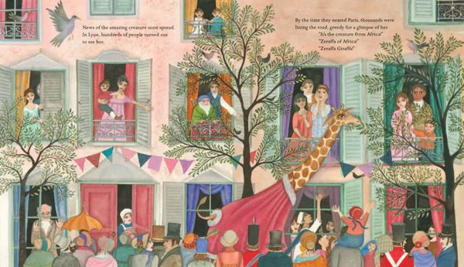

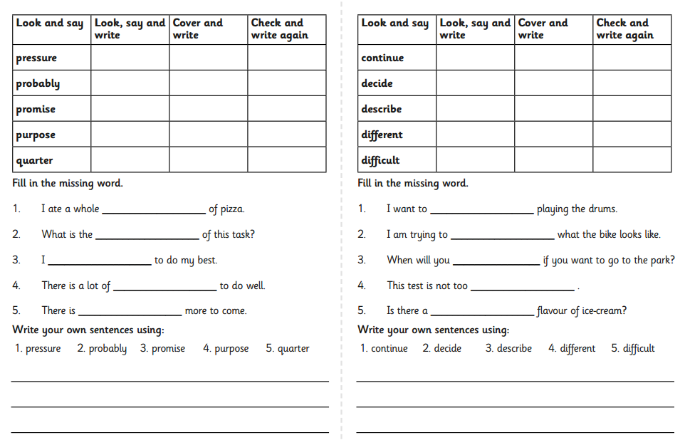

Science:
https://www.bbc.co.uk/bitesize/topics/zbssgk7
What is light?
Watch clip and think about light and what sources of light are there?
Complete activity below

Geogaphy:- Mapping Skills Look at the symbols which you will find on a map
Using the symbols:- can you make a plan of your journey to school and use the symbols to represent buildings etc you would pass? Or why not make a plan of an imaginary village and put the symbols on your map? Don’t forget to add a key to your plan.

History -Ancint Egyptians As we have been looking at the Ancient Egyptians perhaps you can make a fact file of Ancient Egyptian life. Finally look at death masks and design one for your pharoah.
What have you enjoyed learning about the Ancient Egyptians?
Also make your own canopic jars.

