St Joseph’s Catholic Primary School - LEARNING AT HOME PLANNING
YEAR 3
Date WC 6th July 2020
Weekly Mathematics Tasks  (Aim to do 1 per day) | Weekly Reading Tasks  (Aim to do 1 per day)
- Continue to play on Times Table Rockstars! It would be lovely to see some more of you joining in with our sessions. Why not challenge one of your friends to a Rock Slam? You can even challenge your teacher!  Remember we are also looking at the scores and choosing Stars of the week!  - Well done to everybody who completed a challenge on Numbots last week. This is the last week that it will be available to us so please make the most of it and see how many challenges you can complete!  - Complete the next pages from the multiplication and division booklet (attached below).  - This week we will look at -What is an angle?  - Complete the worksheets attached below. | - Read chapter 3 of ‘The Story of Osiris’ attached below (alternatively you can listen to the first chapter being read here  - Answer questions below.  - Let look at the next part of this true story.  https://www.youtube.com/watch?v=bPwtl9x4xww  Work linked to the book is below.
Weekly Spelling Tasks  (Aim to do 1 per day) | Weekly Writing Tasks  (Aim to do 1 per day)
circle complete  consider continue  strength suppose  surprise therefore  though | - Uplevelling sentences-see below.  - Comprehension  - Handwriting  - Spelling  All sheets below with help !
Foundation subjects and Learning Project - to be done throughout the week
Science Plants- Life cycle of a plant.

https://www.bbc.co.uk/bitesize/topics/zy66fg8/articles/zcmtk2p

Geography:- Looking at map skills

History Ancient Egypt How did the Ancient Egyptians farm?

Art
https://classroom.thenational.academy/lessons/texture-treasure-hunt-76b021/activities/1
Watch this video showing you a technique used by
Now can you create your own picture in the same style?
Frottage by Max Ernst
Let’s get physical!
Cricket skills Chance to Shine-
https://www.chancetoshine.org/staying-active-during-the-covid-19-outbreak#h_991011545111587376839180

As we would normally be having sports day, can you design your own games for a sports day?

Some ideas:-
Use ping pong balls or balled-up socks for a ball toss game (make it in the bucket or box), or toss throw pillows into a laundry basket.
- Set up cup stacking, a station where kids have to stack and unstack items
- Have them put blocks or Legos in a basket, carry it to a certain spot, return to the start, and pour them out for the next player.

Pray together
RE - Being a Christian How can I use my talents? See story below and work.

Read story from the bible below and think about the message Jesus was giving.
Think about the gifts you have. Make a list of your talents and gifts. Draw a picture of yourself and add all your gifts and talents. Now think of ways you can use these talents to help others. Think of ways people have used all their talents in the past few weeks, like Capt. Tom Moore.
How can you use your talents? Draw a picture or take a photograph to show what you can do.

A prayer to help us share our gifts. To ask God how we can help others.

Additional learning resources parents may wish to engage with
Classroom Secrets Learning Packs - These packs are split into different year groups and include activities linked to reading, writing, maths and practical ideas you can do around the home.
Oxford Owl – eBooks for children aged 3-7 (free but need to register)
www.ictgames.co.uk - maths and English games
www.topmarks.co.uk - online games
Explorify – Science quizzes (free but need to register).
Headteacherchat - This is a blog that has links to various learning platforms. Lots of these are free to access.

Teacher Tips
- Remember - in a normal school day, there are several ‘break times’ throughout the day, so make sure as well as ensuring they complete their work, you build in ‘relaxation’ time. For you as well as the children!

- If the children are really engaged and interested in something, see what cross curricular links you can make. If they are in to trains, could they design a poster for a train exhibition, build a train out of cardboard, write an adventure story about a train journey, research facts about railways etc Capitalise on their interests and don't worry too much if it ‘fits’ into their weekly learning.

.

M

Can you look around your house
for different angles ?
Where did you find them?
English
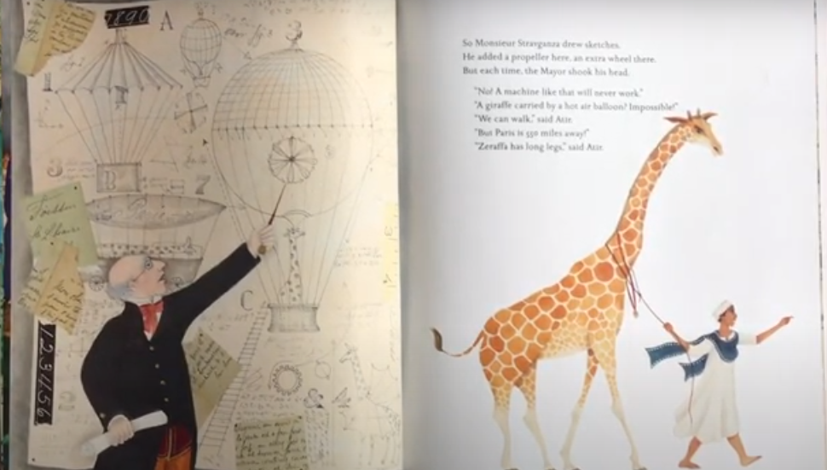

Listen to the next part of the story.
Read the letter written by Geoffroy Saint Hiliare
Can you design a way of getting Zeraffa to Paris? Describe what you would build. Think about how tall Zeraffa is:- 11feet 6 inches,hooves and horns called ossicones
Read facts about giraffes from Chester Zoo website:
https://www.chesterzoo.org/our-zoo/animals/giraffe/
Look at all the facts to help you decide what Zeraffe may need on his long journey and plan what to take for him.
Make a list of items needed.
It has been decided to walk Zeraffa to Paris 500 miles away, what will he and his companion Atir need on the way? Would they do it one day or a few days?
Make a list of requirements.
Pack a suitcase for Zeraffa. What would he need?

Modifying nouns e.g. coffee table 2 nouns- but 1st describes the 2nd To explain further watch this video clip.
https://www.youtube.com/watch?v=h_g0rkPUNuo

R.E

Parable of the Talents
by Sharla Guenther
This story is called the Parable of the Talents. A parable is a type of story Jesus would tell so we would learn something from it.
Jesus' stories had more than one meaning. For example, this story is about talents which was a super large amount of money in Bible times. Today a talent might be worth a million dollars!
A talent in this story can also mean our gifts or abilities. Something special and amazing God gives just to you, almost like a super power.
The parable starts like this: A man decided to go on a long trip, so he called his servants and asked them to take care of his house, his stuff and his money.
Keep in mind that the man in this story is like God and the man's servants are God's people (you and me!) The man in this story trusted his servants and believed that they would take care of his special and valuable things.
The man decided to give one servant five talents of money (lets say that it's about five million dollars), to another he gave two talents (or two million) and to the last servant he gave one talent. He gave each servant a large amount he thought they could handle or according to their ability.
Our abilities are our special gifts that God gave to each of us. He made some of us smarter about some things than others. Some of us are good at memorizing, some of us are better at certain sports, and some of us are better at knowing how to help others. Some can solve problems better and some are more generous. Our ability is something special we have that's different than anyone else.
Back to the story, the man left on his trip and the servants each did something with the money that they received.
The man with the five talents went right away and used his money and got five more! The man with the two talents also used his money wisely and gained two more talents.
But the man with one talent took his talent and buried it in the ground to keep the money safe. He didn't even try to do something with it.
He reminds me a bit like a dog that buries a bone. He had lots of time to do something with his money. He could've bought some seeds and planted a garden and made some money but he didn't do anything!
After a nice long trip the master came back and wanted to know what his servants did with his money. The first man with the five talents said, "You trusted me with five talents and I made five more!"
His master smiled and replied, "Great job, good and faithful servant!" You are trustworthy with a few things so I will put you in charge of lots of things. Come celebrate with me!
I think it's interesting that the master says he trusted him with a FEW things. He gave him five million dollars! That's ALOT of things. But to this master it was small compared to what he would give and trust him with now.
Then the man with the two talents came and said, "You trusted me with two talents and I made two more!"
His master smiled and replied, "Great job, good and faithful servant!" You are trustworthy with a few things so I will put you in charge of lots of things. Come celebrate with me!
Then the man who received the one talent came and told his master, "I know you work hard for your money, so I was afraid to lose any of it. I decided to bury it and keep it safe. Here is your one talent back."
The master was not impressed and said, You lazy servant! At the very least you could've taken the money to the bank and you would've at least collected some interest from it."
He immediately took the talent away from the man and gave it to the first man who used his money to make more.
The point Jesus was trying to make is that if you use your special gifts and abilities God will give you more to keep doing these things you are good at. He will trust you with so much more.

That we must always try to use the talents God has blessed us with to bring joy and happiness to others
- We must not waste our talents or hide them away
- We should always celebrate our talents but never allow our success to make us boastful
- We should always celebrate the talents and successes of others and never become resentful of what God has given to others
- We should always strive to develop our talents by working hard and never giving up, even when things appear difficult.

Science:

Find out about each stage of the life cycle of a flowering plant.
Then using sheet below put into order.

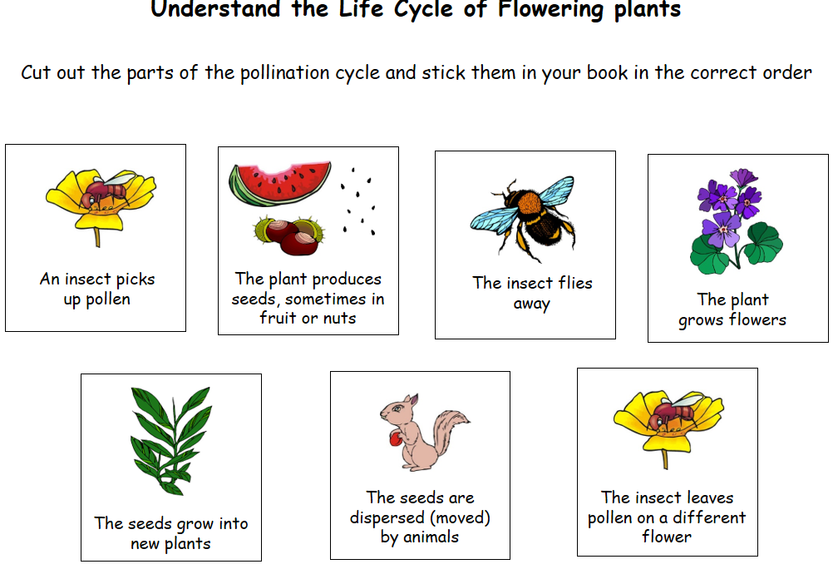

Geogaphy:-

What OS symbols can you see on this map? What do they stand for?
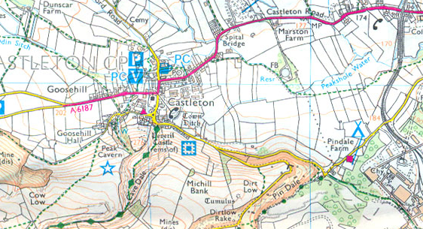

History Ancint Egyptians
https://www.bbc.co.uk/bitesize/topics/zg87xnb/articles/zkkywty
Look at clip about how important farmimg was to the Ancient Egyptians.

Can you make a circular calendar for an Ancient Egyptian Farmer?
What have you learnt that surprises you about the farmers?

