St Joseph’s Catholic Primary School - LEARNING AT HOME PLANNING
YEAR 1
Date wc 8th June
Weekly Mathematics Tasks  (Aim to do 1 per day) | Weekly Reading Tasks  (Aim to do 1 per day)
- Download the classroom secrets home learning pack for week 7. Complete the tasks for each day. https://classroomsecrets.co.uk/free-home-learning-packs/.  - Monday – complete maths activity sheet 1 which you can find below.  - Tuesday – complete maths activity sheet 2 which you can find below.  - Wednesday – complete maths activity sheet 3 which you can find below.  - Thursday – complete maths activity sheet 4 which you can find below.  - Friday – complete maths activity sheet 5 which you can find below. | - Share a story with someone in your family. It could be a picture book, or a chapter in a longer story book.  - Choose a story to listen to from the below link. Talk to an adult about how the character might feel in the story based on their actions.  https://www.worldofdavidwalliams.com/elevenses-catch-up/  - Ask an adult to sign up to https://www.teachyourmonstertoread.com/accounts/sign_up. This is a free website on computers. You can play games and read all at the same time.  - Ask an adult to use the link provided and listen to stories that interest you. https://stories.audible.com/discovery  - Read the comprehension about ‘Hot places’ and answer the comprehension questions. Please find the reading and questions below.
Weekly Spelling Tasks  (Aim to do 1 per day) | Weekly Writing Tasks  (Aim to do 1 per day)
- Choose a phase 3 or phase 5 sound and write as many words as you can think of containing that sound in 3 minutes.  - www.phonicsbloom.com  - www.phonicsplay.co.uk  - http://www.familylearning.org.uk/phonics_games.html  - Ask an adult to choose 10 common exception words each day. How many can you spell? Can you learn them all by the end of the week?  - Monday - complete phonics activity mat 1 which you can find below.  - Tuesday – complete phonics activity mat 2 which you can find below.  - Wednesday – complete phonics activity mat 3 which you can find below.  - Thursday – complete phonics activity mat 4 which you can find below.  - Friday – complete phonic activity mat 5 which you can find below. | - Keep writing a diary about what you are doing each day - we are making history at the moment - keep a record of it!  - Write a letter to your class teacher. Let them know how you are and the activities you have completed. Ask an adult to upload them to twitter or email them to school. We will reply to your letter via twitter.  - Look at the picture on pobble365. Write some sentences to describe the picture or write a story that you can imagine. https://www.pobble365.com/  - Download the classroom secrets home learning pack for week 7. Complete the tasks for each day. https://classroomsecrets.co.uk/free-home-learning-packs/.  - Create your own story. Can you use the pirate picture below to help plan and write your own imaginative story? How did this pirate get stuck on an island? What is his name? Where did he come from? How will he get home?  - Imagine you were a pirate for the day. Write about the things you would do on the sheet below.

Foundation subjects and Learning Project - to be done throughout the week
Last week we had lots of different weather, we had hot days, days when it rained and days when it was cloudy. So this week let’s do some Geography work all about the weather.
- Watch a weather report for today on the news or online. How is the weather different across the country? Draw the different types of weather on a blank outline map of the Uk. Do this for another day in the week and make comparisons of the weather on two different days. Please find a blank outline map below.
- Think about the seasons we see throughout the year. Can you name the four seasons? Can you draw a picture of what the trees would look like in each season? Please find the how seasons change sheet below.
- Scenario: What if…it snowed all year round? Write down what you think would happen if it snowed all year? What jobs would there be if it snowed all year? What would you eat? What clothes would you wear?

We have set up some music lessons for you to do at home using Charanga, which is the scheme we use in school. Have a look below for your login and access the website www.caranga.com/yumu. Once you have logged in, there are two sections for you to access and work through. Click on either ‘Your Imagination’ or ‘Song Packages’ and follow the instructions. We hope you enjoy your music lessons at home as much as you do in school. Make sure you let school know how you are getting on and if you need more music work setting for you.

Let’s get physical!
https://family.gonoodle.com/ - use this website for moving and mindfulness

https://www.bbc.co.uk/teach/supermovers/just-for-fun-collection/z7tymfr - get physical

Complete your daily exercise- go on a walk, run, bike, scooter etc.

Cosmic yoga on youtube

Dance with Oti Mabuse
https://www.youtube.com/channel/UC58aowNEXHHnflR_5YTtP4g

Ask your family to make up a dance with you or try and do an exercise routine with them.

Pray together
If we were in school, you would be learning all about Jesus’ miracles. This week ask and adult to read the story of the paralysed man and colour in the picture below.

When you go to bed read this prayer:

Bless me, Lord, as this day ends,
Bless my family and all my friends,
Keep me safe throughout the night,
And wake me with the morning’s light.
Amen

Additional learning resources parents may wish to engage with
- www.phonicsbloom.co.uk phonics games/ activities
- www.phonicsplay.co.uk Username: mach20. Password: home for free access
- http://www.phonicsplaycomics.co.uk/comics.html Reading Activities
- www.twinkl.co.uk lots of resources in a variety of subjects. Code: UKTWINKLHELPS for free access.
- www.ictgames.co.uk maths and English games
- www.topmarks.co.uk online games
- www.bbc.co.uk/cbeebies educational games and activities linked to charcters
- www.classroomsecrets.co.uk home learning packs for year 1
- www.oxfordowl.co.uk phonic and reading resources and ebooks.
- https://www.bbc.co.uk/cbeebies/shows/numberblocks sing and learn about numberblocks from cbeebies
- Joe Wicks Daily PE sessions
Teacher Tips
The work above is an idea of activities you could try at home. The most important thing at the moment is keeping your child happy and healthy. Any learning at home is learning, so if that takes a more practical approach then that’s fine. Bake a cake, play a board game together, build with Lego - your child is learning important maths and communication skills doing these things. Take the work at their own pace. If it is too much stop, if they want to do more let them. Remember we have breaks during the school day too, a little bit of fresh air in the garden is helpful for a ‘brain break’. We would really like to see what they’re doing. If you have any photographs then please send them into the school via Twitter @stjosephsbh if its building a den in the garden, creating a banner for the NHS, or spending time with the family we want to see it. Stay safe everyone!

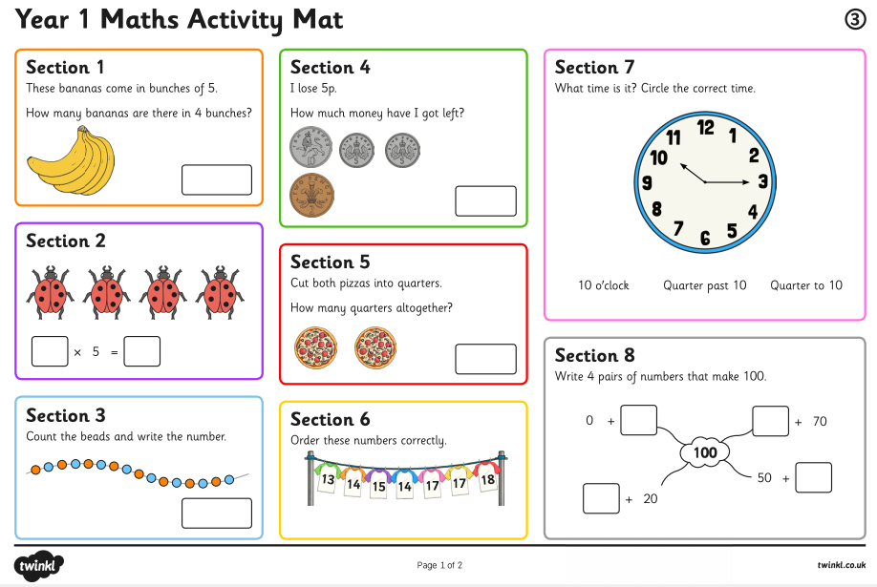

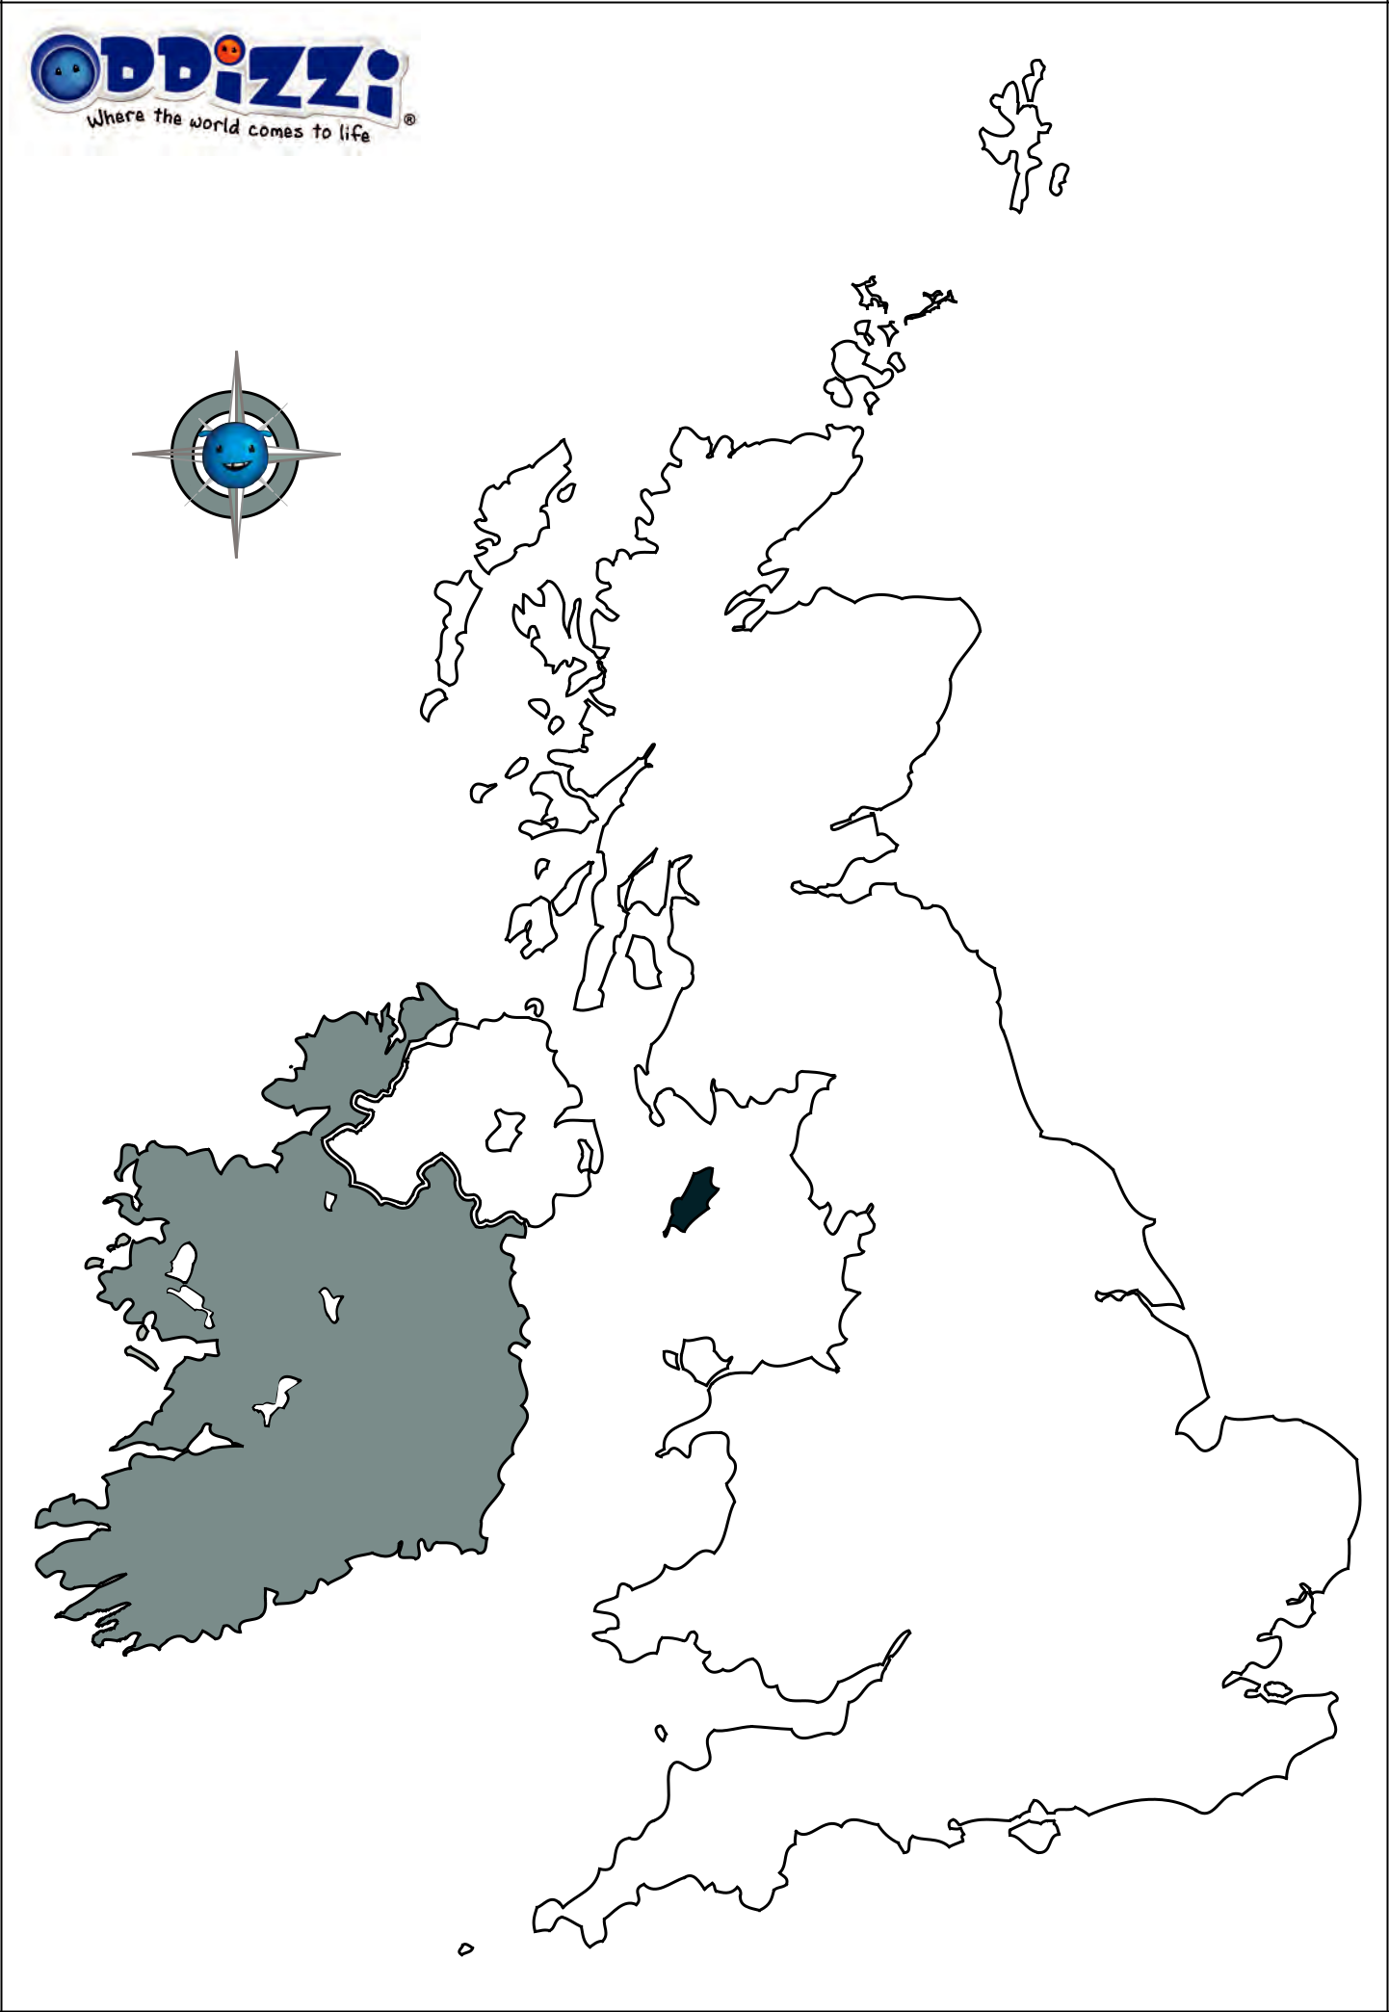

How Seasons Change

Spot the differences between the seasons.

Autumn

