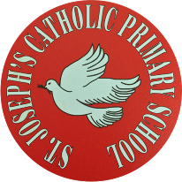

|  |  |
| --- | --- |
| **St Joseph’s Catholic Primary School - LEARNING AT HOME PLANNING** | |
| YEAR 3 | |
| Date - WC 4th May | |
| **Weekly Mathematics Tasks**  **(Aim to do 1 per day)** | **Weekly Reading Tasks**  **(Aim to do 1 per day)** |
| * Continue to play on Times Table Rockstars- your child will have an individual login to access this (preferably 5 mins everyday but they have been set a target of 5 games over the week). Also continue to play on Numbots daily as well. * Complete the 5-a day for 4th May at <https://corbettmathsprimary.com/wp-content/uploads/2018/06/bronze-may-4.pdf> * Complete pages 19-22 in “Addition & Subtraction” booklet in your pack. * Recap on the Roman Numerals powerpoint from last week’s sheet then complete the clock attached below using Roman Numerals. * Complete the 24-hour clock/ Roman Numeral worksheet. | * Encourage your child to read for at least 15 minutes independently. * Complete this reading comprehension about Ancient Egypt.      * Complete week 2 of the Poetry Challenge. Read the poem ‘A Word’ by Emily Dickinson. <https://www.whatdowedoallday.com/poetry-challenge-for-kids-week-2/> * Listen to your child read part of a chosen book. Work together to write a list of any words that they do not know the definition of. Work together to use a dictionary/ the internet to find the meaning of the words and then put each one into a sentence?      * Complete the common exception words crossword attached below. Answers 🡪 |
| **Weekly Spelling Tasks**  **(Aim to do 1 per day)** | **Weekly Writing Tasks**  **(Aim to do 1 per day)** |
| |  |  |  | | --- | --- | --- | | **I will** | **is not** | **has not** | | **I am** | **he will** | **will not** | | **do not** | **cannot** | **I had** | | **I would** | **I have** | **are not** | | **had not** | **have not** | **could not** | | **you are** | **they are** | **you will** | | **he will** | **you have** |  |  1. Can you work out the contracted form for each of these phrases? 2. Why do we use apostrophes in these contractions? Where does it go? 3. Can you put these words into sentences? (4 a day) 4. Can you find any words with contractions in the book(s) that you are reading? | * Read the ‘Truth about Trolls’ (see last week’s sheet). Complete Task 2 –The Adjective Game (p8 and 9)      * Write a letter to your teacher to tell them how you are getting on and what you have been doing (we would love to see them on the school’s Twitter page- you might even see one from us on there too!) * Select one of the activities from this Powerpoint based upon the picture. * Continue to write your diary and fill in your time capsule from last week’s sheet. * Complete these handwriting sheets. |

|  |
| --- |
| Foundation subjects and Learning Project - to be done throughout the week |
| **RE-** The meaning of the resurrection – Make a poster for your window to remind everybody about what happened at Easter and why it is important.  **Geography** - To identify the world’s longest rivers. Complete the sheet below and write the correct number on the map. There are some clues to help you!! (Also for parents -answers under!!)  **History** - Ancient Egyptians - Why was the River Nile so important for them? There is a clip to watch and some facts to read before you can fill in the fact file.  You could make your own fact file and decide how to present information.  **Science** – What are the requirements for plant growth? Watch the video and complete the fill in the gaps activity on the website. <https://www.bbc.co.uk/bitesize/topics/zy66fg8/articles/z98jpbk> |
| **Let’s get physical!** |
| **Start each day by following Joe Wicks/ Just Dance or Cosmic Kids Yoga on You Tube**  **Cricket skill this week is bowling. In cricket your bowling arm must be straight.**  **See the diagram and activities below. Have a go!!** |
| **Pray together** |
| See the source image    ***The materials produced by ‘The Wednesday Word’ are available through a***  ***temporary link during lockdown.***  [***http://www.wednesdayword.org/stopgap/Special-Edition.pdf***](http://www.wednesdayword.org/stopgap/Special-Edition.pdf)  ***This link will be regularly updated every Tuesday.*** |
| Additional learning resources parents may wish to engage with |
| [NASA Kids](https://www.nasa.gov/kidsclub/index.html) is perfect for space fans. Learn all about the universe we live in by viewing these online videos.  Cartoon lessons on YouTube with [Pete McKee](https://www.youtube.com/watch?v=q8f8ag58jDs).  [Minecraft: The Education Edition](https://education.minecraft.net/) is popular with children already – these resources all have an educational purpose. |
| **Teacher Tips** |
| * Please don’t worry if you are unable to complete some activities. * Have fun with learning and feel free to adapt any of the activities to suit your child’s interests. |

# Roman Numeral Cut and Stick Activity

Cut out the Roman numerals from the next page and stick them in the correct places on the clock. Then cut out the clock hands and stick them on to show me the time that you go to bed. What time this is in words?

# 1

VII

II

IV

IX

X

VI

XI

VIII

XII

III

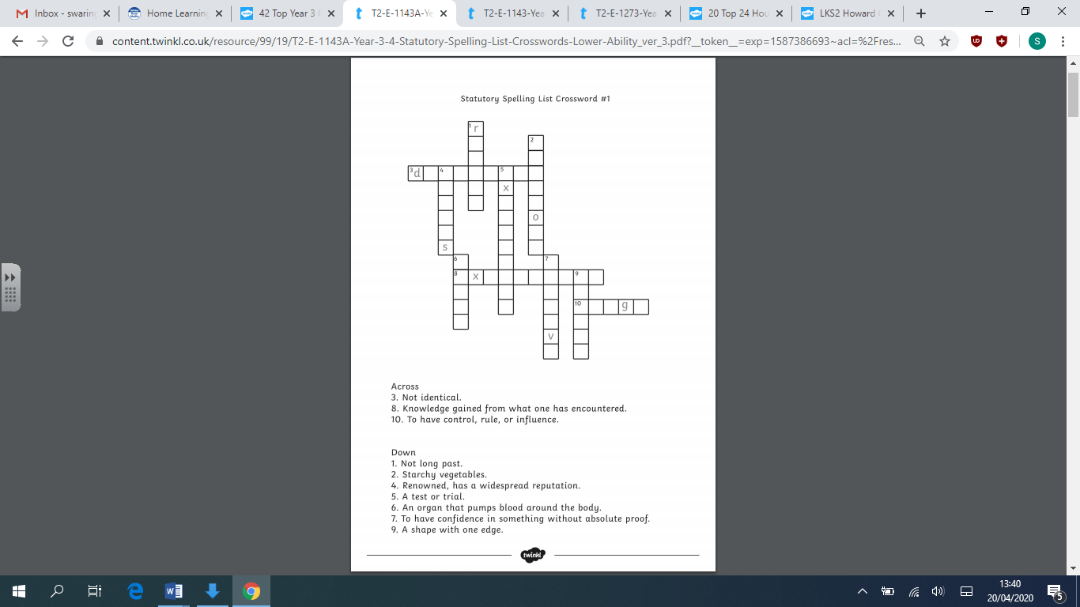**Common Exception Words Crossword**

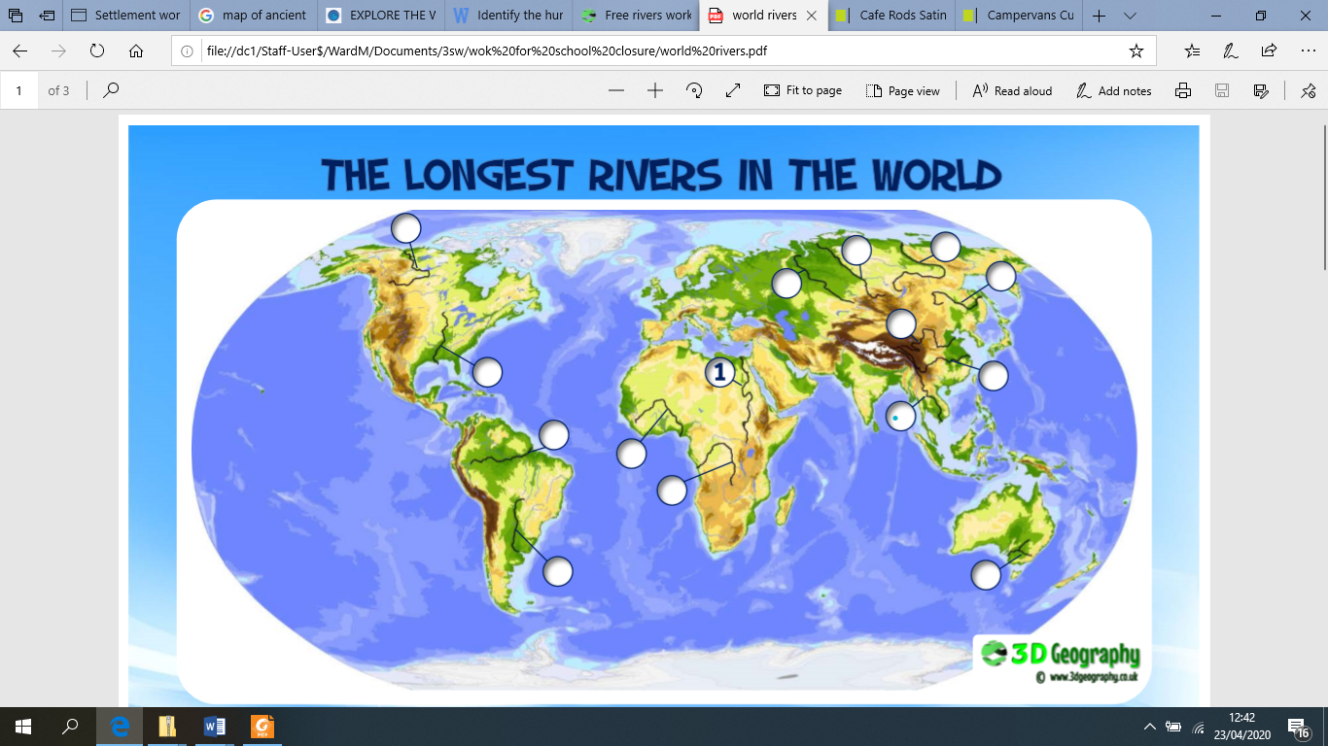

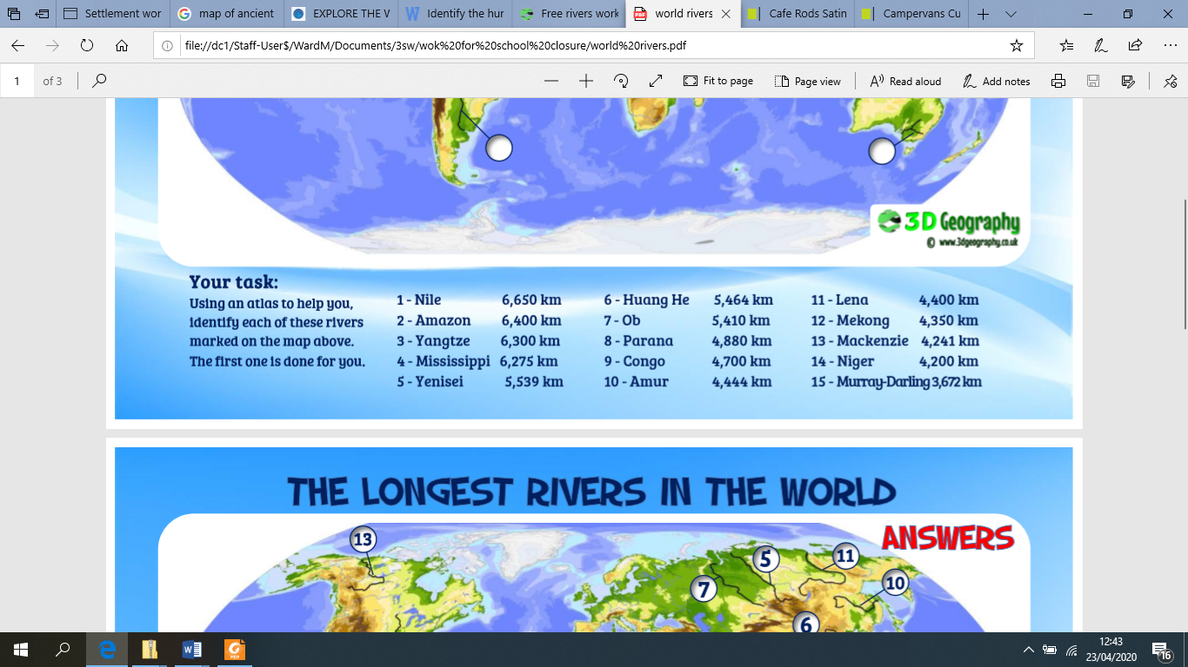

**The 10 longest rivers in the world are:**   
  
**1. Nile** - The [Nile River](https://www.ducksters.com/history/ancient_egypt/geography_nile_river.php) is 4,135 miles long. It is located in the continent of Africa, mostly in the countries of Egypt and Sudan. It flows north into the Mediterranean Sea.   
  
**2. Amazon** - The Amazon River is 3,980 miles long. It is located in the continent of South America and flows through several countries including Brazil, Venezuela, Bolivia, and Ecuador. It ends at the Atlantic Ocean.   
  
**3. Yangtz**e - Located in China, the Yangtze River is 3,917 miles long and flows into the East China Sea.   
  
**4. Mississippi, Missouri** - The river system of the Mississippi River and the Missouri Rivers is the longest river system in North America at 3,902 miles. It flows south into the Gulf of Mexico.   
  
**5. Yenisei** - The Yenisei River starts in Mongolia and flows through Russia to the Kara Sea in the Arctic Ocean. It is 3,445 miles long.

**6. Yellow** - At 3,398 miles long, the Yellow river is the 6th longest river in the world, but only the 2nd longest in China. It ends at the Bohai Sea.   
  
**7. Ob, Irtysh** - The river system of the Ob River and the Irtysh River is 3,364 miles long. It flows through Russia, China, and Mongolia on its way to the Gulf of Ob.   
  
**8. Congo** - The Congo River flows 2,922 miles through several countries in Africa before reaching the Atlantic Ocean.   
  
**9. Amur** - The Amur River is 2,763 miles long. It flows through Russia, China, and Mongolia and ends at the Sea of Okhotsk.   
  
**10. Lena** - The Lena River flows through Russia on its way to the Laptev Sea in the Arctic Ocean. It is 2,736 miles long.

**Answers for Adults!**

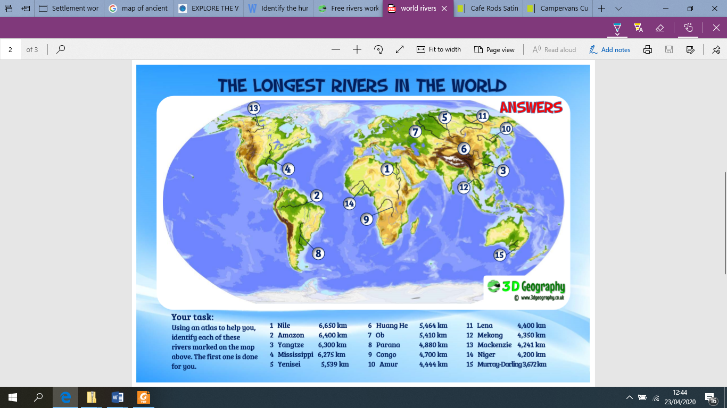



**History : Watch the clip about Ancient Egyptians and read facts.**

Fill in the fact sheet saying why the River Nile was so important for the Egyptians.

<https://www.bbc.co.uk/teach/class-clips-video/history-ks2-introducing-ancient-egypt/z6jrkmn>

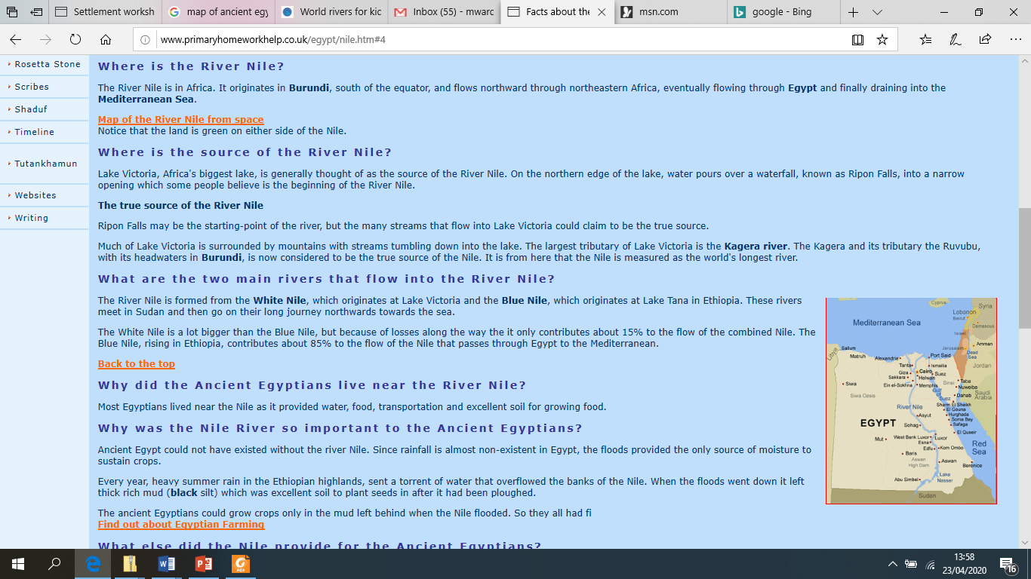

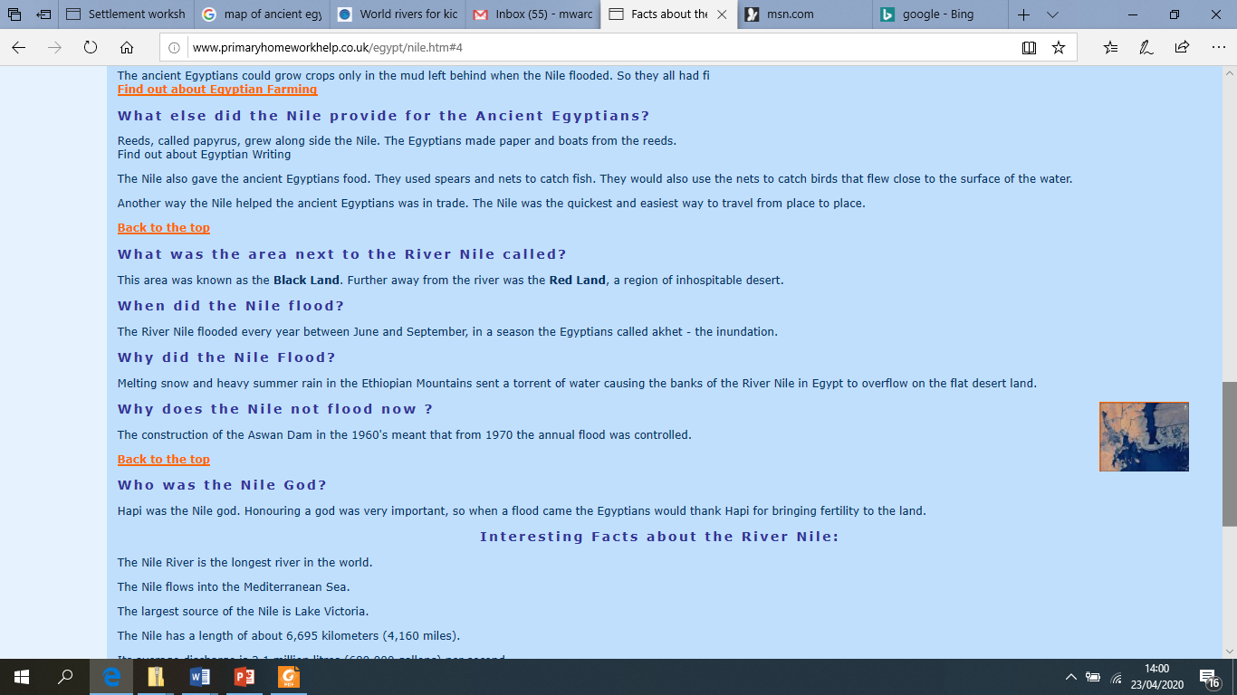

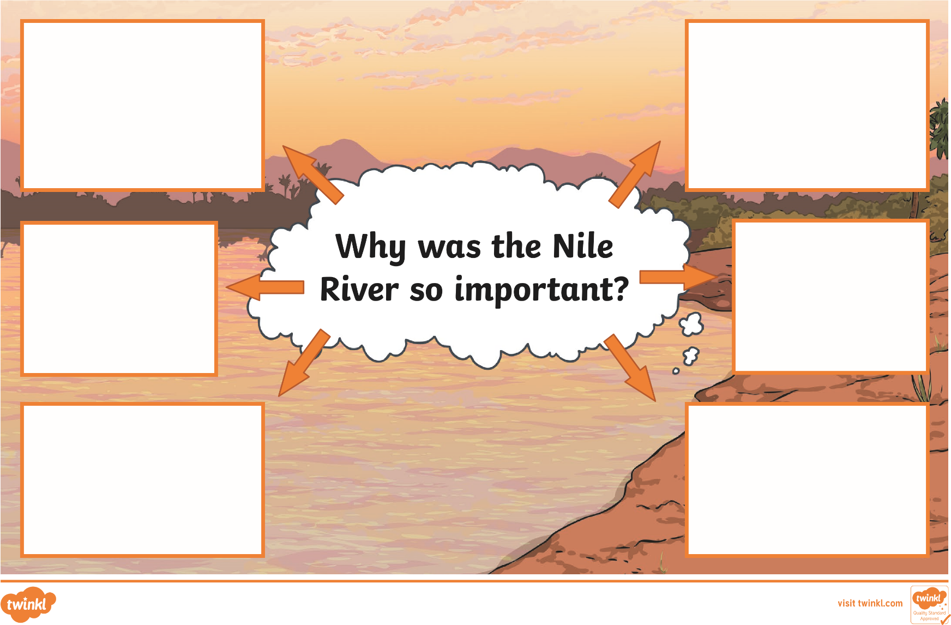

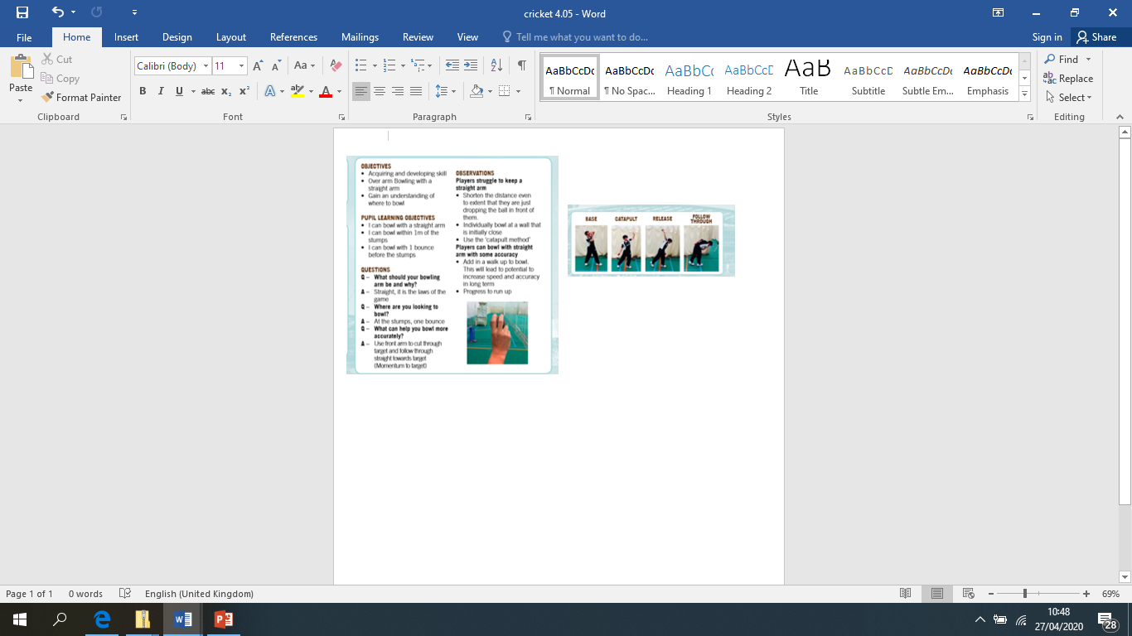**PE- Cricket**