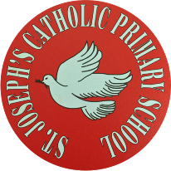
St Joseph’s Catholic Primary School - LEARNING AT HOME PLANNING
YEAR 3
Date WC 18.5.20
Weekly Mathematics Tasks  (Aim to do 1 per day) | Weekly Reading Tasks  (Aim to do 1 per day)
- Continue to play on Times Table Rockstars- Don’t forget the Class v Class battle between Year 3. We will be looking at the scores and choosing Stars of the week!  Continue to play on Numbots daily as well.  - Complete the 5-a day for 16th May at https://corbettmathsprimary.com/wp-content/uploads/2018/06/bronze-may-16.pdf  - Complete the last two pages of the “Addition and Subtraction” booklet from your pack.  - Learn about 24 Hour Time and complete the activities on the power point.  - Complete the Converting Time worksheet below. | - Encourage your child to read for at least 15 minutes a day. Please see the sheet below for some ideas of questions you might want to ask.  - Our driver text for this half term is ‘Journey’ by Aaron Becker. Read the blurb attached below. What does ‘journey of magic and adventure’ tell us? What type of story is it? What could the danger be?  - Watch the book trailer and discuss what more they have discovered about ‘Journey’:  http://www.storybreathing.com/journey/  - Complete the reading comprehension attached about ‘The Ascension of the Lord’.  - Complete week 4 of the Poetry Challenge.  Read both poems by Christina Rossetti. Which poem do you like best? Why?  https://www.whatdowedoallday.com/poetry-challenge-for-kids-week-4/
Weekly Spelling Tasks  (Aim to do 1 per day) | Weekly Writing Tasks  (Aim to do 1 per day)
gym system  cygnet oxygen  myth mystery  pyramid hymn  Egypt crystal  - Sound out each word and write it down.  What do you notice? The ‘i’ sound spelt  as ‘y’.  - Create a sentence for at least 5 of the words. Write out the sentences and then check your spelling. | - Look at the front cover of the book ‘Journey’ and complete the activity attached.  - Write a short prediction of what you think will happen in the story.  - Practise your grammar with some of  these fun grammar games: https://www.topmarks.co.uk/english-games/7-11-years/spelling-and-grammar  - Using ‘a’ and ‘an’ correctly.  Complete the activity attached.  - Complete the handwriting sheet below. Can you put some of these words into sentences using your best handwriting? Can you think of any more words that follow this spelling rule?
Foundation subjects and Learning Project - to be done throughout the week
RE
- This Thursday is the Feast of the Ascension https://youtu.be/UcFw8pLBSIo
- Celebrate the Feast of the Ascension with this craft activity.
https://www.catholicteacherresources.com/arts-and-crafts-the-ascension-of-jesus/
We would love to see a photograph of your artwork on Twitter.

Music
- Google “YUMU login” and login using your child’s login which can be found below.
Continue the assignment ‘Bringing us Together”.

Geography: Rivers
- This week we are looking at the River Mersey. Can you match the statements to the various parts of the river?
- What towns does the Mersey pass through?

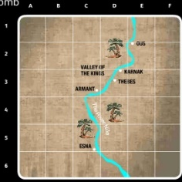
History: Ancient Egypt How can we discover what Ancient Egypt was like over 5,000 years ago?
- This week we are going to look at a picture found in a tomb in Egypt. The tomb where the drawing was found lies between Thebes and Esna. Look at the picture found in the tomb – see below What can you see? Answer the questions around the tomb picture.
When you have answered the questions, scroll down to discover the meaning of the picture.

Let’s get physical!
Invent a workout routine to part of your favourite song. It should include 5 different moves, including at least one type of jump. Can you teach it to your family?

Cricket: Watch this clip and practise your bowling techniques. https://www.youtube.com/watch?v=qgo8cQodons

To keep us active during our time away from school, we have teamed up with Joy of Moving, the EFL Trust and Tranmere Rovers FC to organise an afternoon of home-based games. We have chosen the afternoon of Thursday 21st May for you to try these activities. Feel free to record and post your skills to our twitter page, tagging in @TRFCcommunity and using the hashtag #JOMHomeFestival. Full details are to be found in this booklet:
https://documentcloud.adobe.com/link/review?uri=urn:aaid:scds:US:de810161-b137-4330-af8d-4504e177eaa8

Pray together
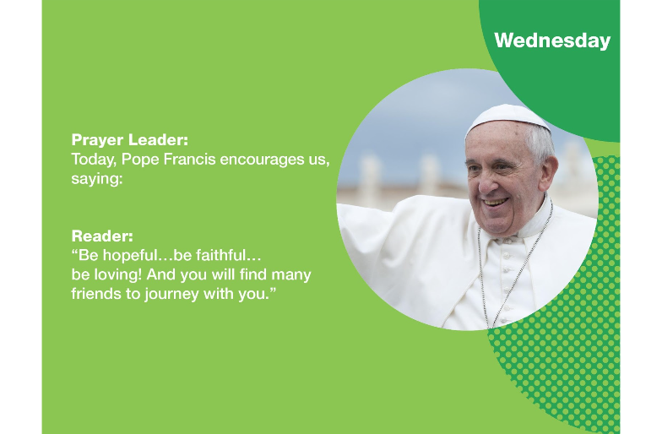

Additional learning resources parents may wish to engage with
- Our school Twitter page will keep you up to date with challenges set by the teachers and let you see what other pupils have been up to. Follow us @stjosephsbh

- The British Museum has made its online collections free to the public.

- Rosetta Stone – For the school closure period, Rosetta Stone has given free access to its language learning resources.

- WWF Together is an app that has proven really popular with children during school closures. Using the app children are able to explore the lives of endangered species. They can also take a selfie with an animal!
.
- Classroom Outdoor Day has brilliant resources for outdoor learning. https://outdoorclassroomday.org.uk/

Teacher Tips
- If your child has produced some work they are really proud of, we would love to see it on our Twitter page.

- Watch CBBC Newsround and discuss the events you find interesting with your family.

Converting Time

Journey by Aaron Becker

Reading- Questions to Ask

Look at the front cover of the book ‘Journey’. Is it a city? Is it a castle? (Introduce the word citadel) What is happening in the picture? What is the journey? Who is the girl? Write your ideas around the picture of the front cover.

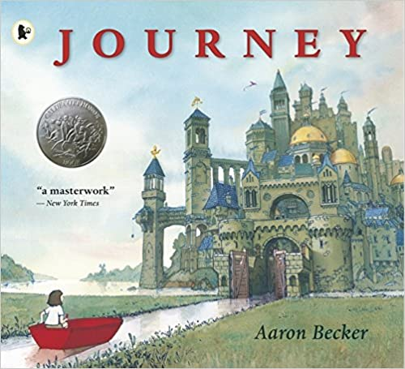

Can you put some of these words into sentences?

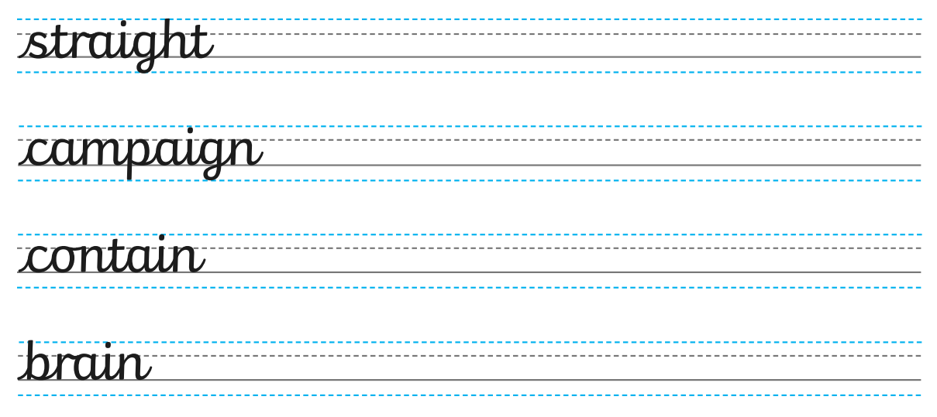
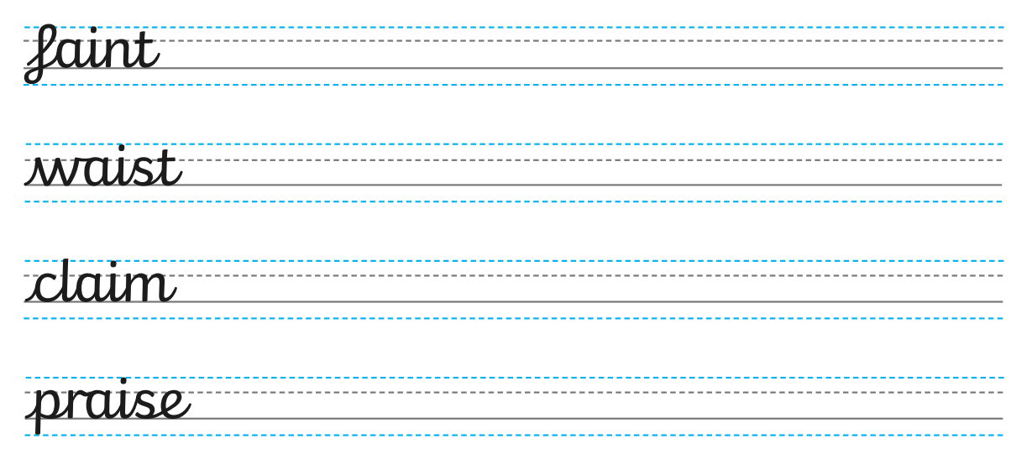

Music Logins 3W
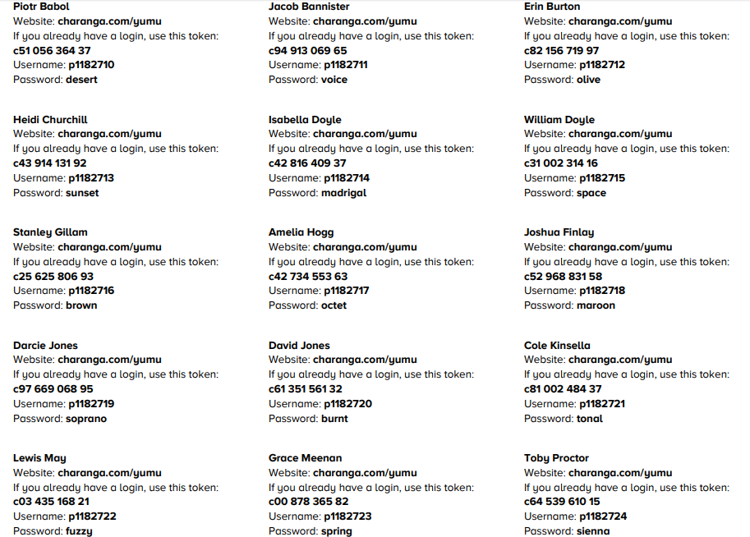

Music Logins 3SW

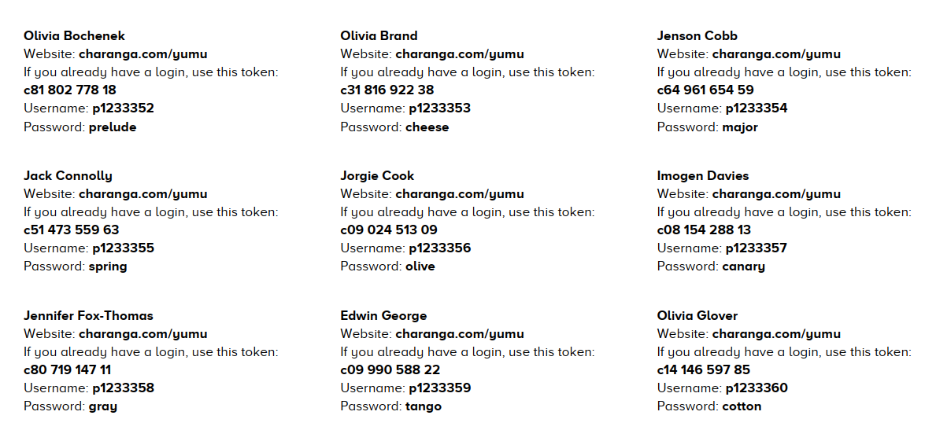
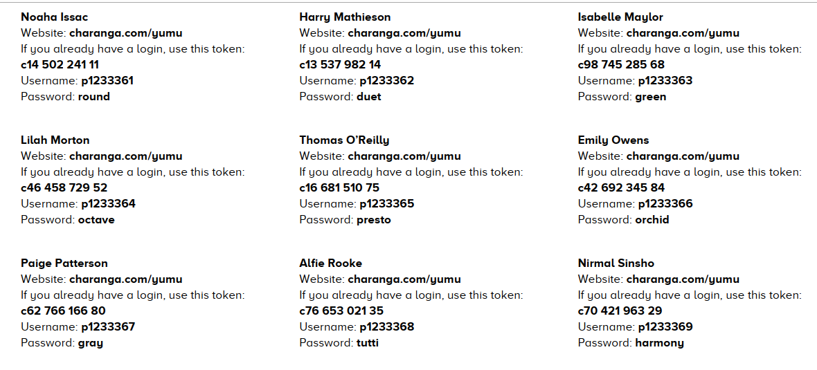
Label the different features of the River Mersey

Source Ox-Bow Lake Estuary Meander Mouth

Ancient Egypt

Only Read after you have finished looking at the picture!!

You can clearly see the boat used to travel along the various canals used for irrigation.
A tawny cat catches birds among the papyrus stems. Cats were family pets.
The marsh is full of lotus flowers and butterflies.
Nebamun is shown hunting birds, in a small boat with his wife Hatshepsut and
their young daughter, in the marshes of the Nile. Such scenes had already been traditional
parts of tomb decoration for hundreds of years and show the dead tomb-owner
"enjoying himself and seeing beauty," as the hieroglyphic Caption here says.

This painting was originally painted on the wall of a tomb built for a rich, important scribe called Nebamun.
Nebamun was in charge of collecting grain for the ancient Egyptian city of Thebes.
Ancient Egyptians believed in life after death and this painting shows one
of the things Nebamun would like to do after he died. He also wanted
people to remember him as he is shown in the painting.

