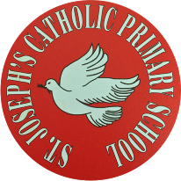
St Joseph’s Catholic Primary School - LEARNING AT HOME PLANNING
YEAR 3
Date WC 8th June 2020
Weekly Mathematics Tasks  (Aim to do 1 per day) | Weekly Reading Tasks  (Aim to do 1 per day)
- Continue to play on Times Table Rockstars! It would lovely to see some more of you joining in with our sessions and battles. Continue to play on the boys v girls battle between Year 3, you have a week left!  Remember we are also looking at the scores and choosing Stars of the week!  - Complete one of the challenges on Numbots- we can’t wait to see how well you do!  - Complete the next pages from the multiplication and division booklet (attached below).  - Now that you have practised making your own pictogram, it is time to try reading other people’s pictograms! Complete the worksheets attached below.  Watch the videos from last week to remind you what a pictogram is!  - Try playing one of these games.  https://www.topmarks.co.uk/Search.aspx?q=pictogram | - Register for free online at www.oxfordowl.co.uk  Here you will find lots of free ebooks and resources to support your child with their reading.  - Choose one of these headlines and tell somebody the story about what might have happened!  - Complete the short reading comprehension attached below “Get Ready with Cleopatra”.  - Think about the last book you read (or your favourite book) and write some true or false questions about it. Test a member of your family using your questions!
Weekly Spelling Tasks  (Aim to do 1 per day) | Weekly Writing Tasks  (Aim to do 1 per day)
break brake  here hear  mane main  male mail  heal heel  - Write some sentences using the words from above. Make sure you spell each of the words correctly! | - Find below your login for SPAG.com. All children have been allocated a task about this week’s grammar to complete.  - Learn about expanded noun phrases on BBC Bitesize and complete ‘Activity 1’. https://www.bbc.co.uk/bitesize/articles/zhfgcqt  - We are looking at the book called ‘The Journey’ by Aaron Becker.  This week there are 2 tasks below for you to complete.  - Complete the handwriting sheet attached below.

Foundation subjects and Learning Project - to be done throughout the week
RE – Being a Christian
- When Jesus was asked what we have to do in order to get to Heaven, he replied that we have to love God and love our neighbour. Jesus went on to tell the story of ‘The Good Samaritan’. https://youtu.be/IWmBQ5ZYub4
- Once you have watched the story of ‘The Good Samaritan’ complete the quiz attached below.

Art- Research the Scottish artist Steven Brown. Who is he and what is he famous for?
Select one of his pieces of artwork and write what you like about it.
Can you recreate this piece of artwork yourself?

Geography- This week it’s a journey task. Look at activity below called Micro journey of an ant!
You are going to imagine you are an ant and follow instructions. It could be in your garden/yard or make your own.

History- Who was Tutankhamun? Look at facts about Tutankhamun. Why was he so famous?
Write a fact file on this famous pharaoh. Use these links to help you.

https://www.britishmuseum.org/ Go on a virtual tour.
https://tutankhamun-london.com/learn-about-tutankhamun-for-kids/

https://www.bbc.co.uk/bitesize/topics/zg87xnb/articles/zvmkhbk

Music- Login to ‘YUMU’ and begin the assignment ‘Reflect, Rewind and Replay – Step 1’

Let’s get physical!
- Continue the ’Physical Skills Challenge’ from last week.
- How are your cricket skills coming along? There are two new cricket skills to practise below.
- This week we want to see how many times you can bounce a ball on a bat. It could be a tennis racquet or a cricket bat. Film your challenge, I will too!

Pray together
This week is the Feast of ‘Corpus Christi’
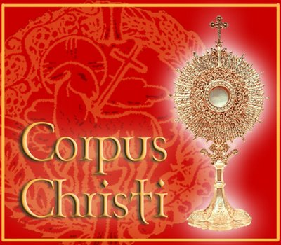
Jesus Body and Blood, We are grateful for the gift of your life and the way it strengthens us to live ours.
Teach us to draw on the gift of your Body and Blood for energy, renewal, strength and grace.
May we never take the gift of your presence for granted.
Amen

Additional learning resources parents may wish to engage with
Pobble 365 – One free resource every day of the year.

Primary school children might enjoy these free resources and videos from Carly Hart. They have been designed to encourage a love of reading and created by the author herself.

Head to History Bombs for free resources- including videos, activities and quizzes.

Teacher Tips
Breathe you’re doing a great job!
- Remember - in a normal school day, there are several ‘break times’ throughout the day, so make sure as well as ensuring they complete their work, you build in ‘relaxation’ time. This is important for both adults and children- lots of short bursts of work are much better than trying to do all work in one go!

- If the children are really engaged and interested in something, see what cross curricular links you can make. If it’s animals and endangered species, could you turn this into a project? E.g. make a poster showing how pollution is affecting the animals, write a letter persuading people to use less plastics, design packaging to replace plastic packaging. Look at all the lovely birds appearing or plants growing.

Multiplication & Division Booklet

SPAG.com 3W
Child’s Name Username Password
Amelia Hogg a-hogg-15 back27
Arlo Robinson a-robinson-147 end45
Blake Rodrigues b-rodrigues-4 play29
Cole Kinsella c-kinsella-1 plant3
Darcie Jones d-jones-181 odd8
David Jones d-jones-182 summer87
Ella Sharp e-sharp-21 spot82
Ellie Thomas e-thomas-114 town50
Erin Burton e-burton-38 play20
Faith O’Gorman f-williams-ogorman-1 sky89
Freya Welsman f-welsman-1 hat52
Grace Meenan g-meenan-1 camp47
Harry Stebles h-stebles-1 desk69
Heidi Churchill h-churchill-5 set3
Isabella Doyle i-doyle-4 set91
Ivy Williams i-williams-80 water85
Jacob Bannister j-bannister-7 jam21
Jacob Roberts j-roberts-146 grass56
James Smart j-smart-8 race70
Joshua Finlay j-finlay-12 house7
Lewis May l-may-32 farm10
Piotr Babol p-babol-1 see31
Simon Sim s-sim-2 tiger26
Sophia Morton s-tomas-morton-1 hall62
Stanley Gillam s-gillam-1 nest1
Toby Proctor t-proctor-3 rabbit8
William Doyle w-doyle-4 cake45
SPAG.com 3SW
Child’s Name Username Password
Alfie Rooke a-rooke-2 mum53
Alfie Smith a-smith-545 poster10
Edwin George e-george-33 bike5
Emily Owens e-owens-11 text93
Ethan Turner e-turner-88 grass9
Harry Mathieson h-mathieson-1 rock87
Harry Wallace h-wallace-6 food52
Imogen Davies i-davies-46 kind29
Isabelle Maylor i-maylor-1 snail3
Jack Connolly j-connolly-14 hall72
James Sullivan j-sullivan-19 sing11
Jennifer Fox-Thomas j-foxthomas-1 fog68
Jenson Cobb j-cobb-9 fact28
Jorgie Cook j-cook-66 arm36
Julia Zborowska j-zborowska-1 road18
Lilah Morton l-morton-23 roof1
Nirmal Sinsho n-sinsho-1 left62
Noaha Issac n-issac-1 key69
Olivia Bochenek o-bochenek-1 key26
Olivia Brand o-brand-1 top49
Olivia Glover o-glover-6 grape82
Paige Patterson p-patterson-2 desk38
Roseanna Wilson r-wilson-90 water66
Thomas O’Reilly t-oreilly-4 top30

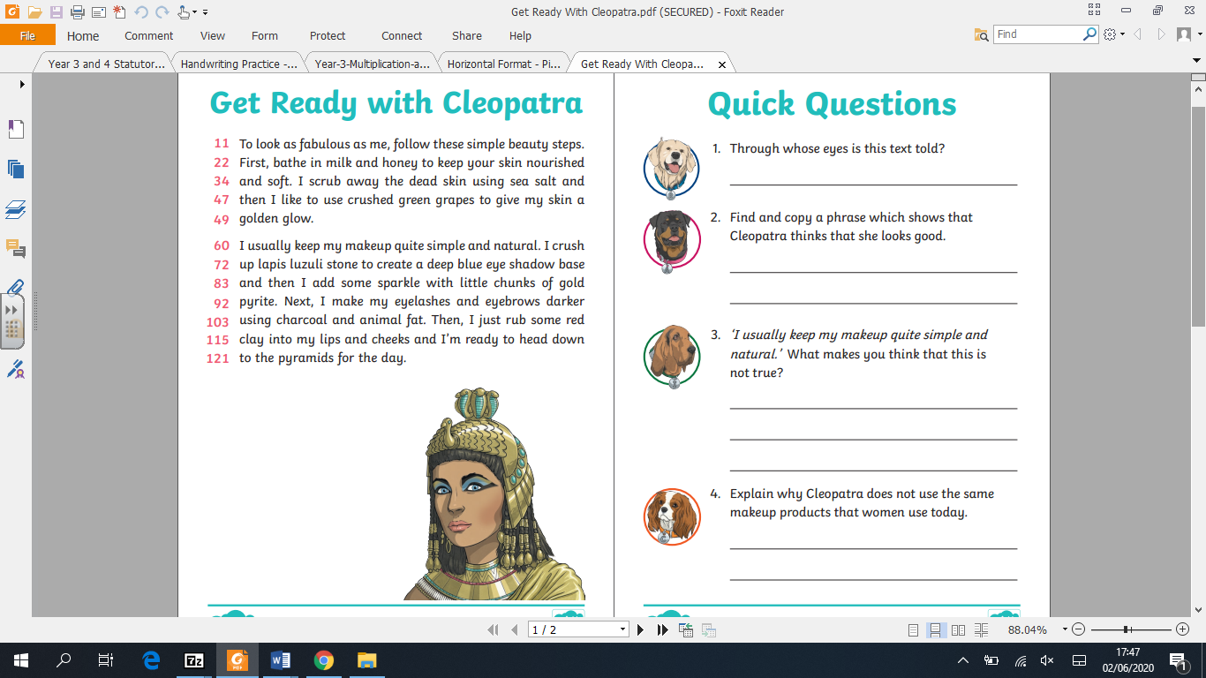

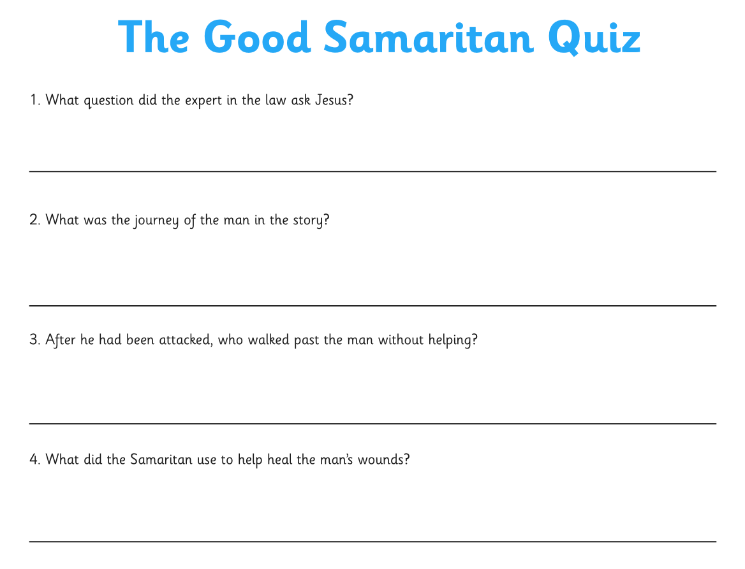
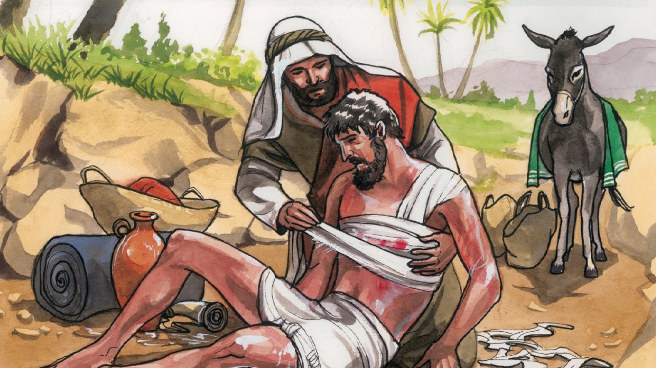
Tutankhamun Fact File

Ca Once you have plotted the route, can you describe it?
Find interesting points on the journey, a piece of clay could feel like mountain for an an ant!
Perhaps take pictures of your route or draw a map.
We would love to see your work, perhaps on Twitter.

C

Physical Skills Challenge

Physical Skills Challenge

