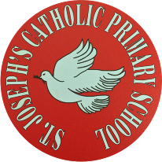
St Joseph’s Catholic Primary School - LEARNING AT HOME PLANNING
YEAR 4
Date: WC 13th July 2020
Weekly Mathematics Tasks  (Aim to do 1 per day) | Weekly Reading Tasks  (Aim to do 1 per day)
Daily 5-A-Day starters:  https://corbettmathsprimary.com/5-a-day/  TIMES TABLES ROCK STARS  Prepare for a class battle in Times Tables Rock Stars this week. Yes, it’s 4C v 4BS. Go to the website and find out more!  https://ttrockstars.com/  - In Maths, we are going to be looking at the revision of key Year 4 topics. Please begin by watching these clips:  - Place value  https://www.bbc.co.uk/bitesize/articles/zhnrcqt  - Rounding numbers:  https://www.bbc.co.uk/bitesize/articles/zjf492p  - Adding 2- or 3-digit numbers  https://www.bbc.co.uk/bitesize/articles/z6vr47h  Subtracting numbers  https://www.bbc.co.uk/bitesize/articles/zrtsy9q  These are web site clips on _{Fractions:}  https://www.youtube.com/playlist?list=PLQqF8sn28L9wBDTntZEccZohH-JPun2eU  This website has a variety of videos on all topics:  https://whiterosemaths.com/homelearning/year-4/  Please complete the attached worksheets below dated 13 7 20 on revising topics in Year 4: | Complete this reading comprehension about the importance of exercise (see below).  Please check out the SPAG.com website.  Just as TTRS is a great and easy to use website for times tables, SPAG.com really helps you to brush up on your vital spelling and grammar skills.  Please attempt the test on fronted adverbials and see how you get on.  Why not give it a go? -you won’t be disappointed!  You all have your own log in. So, try it now!  Here’s the link: https://www.spag.com/  Poetry Competition  Want to take part in a poetry competition?  Check out this link below:  https://www.poetrybyheart.org.uk/learningzone/summer-challenge/  Here are some fun end of term activities that you may like to use:
Weekly Spelling Tasks  (Aim to do 1 per day) | Weekly Writing Tasks  (Aim to do 1 per day)
Practise the following words:  appear certain difficult favourite heard important library medicine perhaps through  Can you write a spelling story including all of these words?  NB: If you normally get given 8 spellings each week, choose 4 of these words and really focus on them over the course of the week.  ______________________________  Proof reading  Read through examples of your own writing from this week and identify any words they think are misspelt. Use a range of strategies to correct the spelling.  ________________________________  Use some of the strategies that you have been taught this year to help you with your spellings this week:  - Look, Say, Cover, Write and Check  - Segmenting – split the word into chunks  - Quick write – see how many times you can write the same word in 1 minute  - Draw an image to match the word – This makes the word memorable.  - Pyramid words – start with the 1st letter, then write the 1st and 2nd underneath, then the 1st, 2nd and 3rd under that and so on. | This half term we have been studying Blue John by Berlie Doherty. This week we would you to consider your thoughts on the book as a whole.  - Go to the web page below and listen again to the whole story.  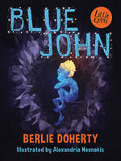https://www.youtube.com/watch?v=WO1JfexygTU  - Imagine you took part in the events. Write a paragraph explaining your feelings at the end of the story. Include details of significant happenings for you and the other characters.  - Next, think about all of your favourite parts of the story. Try and remember the most dramatic scenes. Write a letter to Berlie Doherty explaining what you enjoyed the most about her book. Go into detail about certain parts and back up your views with examples from the text.  - Choose one of the main characters and pick a key scene from the book. Write a diary extract from this character’s point of view, explaining the events from their point of view.  - Now please complete the book review below on Blue John, giving your overall opinion of the story:  Direct Speech  Please view this web page on direct speech:  https://www.bbc.co.uk/bitesize/clips/zvftsbk  Now complete this:

Foundation subjects and Learning Project - to be done throughout the week
- Science – We have been studying Electricity this half term. This week we are asking you to think about all of the things you have learnt about electricity and complete the attached revision sheet. Then have a go at the WWTBA millionaire quiz:
- History – In this half term, we have been studying the ancient hill “Mam tor” in the Peak District. This week we would like you to think about what you would tell a child in year 3 about Mam tor and complete the attached worksheet.
- Geography – This half term the focus is on the physical characteristics of mountains and hills. Last week the focus was on the people who live on mountains. This week we are looking at how tourism affects mountainous regions
This is a useful web site exploring what climbing up a mountain is like:
https://www.youtube.com/watch?v=nmvxxAnP1Yk
Now, using the attached worksheet, write about the effects of tourism in these areas. The power point below will help with giving you some pointers.

- Art Please check out this website for great ideas on doing art at home:
https://www.bbc.co.uk/bitesize/subjects/zn3rkqt
- Music Please access this website for some fun activities on music related topics.
https://www.bbc.co.uk/teach/ks2-music/zfv96v4
- Please log onto this website for fun music activities There are lots of simple to do activities that are a lot of fun. Give it a try. You all have your own log ins so what are you waiting for?! Let us know how you get on. The link: https://charanga.com/yumu
Let’s get physical!
- Exercise is a very important part of all of our lives.
- This is especially true at this time
- Look at the activities on the chart opposite.
- How many of these do you think you could do this week?
- Challenge yourself to complete one a day
- Have a look at this web site for other interesting ideas
https://www.bbc.co.uk/bitesize/subjects/zj6pyrd

Pray Together
The Gospel for the coming Sunday can be found at http://universalis.com/mass.htm Read it together.
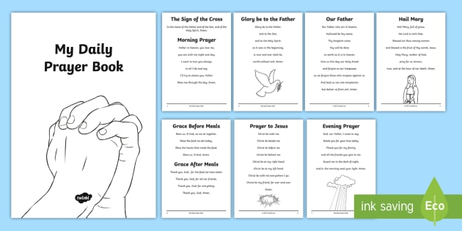

Read and enjoy a copy of the Wednesday Word http://www.wednesdayword.org/stopgap/Temporary-Special-Edition.pdf

Additional learning resources parents may wish to engage with
School Twitter page - this will keep you up to date with challenges set by the teachers and let you see what other pupils have been up to. Follow us @stjosephsbh
Top Marks – This site contains lots of fun English and Maths games. Click on ‘Learning Games’ at the top of the page and select the 7-11 age group tab. www.topmarks.co.uk
Twinkl – to access these resources click on the link and sign up using your own email address and creating your own password. Use the offer code UKTWINKLHELPS.
Classroom Secrets: - Free Learning Packs - These packs are split into different year groups and include activities linked to reading, writing, maths and practical ideas you can do around the home. https://kids.classroomsecrets.co.uk/
Headteacher chat - This is a blog that has links to various learning platforms. Lots of these are free to access https://www.headteacherchat.com/post/corona-virus-free-resources-for-teachers-and-schools
Teacher Tips
Working for short but focussed chunks of time, punctuated by breaks to play or have snack, may suit your child best. Remember that this week is half term so try to enjoy the week.
If the children are really engaged and interested in something, see what cross curricular links you can make. Could it be turned into a project? Please share any work that you are proud of with us on our school Twitter account as we would LOVE to see it.

