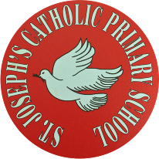
St Joseph’s Catholic Primary School - LEARNING AT HOME PLANNING
YEAR 4
Date: WC 15th June 2020 – Refugee Week
Weekly Mathematics Tasks  (Aim to do 1 per day) | Weekly Reading Tasks  (Aim to do 1 per day)
Daily 5-A-Day starters:  https://corbettmathsprimary.com/5-a-day/  Bronze or silver level: 15th – 19th June  In Maths this week we are studying Geometry. We will look at angles and symmetry.  - Please begin by watching this clip from the BBC bitesize website on angles:  https://www.bbc.co.uk/bitesize/topics/zb6tyrd  Now attempt the 2 attached worksheets on angles.  - Next up is symmetry. Please watch this clip:  https://www.bbc.co.uk/bitesize/topics/zrhp34j  Please complete the 3 attached worksheets dated 15 6 20 on symmetry.  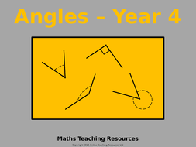  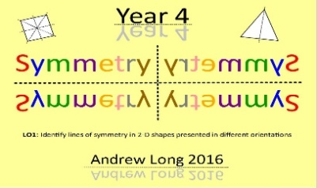 | Continue to read for 20 minutes a day and to keep up with your usual reading activities as set previously. Create a Vocabulary Bookmark. On one side write words that impress you. On the other side, write words that puzzle you and find out the meaning of them. Please share any exciting vocabulary that you come across on our school Twitter page.  Complete this reading comprehension about Mount Everest. Do you know anyone who has climbed Mount Everest? We don’t!  Refugee Week is an annual festival celebrating the contributions, creativity and resilience of refugees. Refugee Week 2020 takes place 15-21 June, and has the theme ‘Imagine’.  Please listen to this interactive read aloud story Wisp. A Story of Hope by Zana Fraillon. Pause and answer any questions that you are asked to.  Write a summary of the events that Idris experiences in the story by creating a timeline of events. You could add Idris’ thoughts and feelings at each stage.  If you are in need of some new reading material, ask a parent to download Epic! They have lots of fabulous books and are offering a FREE 30 day trial. There are some great titles on there!  We love the information book about Martin Luther King. There are also a lot of Goosebumps books...read them if you dare! Mrs Burley really likes the Fragglerock book, it takes her back to when she was your age...a LONG time ago!
Weekly Spelling Tasks  (Aim to do 1 per day) | Weekly Writing Tasks  (Aim to do 1 per day)
Practise the following words:  separate special straight strange suppose surprise therefore though thought through  Can you write a spelling story including all of these words?  NB: If you normally get given 8 spellings each week, choose 4 of these words and really focus on them over the course of the week.  ______________________________  Further practice can be found at https://spellingframe.co.uk/spelling-rule/72/34-Word-list-years-3-and-4---sep--to-su- and also try the activities at https://spellingframe.co.uk/spelling-rule/73/35-Word-list-years-3-and-4---t-to-w  _____________________________  Proofreading  Read through examples of your own writing from this week and identify any words they think are misspelt. Use a range of strategies to correct the spelling.  ________________________________  Use some of the strategies that you have been taught this year to help you with your spellings this week:  - Look, Say, Cover, Write and Check  - Segmenting – split the word into chunks  - Quickwrite – see how many times you can write the same word in 1 minute  - Draw an image to match the word – This makes the word memorable.  - Pyramid words – start with the 1st letter, then write the 1st and 2nd underneath, then the 1st, 2nd and 3rd under that and so on. | Using this website, investigate and make a list of word endings with the scientific endings ‘-ite’ (Greek origin meaning rock or stone) and ‘-ine’ (meaning made/of the nature of).  _______________________  Look at the powerful and effective verbs written in bold. Can you think of any other powerful verbs to describe how Blue John moved?  His feet slithered away from him and he toppled head over heels into a pool. He picked  himself up and began again, skidding and sprawling, crawling and tumbling, and his  footsteps chimed like bells  _________________________  Choose a word from the table below and create a vocabulary graphic organiser for it:  ______________  Watch the short, animated video ‘A Cloudy Lesson’ imagining how clouds are made. Explanation texts answer the question ‘How’ or ‘Why’ and often have this in the title. A suitable title for the film would be ‘How Clouds are Made’. Use the video to retell the explanation of how clouds are made orally.  _______________________  Explanations sometimes show the steps involved using a diagram or flowchart such as  the one below. Model the process of how clouds are made in note form.  Using this resource to help you, write your own 3 paragraph explanation of the  process of creating rain.  If you want to, you could choose a different process and write an explanation and illustrate with a flowchart or labelled diagram, for instance, how lightning or hail are made.

Foundation subjects and Learning Project - to be done throughout the week
- Science – Electricity is our topic this half term. This week we are focusing on circuits, batteries and power sources. Watch these clips from the BBC bitesize website.
https://www.bbc.co.uk/bitesize/clips/z2tmhyc
Now complete the attached worksheet on electrical circuits.
- History – We are studying the ancient hill “Mam tor” in the Peak District. This week we want you to think about what life may have been like in a hillfort. Use the website below to find out what life may have been like at this hill fort. Then complete the attached History Sheet.
https://www.bbc.co.uk/bitesize/topics/z82hsbk/articles/z8bkwmn#:~:text=By%20the%20end%20of%20the,their%20people%20from%20enemy%20attacks.&text=Iron%20Age%20farmers%20grew%20crops,cows%20and%20flocks%20of%20sheep.
- Geography – This half term the focus is on UK geographical regions and the physical characteristics of mountains and hills. This week the focus is on gradients. Please read the attached geography sheet 1 and use it to complete Sheet 2.
- Music- Blue John is a children’s folk tale written by Berlie Doherty to accompany a piece of music entitled ‘From My Life’ by the 19th century Czech composer, Smetana. Berlie was inspired by the Blue John Caverns near her home in Derbyshire. Listen to this music and try to imagine you are in Blue John’s cave. https://youtu.be/ZWW0dXCpTuA
- Please log onto this website for fun music activities https://charanga.com/yumu

Let’s get physical!
It’s very important to keep our bodies healthy.  There are many videos online to help us do this.  You could make a chart to record your daily exercise! We should all aim to do about 30 minutes a day to stay healthy.  Each week you could challenge yourself to try and do slightly more than the week before!  Can you do this every day for a week? Once at 9am? Once at 12pm? Once at 3pm?  - 10 Star Jumps  - 10 squats  - 10 Frog jumps  - 10 second plank  - 1 minute - running on the spot | 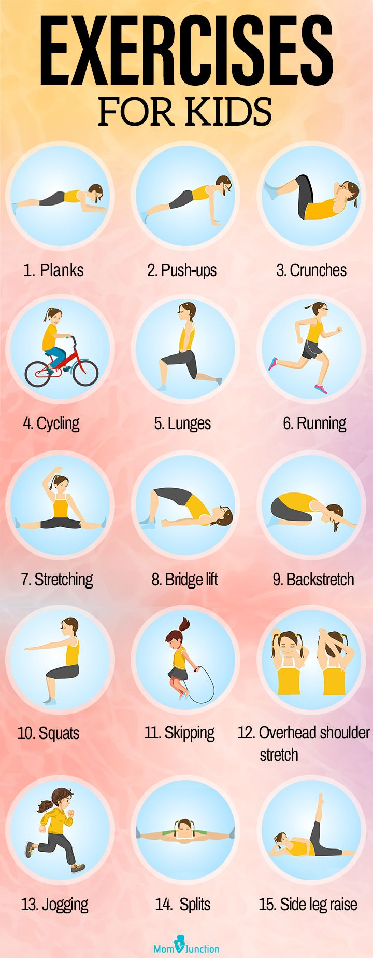

Pray Together
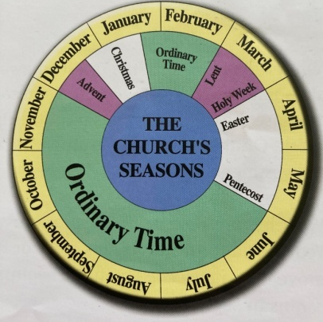
In the Church’s year there are 5 seasons: Advent, Christmas, Lent, Easter and Ordinary Time. Each season has its own colour.

Which season do you think is the most important in the
Church’s year and why?

The 5 seasons of the Church are jumbled up. Put them in
the correct order starting at the beginning of the
Liturgical Year and match them with the correct sentence.

Lent | A time to celebrate the birth of Jesus.
Christmas | A time to celebrate the presence of Jesus in our ordinary lives.
Ordinary Time | A time to celebrate that Jesus rose from the dead.
Advent | A time to prepare for Christmas.
Easter | A time to prepare for Easter.

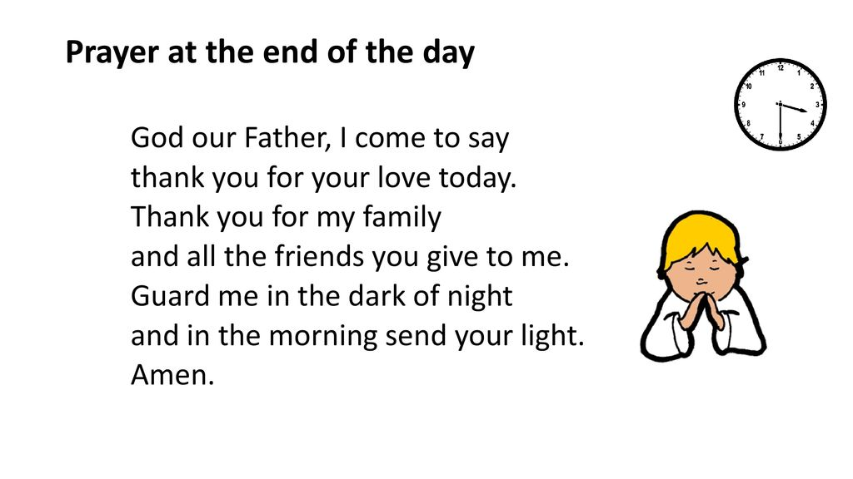

Additional learning resources parents may wish to engage with
School Twitter page - this will keep you up to date with challenges set by the teachers and let you see what other pupils have been up to. Follow us @stjosephsbh
Top Marks – This site contains lots of fun English and Maths games. Click on ‘Learning Games’ at the top of the page and select the 7-11 age group tab. www.topmarks.co.uk
Twinkl – to access these resources click on the link and sign up using your own email address and creating your own password. Use the offer code UKTWINKLHELPS.
Classroom Secrets:- Free Learning Packs - These packs are split into different year groups and include activities linked to reading, writing, maths and practical ideas you can do around the home. https://kids.classroomsecrets.co.uk/
Headteacherchat - This is a blog that has links to various learning platforms. Lots of these are free to access https://www.headteacherchat.com/post/corona-virus-free-resources-for-teachers-and-schools
Teacher Tips
Working for short but focussed chunks of time, punctuated by breaks to play or have snack, may suit your child best. Remember that this week is half term so try to enjoy the week.
If the children are really engaged and interested in something, see what cross curricular links you can make. Could it be turned into a project? Please share any work that you are proud of with us on our school Twitter account as we would LOVE to see it.

