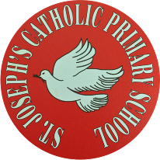
St Joseph’s Catholic Primary School - LEARNING AT HOME PLANNING
YEAR 4
Date: WC 29th June 2020 - ART WEEK
Weekly Mathematics Tasks  (Aim to do 1 per day) | Weekly Reading Tasks  (Aim to do 1 per day)
Daily 5-A-Day starters:  https://corbettmathsprimary.com/5-a-day/  TIMES TABLES ROCK STARS  Prepare for a class battle in Times Tables Rock Stars this week. Yes, it’s 4C v 4BS. Go to the website and find out more!  https://ttrockstars.com/  In Maths this week we are studying position and direction in Geometry. First, we will look at describing movements between positions as translations of a given unit to the left/right and up/down.  Please begin by watching this clip from the BBC bitesize website:  https://www.bbc.co.uk/bitesize/topics/z2dqrwx/articles/zcjs97h and then this clip:  https://home.oxfordowl.co.uk/maths/primary-geometry-shapes/geometry-shapes-year-4-age-8-9/  Please complete the attached worksheets below dated 29 6 20 on Translation.  Next, we will look at how to plot specified points and draw sides to complete a given polygon. Please view these clips on this:  https://www.bbc.co.uk/bitesize/topics/zgthvcw/articles/z96k9qt and then this:  https://www.youtube.com/watch?v=6eX4PZJjofI  Now attempt the attached worksheets on plotting points.  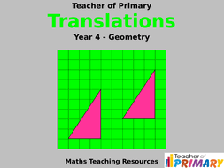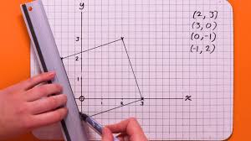 | Complete this reading comprehension about The Three Peaks Challenge (see below). Have you ever climbed one of these mountains?  Read Chapter 4 of Blue John and answer the VIPERS questions (see below).  Please check out the SPAG.com website.  Just as TTRS is a great and easy to use website for times tables, SPAG.com really helps you to brush up on your vital spelling and grammar skills.  Please attempt the test on fronted adverbials and see how you get on.  Why not give it a go? -you won’t be disappointed!  You all have your own log in. So, try it now!  Here’s the link: https://www.spag.com/
Weekly Spelling Tasks  (Aim to do 1 per day) | Weekly Writing Tasks  (Aim to do 1 per day)
Practise the following words:  sadly completely usually finally comically nobly publicly angrily truly wholly  Can you write a spelling story including all of these words?  NB: If you normally get given 8 spellings each week, choose 4 of these words and really focus on them over the course of the week.  ______________________________  This is the 2nd week of learning about the –ly suffix. Now try this quick quiz to see how you’re getting on. Good luck! https://spellingframe.co.uk/spelling-rule/13/8-The-suffix-ly  _____________________________  Proofreading  Read through examples of your own writing from this week and identify any words they think are misspelt. Use a range of strategies to correct the spelling.  ________________________________  Use some of the strategies that you have been taught this year to help you with your spellings this week:  - Look, Say, Cover, Write and Check  - Segmenting – split the word into chunks  - Quick write – see how many times you can write the same word in 1 minute  - Draw an image to match the word – This makes the word memorable.  - Pyramid words – start with the 1st letter, then write the 1st and 2nd underneath, then the 1st, 2nd and 3rd under that and so on. | Now read Chapter 4 – Dance.  - Re-read p.37-38 and focus on the words ‘…the cave was full of pale white moons and glittering stars…’ Think about how the use of light against the darkness is described. Was the cavern really filled with stars?  - Listen to an extract from Smetana’s music (see clip embedded on the page in the link below: the section from 3 min 30 to 4 min 50 characterises this part of the story). https://www.barringtonstoke.co.uk/blog/2017/02/27/getting-to-know-blue-john/  - Write sentences describing what might be happening in the story based on the music. Then read to the end of p.44 and discuss how the dancing sequence fits with their ideas.  - Look at the illustration below and try to imagine you are one of the children dancing with Blue John.  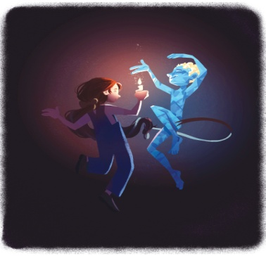  - Write a paragraph describing your experience. Describe the cave and then start a new paragraph to introduce Blue John dancing.  - Once inside the cave, the children were fascinated to see the colour and textures, stalactites and stalagmites and perhaps even fossils. Look at this BBC link, describing how fossils are made: https://www.bbc.com/bitesize/articles/z2ym2p3  - Complete the questions based on ‘How are Stalactites and Stalagmites Formed?’ in the resources below.  - Homophones – are words that sound the same but are spelled differently. Play an interactive game to reinforce the concept and correct  misunderstandings, such as the one in the link below.  http://www.bbc.co.uk/skillswise/game/en21watc-game-paris-word

Foundation subjects and Learning Project - to be done throughout the week
Science – Electricity is our topic this half term. This week we are looking at how to recognise when a switch opens and closes a circuit and associate this with whether
or not a lamp lights in a simple series circuit.
- Copy and paste this link to these clips from the BBC bitesize website.
- https://www.bbc.co.uk/bitesize/topics/zj44jxs
and this clip: https://www.youtube.com/watch?v=HOFp8bHTN30
Now complete the attached worksheet on circuits.
- History – We are studying the ancient hill “Mam tor” in the Peak District. Last week we asked you to think about what life may have been like in a hillfort. This week we want you to read worksheet RS2 (a series of statements) and worksheet RS3 (images of finds). Find the image that supports each statement and record a brief summary of the evidence. Use the website below to find out what life may have been like at this hill fort.

https://www.bbc.co.uk/bitesize/topics/z82hsbk/articles/z8bkwmn#:~:text=By%20the%20end%20of%20the,their%20people%20from%20enemy%20attacks.&text=Iron%20Age%20farmers%20grew%20crops,cows%20and%20flocks%20of%20sheep.
- Geography – This half term the focus is on UK geographical regions and the physical characteristics of mountains and hills. Last week the focus was on how different types of mountains are formed. This week we are looking at the key features of a mountain range. Please read the power point entitled Features of mountains:
This is a useful clip showing Mount Roraima in Guyana - a mountain with sheer sides https://www.youtube.com/watch?v=aGv_MitUe7A
Now complete Geography Year 4 worksheet 29 6 20.
- Art Please check out this website for great ideas on doing art at home:
https://www.bbc.co.uk/bitesize/subjects/zn3rkqt
- Music Please access this website for some fun activities on music related topics.
https://www.bbc.co.uk/teach/ks2-music/zfv96v4
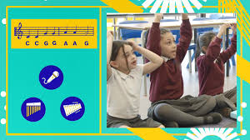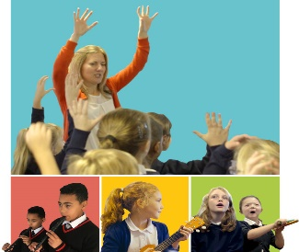
- Please log onto this website for fun music activities There are lots of simple to do activities that are a lot of fun. Give it a try. You all have your own log ins so what are you waiting for?! Let us know how you get on.
Here’s the link: https://charanga.com/yumu

Let’s get physical!
It’s very important to keep our bodies healthy.
There are many videos online to help us do this.
You could make a chart to record your daily exercise! We should all aim to do about 30 minutes a day to stay healthy.
Each week you could challenge yourself to try and do slightly more than the week before!
Can you do this every day for a week? Once at 9am? Once at 12pm? Once at 3pm?
- 10 Star Jumps
- 10 squats
- 10 Frog jumps
- 10 second plank
- 1 minute - running on the spot

Pray Together
St. Peter and St. Paul
On 29th June the Church celebrates the feast day of two great saints, Saint Peter and Saint Paul. Peter and Paul were both friends of Jesus, but their lives were very different.

St Peter and St Paul
Peter and Paul both died as martyrs in Rome, around 63 AD: Peter by crucifixion and Paul, as a Roman citizen, by beheading with a sword. You can read about them in the Bible: in the four Gospels and in the Acts of the Apostles. In the New Testament, you can also read letters (Epistles) that Paul wrote to people in the churches he had founded, in places such as Rome, Corinth, Galatia, Ephesus and Philippi.
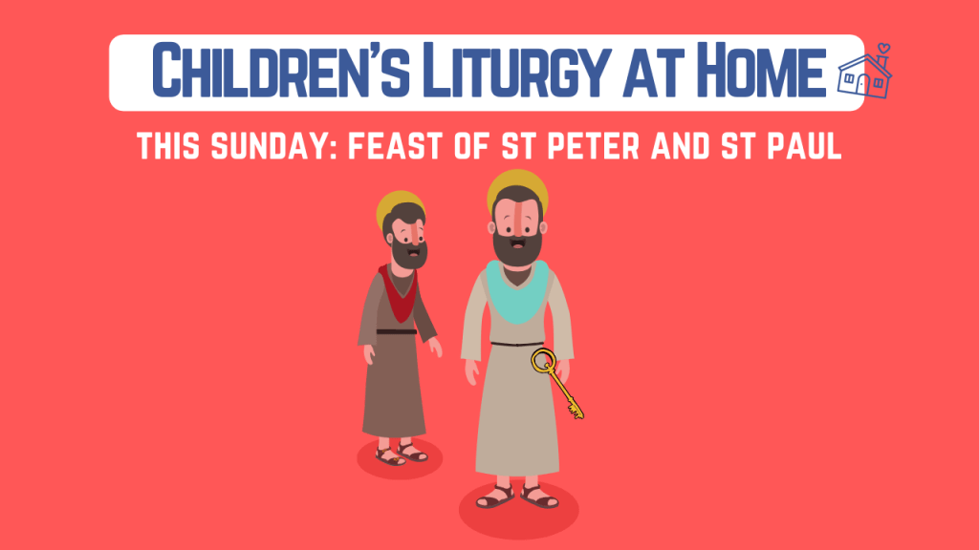

Please complete this worksheet on St. Peter and St. Paul.

Additional learning resources parents may wish to engage with
School Twitter page - this will keep you up to date with challenges set by the teachers and let you see what other pupils have been up to. Follow us @stjosephsbh
Top Marks – This site contains lots of fun English and Maths games. Click on ‘Learning Games’ at the top of the page and select the 7-11 age group tab. www.topmarks.co.uk
Twinkl – to access these resources click on the link and sign up using your own email address and creating your own password. Use the offer code UKTWINKLHELPS.
Classroom Secrets: - Free Learning Packs - These packs are split into different year groups and include activities linked to reading, writing, maths and practical ideas you can do around the home. https://kids.classroomsecrets.co.uk/
Headteacher chat - This is a blog that has links to various learning platforms. Lots of these are free to access https://www.headteacherchat.com/post/corona-virus-free-resources-for-teachers-and-schools
Teacher Tips
Working for short but focussed chunks of time, punctuated by breaks to play or have snack, may suit your child best. Remember that this week is half term so try to enjoy the week.
If the children are really engaged and interested in something, see what cross curricular links you can make. Could it be turned into a project? Please share any work that you are proud of with us on our school Twitter account as we would LOVE to see it.

Blue John: Chapter 4 – Dance
Blue John lay as still as the stones. He had never seen children before. He watched the wonder in their eyes. He saw how their faces opened with awe as his mother, the Queen of Darkness, swirled silently around them.
One of the children struck a match. Its blue flame danced like a moth. Then the boy lit a candle and held it up so his face glowed like a moon and his eyes shimmered like stars. He passed the candle round and the other children lit theirs and held them up, and the cave was full of pale white moons and glittering stars. The lights of the candles flickered and gleamed on the wet walls.
(p37-39)
A little girl with ribbons as green as trails of moss held out her candle towards Blue John’s ledge.
There he was, lit up in the darkness, with his amethyst eyes purple and blue like the deepest glacier, and his amber hair as golden as the sun.
“Beautiful,” the little girl whispered. “You’re beautiful.”
“You’re beautiful,” Blue John whispered back. “Beautiful.”
The girl stepped into the middle of the chamber and began to move around, slowly, slowly. She held out her candle to light up the pockets and eyes and creases of the chamber, the satiny water on its walls, the shimmer and glisten, the blue and the gold. She began to dance.
(p40 – 41)
And soon all the children were dancing in a crazy, laughing, happy way. Their shadows leaped around them.
Blue John tumbled down from his shelf and began to dance among them. He couldn’t help himself. He flung out his arms and legs and he tossed back his head and his eyes were wide with happiness.
“Stop!” the Queen of Darkness screamed. “You’re spoiling my silence. Stop dancing! Go away!”
She streamed around the children like the wind of night, and her cold breath chilled them and made their dance faster and wilder. She blew the candle flames so they flickered and flattened like birds.
(p42 – 45)
“Go away!”
And the children ran, dancing and laughing. They tumbled out of the Queen’s chamber and up along the echoing passages, dancing and laughing, singing and skipping, out into the brilliant light of day.
And then they were gone.
As fast as they had come, the children disappeared, and their voices and laughter and the sunshine of the outside world had gone with them.
(p46 -47)
V | Find a word that means the same as cold. Can you think of any others? (p42-45)
I | How does Blue John feel when the children begin to dance? Remember to go APE – Answer, Prove and Explain. (p42-45)
P | Do you think the children will go back into the cave? Why?
E | Explain what the author means when he writes, “and the sunshine from the outside world had gone with them.”
R | What colour were the girl’s ribbons?
S | Summarise what happens in this chapter in no more than 30 words.

Word R E S C U E
The word I have chosen is: _________________
Read the word
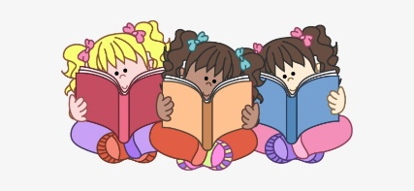
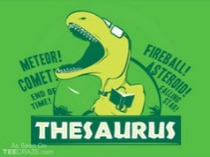
Explore it

Spell it
(use spelling strategies – sound buttons, pictures etc)
Check it
(write it 3 times from memory)
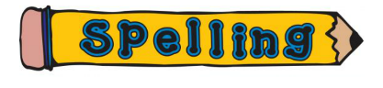
Understand it
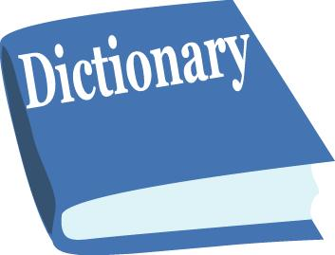
Explain it
(explain it in context)

