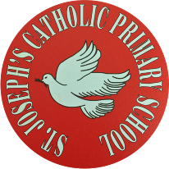
St Joseph’s Catholic Primary School - LEARNING AT HOME PLANNING
YEAR 4
Date: WC 8th June 2020
Weekly Mathematics Tasks  (Aim to do 1 per day) | Weekly Reading Tasks  (Aim to do 1 per day)
Daily 5-A-Day starters:  https://corbettmathsprimary.com/5-a-day/  Bronze or silver level: 8th – 12th June  - Continue your daily work on Times Tables Rock stars- we would like to see more of you logging in! We have set up a Battle between Year 4 girls and Year 4 boys. Who will be victorious?  Miss Ward has also set up a Rock Slam for 4BW- so far only 1 challenger has beaten her score!  - Ensure you are completing your daily 4 calculations in your orange book. Want to challenge yourself? Ask for some adding decimals this week.  Our focus in Maths this week is on classifying 2-D shapes, based on their properties and sizes.  Please click on the link and watch the clips on polygons,triangles circles and perimeter.  Then complete the exercises which accompany the videos.  https://www.bbc.co.uk/bitesize/topics/zvmxsbk | Continue to read for 20 minutes a day and to keep up with your usual reading activities as set previously. Remember to discuss what you are reading, using the key questions provided.  Complete this reading comprehension about Making a Mountain:  Read Chapter 2 of Blue John and answer the VIPERS questions.  Visit Oxford Owl for free eBooks. Parents can create a free account. Choose a book in the 9-11+ age range. There are lots of books to choose from, including Project X Adventures and many great non-fiction texts, to help you explore the world from your home! Choose a reading comprehension to complete.  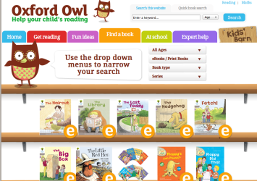  Monday 8th June is World Oceans Day. Read the attached article about how plastic pollution in our oceans is affecting turtles.
Weekly Spelling Tasks  (Aim to do 1 per day) | Weekly Writing Tasks  (Aim to do 1 per day)
Practise the following words:  unbelievable unnatural disloyal discourteous inevitable incorrect recover rebuild submarine submerge  Can you find words within these words to help you?  Can you rainbow write these words?  Can you write a spelling story including all of these words?  NB: If you normally get given 8 spellings each week, choose 4 of these words and really focus on them over the course of the week.  ______________________________  Further practice can be found at https://spellingframe.co.uk/ Choose the Y3/4 section and select prefixes.  _____________________________  Proofreading  Read through examples of their own writing and identify any words they think are misspelt.  Use a range of strategies to correct the spelling.  Particularly focus on words with ‘-ous’ endings, if possible.  ________________________________  Complete the spelling tasks on the sheet below:  Prefixes ‘un-’, ‘dis-’, ‘in-’, ‘re-’, ‘sub-’, ‘inter-’, ‘super-’, ‘anti-’, ‘auto-’. | What kinds of stories are set in caves? Do you know any? Are there any common themes among the stories you know?  _______________________  This half term, you are going to be working on a story that is set in a cave, learning about caves and how to write an explanation.  With an adult, discuss what you think the story might be about by looking closely at the cover and the opening line ‘Deep, deep in the shadow of the mountain…’. Once you have made your prediction, read Chapter 1- Ice on the link below.  https://issuu.com/barringtonstoke/docs/blue_john_chapter_samples  _________________________  Listen to this piece of music ‘In the Hall of the Mountain King’ by Grieg:  https://www.bbc.co.uk/programmes/p02fltbj  Peer Gynt is the son of a wealthy family. When his father dies, he inherits a great fortune but quickly spends it all and finds himself penniless.  He chooses to wander the world as a poet. Every time something happens to him, he writes home to his mother, but often his adventures seem too fantastical to be true!  Write a letter from Peer Gynt to his mother describing his adventure in the cave.  ____________________________  Read Chapter 2 Fire.  Look at the images of stalactites on the National Geographic website below:  https://www.nationalgeographic.com/science/earth/surface-of-the-earth/caves/  ‘Stalactites grew like...’ This is the start of a simile. What did the stalactites grow like? Write your own sentences, e.g. stalactites grew like horns of unicorns.  Write a description showing what Blue John might hear and see in the cave, as well as how he might feel, what he thinks and what he might do next.  _______________________________  Complete the vocabulary activity sheet.

Foundation subjects and Learning Project - to be done throughout the week
- Science – We are looking at electricity during this half term. Using the attached Mains or Battery? Activity Sheet, can you sort the appliances based on the type of electricity they use.
- History – We are studying the ancient hill “Mam tor” in the Peak District. Please look at the attached History sheet (RS1) showing the key features of a hill fort. Match the features of a hill fort to the image on history sheet RS2.
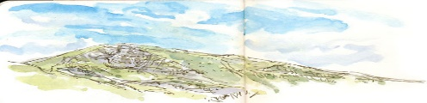
- Geography – This half term the focus is on UK geographical regions and the physical characteristics of mountains and hills. This week the focus is the heights of some of the tallest mountains in the UK. Can you put the data into a bar graph and then answer the questions on worksheet 4B?
- Music- Blue John is a children’s folk tale written by Berlie Doherty to accompany a piece of music entitled ‘From My Life’ by the 19th century Czech composer, Smetana. Berlie was inspired by the Blue John Caverns near her home in Derbyshire. Listen to this music and try to imagine you are in Blue John’s cave. https://youtu.be/ZWW0dXCpTuA
- Please log onto this website for fun music activities https://charanga.com/yumu

Let’s get physical!
- Start each day by following Joe Wicks/ Just Dance on You Tube
How many burpees can you do in 1 minute?
Can you beat your score each day?
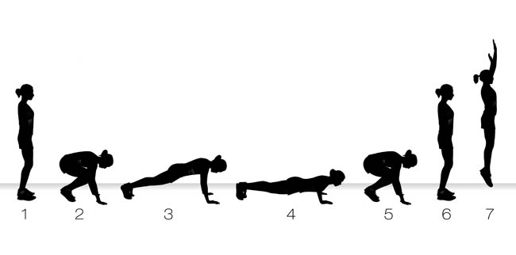

You could also try these activities on You Tube
Go noodle – fun dances to try https://www.gonoodle.com/ Cosmic yoga for kids
- try the strictly dance challenge
https://www.bbc.co.uk/programmes/p089h234
and Oti Mabuse from strictly
https://www.youtube.com/channel/UC58aowNEXHHnflR_5YTtP4g
Pray Together
The Gospel for the coming Sunday can be found at http://universalis.com/mass.htm
Please continue to keep the Pope in your prayers.
JUNE’S PRAYER INTENTION
This month, during which the Solemnity of the Sacred Heart occurs, the Pope asks that “We pray that all those who suffer may find their way in life, allowing themselves to be touched by the Heart of Jesus”.
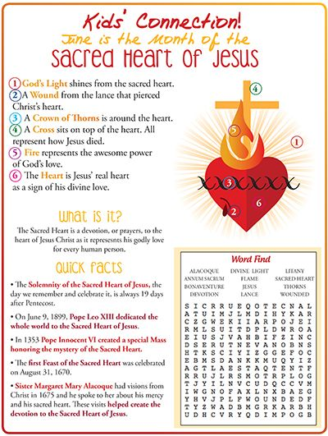
Our topic this term is all about The Church. What do you know about your parish? Take a look at their website.
Design a newsletter to let people know about your parish. Include the name of your parish priest, what he does and what happens at the parish, e.g. Mums and Tots, Youth Groups etc
The Church is ‘good news’ for people. It is like a journey with a starting point and an end. At every stage in our Christian journey of life there is a special celebration to give us help and support. These are called sacraments. A sacrament is a meeting between Jesus and the person who is receiving the sacrament.
Research one of the seven sacraments (Baptism, reconciliation, Eucharist, Confirmation, Marriage, Holy Orders, Anointing of the Sick)and design an information poster.
Additional learning resources parents may wish to engage with
School Twitter page - this will keep you up to date with challenges set by the teachers and let you see what other pupils have been up to. Follow us @stjosephsbh
Top Marks – This site contains lots of fun English and Maths games. Click on ‘Learning Games’ at the top of the page and select the 7-11 age group tab. www.topmarks.co.uk
Twinkl – to access these resources click on the link and sign up using your own email address and creating your own password. Use the offer code UKTWINKLHELPS.
Classroom Secrets:- Free Learning Packs - These packs are split into different year groups and include activities linked to reading, writing, maths and practical ideas you can do around the home. https://kids.classroomsecrets.co.uk/
Headteacherchat - This is a blog that has links to various learning platforms. Lots of these are free to access https://www.headteacherchat.com/post/corona-virus-free-resources-for-teachers-and-schools
Teacher Tips
Working for short but focussed chunks of time, punctuated by breaks to play or have snack, may suit your child best. Remember that this week is half term so try to enjoy the week.
If the children are really engaged and interested in something, see what cross curricular links you can make. Could it be turned into a project? Please share any work that you are proud of with us on our school Twitter account as we would LOVE to see it.

