

**RE Newsletter – Summer 1**

Dear Parents,

The Church is celebrating the great feast of Easter – Jesus risen from the dead. This celebration goes on until the solemnity of Pentecost (Sunday 5th June), the birthday of the Church. At Pentecost, we celebrate the outpouring of the Holy Spirit who empowers and enables us to follow in the footsteps of Jesus. During this term, the Church dedicates the month of May to Mary, Jesus’ mother.

We hope you find this newsletter of interest and as always, please keep us in your prayers as we continue to support your child in their religious education.

**Year 5 - Life in the Risen Jesus**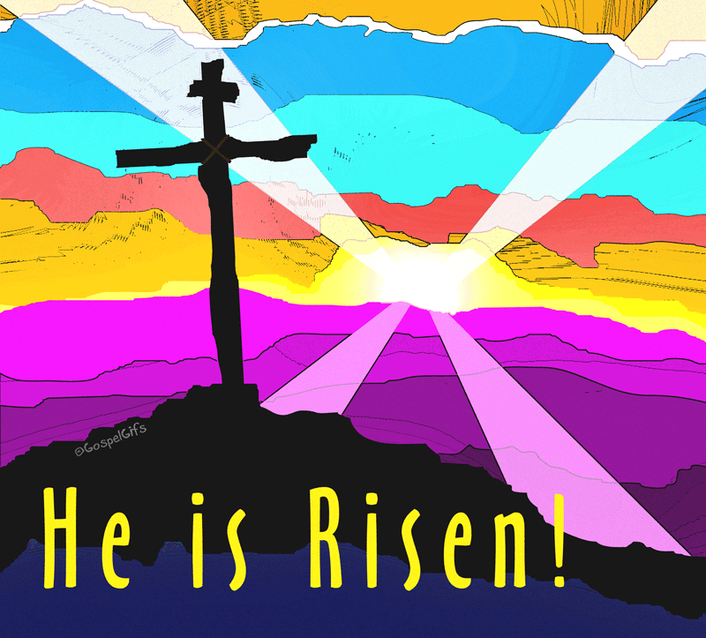

Year 5 will learn the story of the appearance of Jesus to Mary of

Magdala and learn that the risen Jesus is present among us in

different ways. They will learn about Jesus’ teaching on, and

example of, prayer and have a better understanding of the Lord’s

Prayer. They will learn that we can pray in different ways.

**At home**

You could help your child by:

• reading and discussing the story of Mary of Magdala

• talking with them about prayer

• making time for prayer together

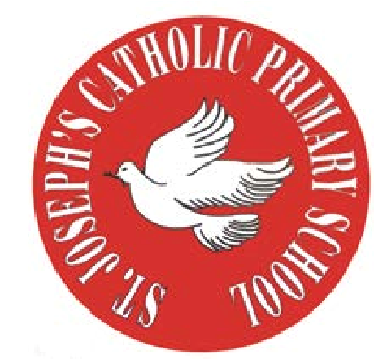

**St Joseph’s Catholic Primary School**

Woodchurch Road, Birkenhead CH43 5U

Headteacher.

**Mr A. Turner**

**RE Newsletter – Summer 2**

Dear Parents,

We welcome you and your children back to school after the half term. We begin in the month of June, which is dedicated to the Sacred Heart of Jesus. The devotion to the Sacred Heart of Jesus reminds us of the never ending and merciful love that Jesus has for us.

We hope, as always, you find this newsletter interesting and informative. Please keep us in your prayers as we support your children in their Religious Education.

Below you will find what your child is learning about in RE this half term.



**Year 5 - Other Faiths**

Year 5 will learn what the Church teaches about other faiths. They will learn about some important Jewish beliefs and celebrations such as ‘Rosh Hashanah’ and ‘Yom Kippur’.

They will learn about some significant Muslim beliefs and have a better understanding of some important practices of Muslims.

**At home**

You could help your child by:

* talking about what happens at ‘Shabbat’.
* researching what beliefs we share with Muslims
* writing or saying a prayer together to promote friendship with people of other faiths