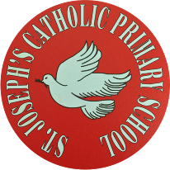
St Joseph’s Catholic Primary School - LEARNING AT HOME PLANNING
YEAR 5
Date – WC 29th June 2020
Weekly Mathematics Tasks  (Aim to do 1 per day) | Weekly Reading Tasks  (Aim to do 1 per day)
- Continue to play on Times Table Rockstars – your child will have an individual login. A new tournament starts this week between 5W and 5F. Can you help your classmates to win the battle?  - This week’s maths is all about perimeter. Watch this video on Corbett Maths to find out how to calculate the perimeter of different 2D shapes: Perimeter Video  - Now practise calculating the perimeter:  - Try these maths challenges from BBC Bitesize:  Year 5 Maths Challenge questions  Complete these arithmetic questions using a mental method or a written method. You will need paper to write your answers on and do any working out. | - Encourage your child to read for at least 20 minutes independently. Ask them to summarise what they have read and make predictions as to what might happen next. They could do this orally or write a short summary.  - Complete the attached reading comprehension on the Himilayas:  - Please have a look at this website which provides lots of useful reading activities to do at home:  https://home.oxfordowl.co.uk/reading/
Weekly Spelling Tasks  (Aim to do 1 per day) | Weekly Writing Tasks  (Aim to do 1 per day)
Homophones  Remember a homophone is a word that sounds the same but has a different meaning and spelling.  led steal herd allowed alter affect lead steel heard aloud altar effect  Try writing them in a sentence making sure the meaning is correct.  Can you find any more homophones?  Here is a useful clip to watch on homophones  https://www.bbc.co.uk/bitesize/topics/zqhpk2p/articles/zc84cwx | - Read Pleasant Sounds by John Clare in the document below  - Find synonyms (words that have similar meanings) for the following words:  Startled, crumpling, patter, trampling.  - Answer the questions from the worksheet as to how sound impacts on the poem.  - Write about sounds that you enjoy outdoors  - Develop some descriptive phrases from the poem.  - Write your own versions of the poem, taking into account all of your ideas and work on this poem.  - Revise the use commas to clarify the meaning of a sentence by completing the attached worksheet on commas.

Foundation subjects and Learning Project - to be done throughout the week
- Science – Revision
Earlier in the year, we learnt about reversible and irreversible changes in materials. Use the link to watch the videos and complete the activities on BBC Bitesize: Reversible and Irreversible Changes
- Art Please check out this website for great ideas on doing art at home:
https://www.bbc.co.uk/bitesize/subjects/zn3rkqt

- Geography Please explore the ideas on this website to brush up on your Geography skills. There are good clips on how to use mapping skills, contours, keys and symbols and many others.
https://www.bbc.co.uk/bitesize/subjects/zbkw2hv
- Music
We have set up some music learning packages that you can access from your computers. We are using the YUMU packages on the Charanga music website.
Each of you has a sticker attached as a document with your own personal log in details.
Login here: charanga login
We have set up 3 different packages for you to use once a week possibly or more if you want to.
We can see your activity so please do have a go. We’re sure you will have lots of fun doing it.
https://charanga.com/yumu

Let’s get physical!
Join in with Joe Wicks – The Body Coach on YouTube each day
or
Do something active with your family every day- maybe you could learn a new skill/game!
or
Choose one of your favourite songs on ‘Just Dance’ using YouTube and enjoy learning some new dance moves.

Pray together
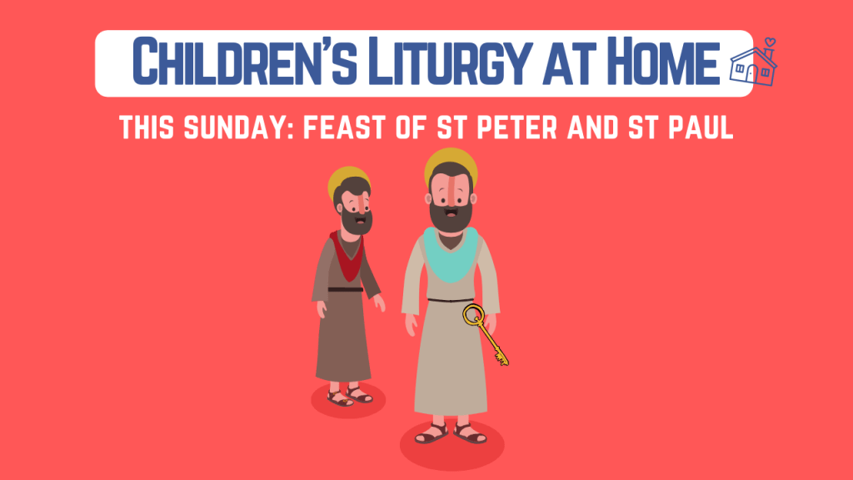
St. Peter and St. Paul
On 29th June the Church celebrates the feast day of two great saints, Saint Peter and Saint Paul. Peter and Paul were both friends of Jesus, but their lives were very different.
Please complete the attached worksheet on St. Peter and St. Paul.
The Gospel for the coming Sunday can be found at http://universalis.com/mass.htm Read it together. What do you think it tells us about how we can live our lives?
Read and enjoy a copy of the Wednesday Word http://www.wednesdayword.org/stopgap/Temporary-Special-Edition.pdf

Additional learning resources parents may wish to engage with
BBC Bitesize – You can access daily lessons in English and Maths, as well as other core subjects, on their website and also programmes broadcast on BBC iPlayer. https://www.bbc.co.uk/bitesize

Top Marks – This site contains lots of fun English and Maths games. Click on ‘Learning Games’ at the top of the page and select the 7-11 age group tab. www.topmarks.co.uk

Teacher Tips
We hope you are all okay. We are missing the children very much and would love to hear how they are getting on. If you are able to tweet any of their work, we will really enjoy seeing it!

Keep looking on the school twitter page for any updates and messages.
Take care xxx

