St Joseph’s Catholic Primary School - LEARNING AT HOME PLANNING
YEAR 5
Date – WC 6th July 2020
Weekly Mathematics Tasks  (Aim to do 1 per day) | Weekly Reading Tasks  (Aim to do 1 per day)
- Continue to play on Times Table Rock stars – your child will have an individual login. There is a tournament between 5W and 5F. Can you help your classmates to win the battle?  - This week’s maths is all about area. Watch this video on Corbett Maths to find out how to calculate the area of squares and rectangles: Finding the Area Video  - Now practise calculating the area by answering these questions:  Find the area Find the area answers  - Try these maths challenges from BBC Bitesize:  Year 5 Maths Challenge questions  - Complete these arithmetic questions using a mental method or a written method. You will need paper to write your answers on and do any working out. | - Encourage your child to read for at least 20 minutes independently. Ask them to summarise what they have read and make predictions as to what might happen next. They could do this orally or write a short summary.  - Complete the attached reading comprehension on a poem by Ros Asquith :  - Please have a look at this website which provides lots of useful reading activities to do at home:  https://home.oxfordowl.co.uk/reading/  - Please watch this clip showing how to use dashes in your writing.  https://www.bbc.co.uk/bitesize/topics/zvwwxnb/articles/zg8gbk7  Now, complete the following worksheet on using dashes.
Weekly Spelling Tasks  (Aim to do 1 per day) | Weekly Writing Tasks  (Aim to do 1 per day)
Year 5/6 Statutory Spelling Words  Practise these words and look them up in a dictionary to find their meaning:  accommodate category determined forty marvellous programme soldier accompany committee develop frequently mischievous pronunciation stomach  Try writing each word in a sentence. | - Look at the image below. Make some notes about who this character might be, where you might meet him, what he looks like, what he might do and what he might say.  - Write a story opening that introduces this character. You can create your own character for him to meet with.  Watch this video called: ‘Lighthouse’: https://www.youtube.com/watch?v=6HfBbSUORvo&t=11s  - Create a timeline of what happened in the video.  - Imagine you are the lighthouse keeper and write his diary explaining what he did when the light went out.  - Think about:  How he was feeling  Why he was worried when the light went out  Describing in detail what he saw and what happened

Foundation subjects and Learning Project - to be done throughout the week
- Science – Revision
Earlier in the year, we learnt about using magnets in our work on materials. Use the link to watch the videos and complete the activities on BBC Bitesize: Magnets
- Art Please check out this website for great ideas on doing art at home:
https://www.bbc.co.uk/bitesize/subjects/zn3rkqt

- Geography Please explore the ideas on this website to brush up on your Geography skills. There are good clips on how to use mapping skills, contours, keys and symbols and many others.
https://www.bbc.co.uk/bitesize/subjects/zbkw2hv
- Music
We have set up some music learning packages that you can access from your computers. We are using the YUMU packages on the Charanga music website.
Each of you has a sticker attached as a document with your own personal log in details.
Login here: charanga login
We have set up 3 different packages for you to use once a week possibly or more if you want to.
We can see your activity so please do have a go. We’re sure you will have lots of fun doing it.
https://charanga.com/yumu

Let’s get physical!
This website has alot of ideas for fun P.E. activities to do at home
https://happiful.com/10-virtual-pe-lessons-your-kids-will-love/

Join in with Joe Wicks – The Body Coach on YouTube each day
or
Do something active with your family every day- maybe you could learn a new skill/game!
or
Choose one of your favourite songs on ‘Just Dance’ using YouTube and enjoy learning some new dance moves.

Please look at this promotion from Mr Nayland for the Wirral virtual School Games starting on Monday 6 7 20- it sounds well worth finding out about.

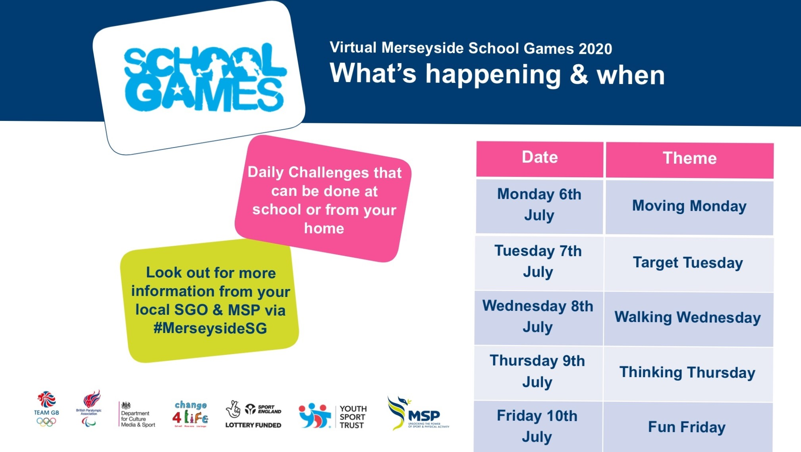

Pray together
Please complete the attached worksheet on St. Peter and St. Paul.
The Gospel for the coming Sunday can be found at http://universalis.com/mass.htm Read it together. What do you think it tells us about how we can live our lives?
Read and complete the tasks in the Wednesday Word http://www.wednesdayword.org/stopgap/Temporary-Special-Edition.pdf

Additional learning resources parents may wish to engage with
BBC Bitesize – You can access daily lessons in English and Maths, as well as other core subjects, on their website and also programmes broadcast on BBC iPlayer. https://www.bbc.co.uk/bitesize

Top Marks – This site contains lots of fun English and Maths games. Click on ‘Learning Games’ at the top of the page and select the 7-11 age group tab. www.topmarks.co.uk

Teacher Tips
We hope you are all okay. We are missing the children very much and would love to hear how they are getting on. If you are able to tweet any of their work, we will really enjoy seeing it!

Keep looking on the school twitter page for any updates and messages.
Take care xxx

