St Joseph’s Catholic Primary School - LEARNING AT HOME PLANNING
YEAR 5
Date – WC 18th May 2020
Weekly Mathematics Tasks  (Aim to do 1 per day) | Weekly Reading Tasks  (Aim to do 1 per day)
- Continue to play on Times Table Rockstars – your child will have an individual login to access this (20 mins).  - Recap on the names of 2D shapes by watching the video and then complete the activity: https://corbettmathsprimary.com/2018/07/18/2d-shapes-video/  - Regular and irregular 2D shapes  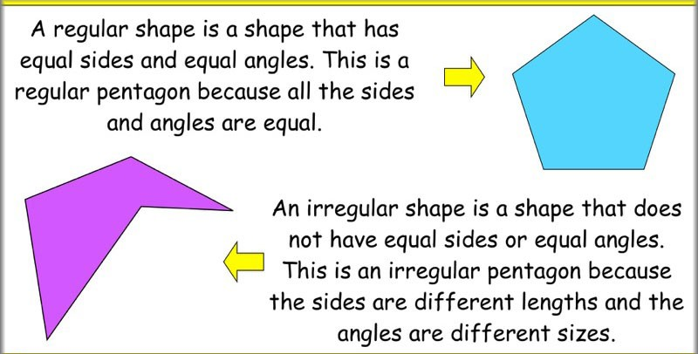  Complete these activities:  - Play some shape games from the Topmarks website:  https://www.topmarks.co.uk/maths-games/7-11-years/shape-position-and-movement  - Complete these arithmetic questions using a mental method or a written method. You will need paper to write your answers on and do any working out. | - Encourage your child to read for at least 20 minutes independently. Ask them to summarise what they have read and make predictions as to what might happen next. They could do this orally or write a short summary.  - Complete the reading comprehension on plastic pollution:  - Visit Oxford Owl for free eBooks. Parents can create a free account. Choose a book in the 9-11+ age range. There are lots of books to choose from, including Project X adventures and many great non-fiction texts, to help you explore the world from your home!  - Enjoy reading ‘The Paperbag Prince’ for pleasure. This is our driver text this half term. You could read it on your own, read it to a sibling or even share the reading with an adult! We hope you enjoy it
Weekly Spelling Tasks  (Aim to do 1 per day) | Weekly Writing Tasks  (Aim to do 1 per day)
Homophones  Remember a homophone is a word that sounds the same but has a different meaning and spelling.  serial whose guest sweet past led through cereal who’s guessed suite passed lead threw  Try writing them in a sentence making sure the meaning is correct.  Can you find anymore homophones? | - You are going to be a ‘Nature Detective’ and find where nature has survived in the rubbish dump. Explore the pictures attached in detail and record your findings in a table like so:  Nature Where it survived  Ivy Wrapped around a bottle  Fir Trees Sprouting from a drawer  - Revise subordinate conjunctions and prepositions using the BBC Bitesize Clips.  There is a quick quiz to test yourself once you are feeling confident.  BBC Clips Subordinate Conjunctions  Remember I SAW A WABUB  BBC Clips Prepositions  - Write a descriptive paragraph to describe how nature survived in the rubbish dump. Use subordinating conjunctions and prepositions to add detail to your sentences.  If you are struggling to start then here is a starting point:  In the darkest depths of the rubbish pile, nature never gave up. Delicate roses began to sprout from a watering can in the shadow of a desk drawer filled with burgeoning conifers. Reaching up towards the sunlight, despite the mountains of junk surrounding it, a single yellow daffodil sprouted from a green glass jar…  - It is important to keep revising the grammar you have learnt so far. Here is a Spelling and Grammar Activity to see what you remember. Good Luck

Foundation subjects and Learning Project - to be done throughout the week
- Science – Separating Mixtures
Use this link to visit BBC Bitesize:
Separating mixtures
Watch the video to learn about separating mixtures using sieving, filtration and evaporation and then complete the activities and quiz.

- Music
Mrs Lester has set up some music learning packages that you can access from your computers. We are using the YUMU packages on the Charanga music website.
Each of you has your own personal log in details which can be found on the Year 5 Remote Learning page of the school website.
Login here: charanga login
We have set up 3 different packages for you to use once a week possibly or more if you want to.
We can see your activity so please do have a go. We’re sure you will have lots of fun doing it.

- RE
May is the month of Mary – Watch this short video and learn about the Rosary.
https://youtu.be/_i7vOUP0LU4
Write your own prayer to Mary. What do you think of when you think of Mary?

Let’s get physical!
Join in with Joe Wicks – The Body Coach on YouTube each day

To keep us active during our time away from school, we have teamed up with Joy of Moving, the EFL Trust and Tranmere Rovers FC to organise an afternoon of home-based games. We have chosen the afternoon of Thursday 21st May for you to try these activities. Feel free to record and post your skills to our twitter page, tagging in @TRFCcommunity and using the hashtag #JOMHomeFestival. Full details are to be found in this booklet:

https://documentcloud.adobe.com/link/review?uri=urn:aaid:scds:US:de810161-b137-4330-af8d-4504e177eaa8

Pray together
The Gospel for the coming Sunday can be found at http://universalis.com/mass.htm

Read it together. What do you think it tells us about how we can live our lives?

Read and enjoy a copy of this week’s Wednesday Word http://www.wednesdayword.org/stopgap/Special-Edition.pdf

Additional learning resources parents may wish to engage with
BBC Bitesize – You can access daily lessons in English and Maths, as well as other core subjects, on their website and also programmes broadcast on BBC iPlayer. https://www.bbc.co.uk/bitesize

Top Marks – This site contains lots of fun English and Maths games. Click on ‘Learning Games’ at the top of the page and select the 7-11 age group tab. www.topmarks.co.uk

White Rose Maths – This site has a home learning section with five maths lessons each week for Year 1-8. Every lesson comes with a short video showing you how to help your child to complete the activity. https://whiterosemaths.com/homelearning/
Teacher Tips
We hope you are all okay. We are missing the children very much and would love to hear how they are getting on. If you are able to tweet any of their work, we will really enjoy seeing it!

Keep looking on the school twitter page for any updates and messages.
Take care xxx

