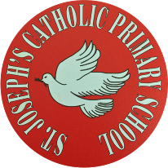.
St Joseph’s Catholic Primary School - LEARNING AT HOME PLANNING
YEAR 6
Date 22.06.20
As most children will return to school this week, the activities will link with some of the work we will be doing in school.
Please email us some of your work as we prepare for your transition to high school.
(Aim to do 1 per day) | Weekly Reading Tasks  (Aim to do x1 per day)
- Daily 5 minute starters:  https://corbettmathsprimary.com/5-a-day/  Platinum level: 22nd – 26th May  TTRS: 5 minutes daily practice. Currently, the Year 6 Girls are in the lead.  Any issues with TTRS - email or Tweet us, and we will sort it out for you.  - Calculator Crunch!  Lesson 1: Don’t make me LOL!  https://documentcloud.adobe.com/link/track?uri=urn:aaid:scds:US:256e5924-135a-49b6-b60b-685eb0b12b58  Lesson 2: Target Practice  https://documentcloud.adobe.com/link/track?uri=urn:aaid:scds:US:9c62f6d9-465d-4ecc-845c-2cd4a75c7d9a  - Preparation for Year 7  Choose topics from here to help prepare you for September:  https://www.mathsgenie.co.uk/homeschool.html  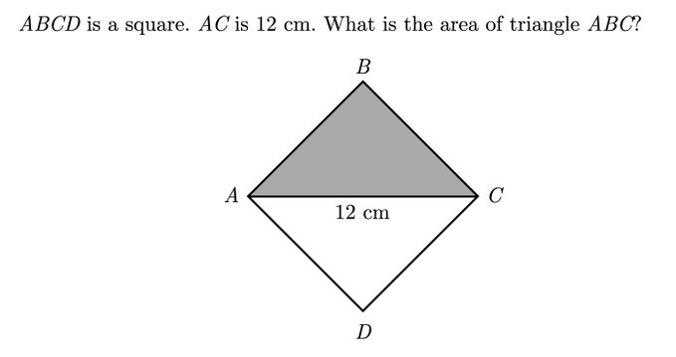  Maths Challenge Puzzle: | Reading:  - Aim to read independently for at least 30 minutes each day. Then, summarise what you have read to someone in your family. Can you predict what you think will happen next? You can choose to do this orally or write it down.  - Read aloud to someone in your family. Include appropriate intonation and expression.  - Read and complete the Cracking Comprehension: ‘Just So Stories’:  https://documentcloud.adobe.com/link/track?uri=urn:aaid:scds:US:0511d65c-7d83-48d4-8d67-5b2204ae37f3
Weekly Spelling and Grammar Tasks  (Aim to do 1 per day) | Weekly Writing Tasks  (Aim to do 1 per day)
- Spelling  Word families based on common words showing how words are related to each other in form and meaning  commit committee transmit submit commitment emit permit intermittent omit unremitting  Use your preferred strategy to learn these words, then use them in sentences.  Grammar  Here are tests to finish, and new ones are set for you to complete:  https://www.spag.com/ | Life during Lockdown:  - Make a poster to explain about the changes you have had to make during lockdown.  How have you made sure that you stay safe and stay alert?  - Lockdown Journal: Keep writing in your diary - one day you will enjoy sharing this experience with others!  - Choose a character from your current reading book and write a character profile.  Transition:  - What would you like to ask your new high school teachers?  Write a list of questions and email them to us to send to your high school. Write a letter to your high school teacher.

Foundation subjects and Learning Project - to be done throughout the week
Topic: ‘Targets and Goals’
Art: decorate your aspiration paragraph and email your work to us.

Make a Happy Box to keep at home and decorate is however you like. You can use a shoe box and fill your box with things that make you feel happy. Anytime that you are feeling anxious or low, use the things in your box to cheer you up.

Music: YUMU Charanga at Home website
Follow the next few lessons in the Dancing in the Street unit. Use your login that we have given you.
Let’s get physical!

- Joe Wicks PE lesson (daily on his YouTube channel - Body Coach)
Pray together
Dear God,
As we contemplate returning to school, please send your Holy Spirit as our guide and protector. Keep us safe, whilst giving us the confidence to enjoy our final weeks in Year 6. Let us learn and grow strong; may the presence of your spirit guide us and fill our hearts. Amen

How can you be a Zero Hero? Use this link to research over the next few weeks and find out how you can help to look after God’s beautiful world.

https://cafod.org.uk/Education/Primary-teaching-resources/Zero-Hero

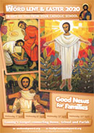
This week’s Wednesday Word:
http://www.wednesdayword.org/stopgap/Temporary-Special-Edition.pdf

Additional learning resources parents may wish to engage with
Watch Newsround each day and discuss the day’s events together
Blue Peter is a great magazine programme covering lots of interesting topics.
Follow the instructions and teach someone how to play a board game.
Amazing authors share their top writing tips: https://www.bbc.co.uk/cbbc/watch/bp-wring-tips-book-awards-20?collection=cbbc-top-picks-today
Free sites and logins for parents:
Oak National Academy Online Learning: https://classroom.thenational.academy/
BBC Bitesize: https://www.bbc.co.uk/bitesize/tags/zncsscw/year-6-and-p7-lessons
Classroom Secrets Year 6 home learning pack: https://classroomsecrets.co.uk/
Twinkl: UKTWINKLHELPS
Third Space Learning: https://thirdspacelearning.com/blog/home-learning-resources/
More ideas are listed on https://www.lessonable.com/
Teacher Tips
Use every opportunity to practice and improve your handwriting - slow it down, sit comfortably with your feet on the floor, don’t tense your hand, hold your pen/ pencil correctly.
Talk through your work to someone in your family. This will help you to understand what you are learning about in more detail.
Try and get up early each morning to work through your tasks. Remember to have regular breaks and drink plenty of water throughout the day.
Thought for the week
“Yesterday is history. Tomorrow is a mystery. Today is a gift. That’s why we call it ‘The Present’.” Eleanor Roosevelt

