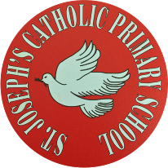.
St Joseph’s Catholic Primary School - LEARNING AT HOME PLANNING
YEAR 6
Date 06.07.20
Most children have returned to school, and these activities will link with the work we will be doing in preparation for our Leavers’ events.
Please email us your work as we prepare for your transition to high school.
(Aim to do 1 per day) | Weekly Reading Tasks  (Aim to do x1 per day)
TTRS: 5 minutes daily practice. Currently, the Year 6 Girls are in the lead.  Any issues with TTRS - email or Tweet us, and we will sort it out for you.  - Calculator Crunch!  Lesson 5: Fascinating Fractions!  https://documentcloud.adobe.com/link/track?uri=urn:aaid:scds:US:42338f2e-47f2-4453-9a55-4329e92187da  Lesson 6: 2020  https://documentcloud.adobe.com/link/track?uri=urn:aaid:scds:US:c78ceebf-9d1c-4eae-bb18-0112a37b6a6e  - Preparation for Year 7  Choose topics from here to help prepare you for September:  https://www.mathsgenie.co.uk/homeschool.html  Maths Challenge Puzzle: | Reading:  - Aim to read independently for at least 30 minutes each day. Then, summarise what you have read to someone in your family. Can you predict what you think will happen next? You can choose to do this orally or write it down.  - Read aloud to someone in your family. Include appropriate intonation and expression.
Please email the following for our Leavers’ video: | Weekly Writing Tasks
Graffiti name art  A photo of you holding your speech bubble with what you would like to be when you grow up  Written memory of primary school or a video of you reading it out.  Video of you singing the Leavers’ song  A recent head and shoulders photo of you  A collection of 4 photos from across the years of you since starting school. | Memories:  What are your happiest memories of primary school? Write a paragraph and email them to us so they can be included in our Leavers’ work.  Transition:  Work through this Transition Book which will help you to get ready for high school.  https://documentcloud.adobe.com/link/track?uri=urn:aaid:scds:US:2e7875f6-96f5-4ef2-a7d2-3d131b43a354  Aspirations:  What would you like to be when you are older? Write it on the speech bubble and decorate it. Then email a photo of you with your speech bubble for our Leavers’ work.  https://documentcloud.adobe.com/link/track?uri=urn:aaid:scds:US:9ff080f9-b18c-4804-a939-fc5cb3637966  Lockdown diary:  Keep writing in your diary about your experiences during Lockdown.

Foundation subjects and Learning Project - to be done throughout the week
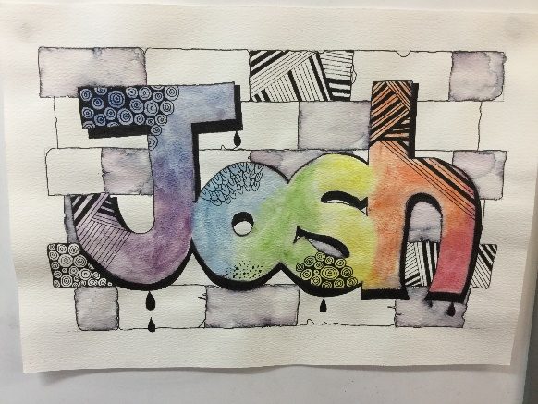
Leavers’ preparations:
Art: Look at the example of graffiti art we have been working on in class. Can you try and make one with your name using black pen ink and watercolour paint or felts if you can?
Then email a photo of your work to us.

Music: Leavers’ song
Learn the words for our Leavers’ song – ‘St Joseph’s Nights’ using the music from Avicii’s The Nights.
https://documentcloud.adobe.com/link/track?uri=urn:aaid:scds:US:83352c98-4226-4a07-8f7f-5a0b75036ba6
https://www.youtube.com/watch?v=n_h8y2mzpns
Email us a video of you singing the song.

Let’s get physical!

As the Merseyside School Games County Festival is unable to go ahead this year, the Merseyside School Games Organisers have created a fantastic week of virtual challenges and activities. All details are in the attached poster below. Each day has a set theme and a set challenge. These activities are for all ages and abilities. They can be enjoyed at school or at home with family.

As you can see, each day has a different focus. At the beginning of the week we will be sharing, via our school’s Twitter page, a breakdown of each day with a 'Challenge Card' so look out for these. You can share and post all of your involvement on the @stjosephsbh Twitter page and also tag, using the hashtag #MerseysideSG and @WirralSG
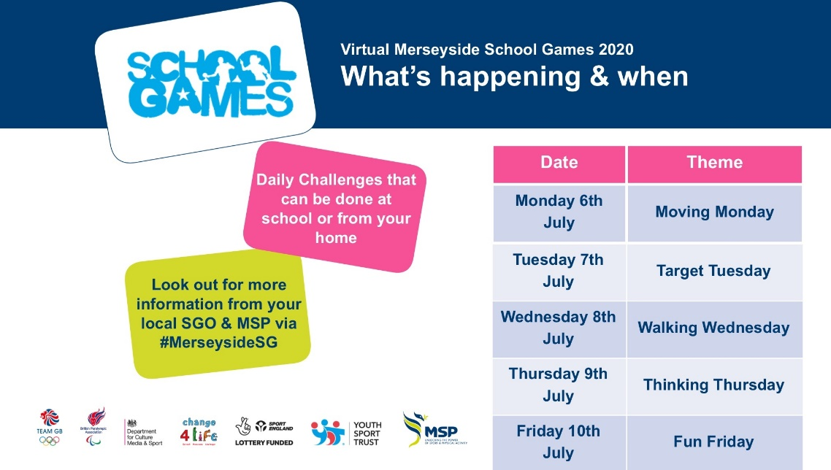

Pray together
Dear God,
Please bless all of the children here at St. Joseph’s, both at school or still at home. Please ensure that July is a month of happiness, achievement and joy as well as being a fitting end to our time in Year 6. Please give us the strength to cope with change and prepare for new chapters in our lives.
Amen.
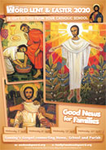
How can you be a Zero Hero? Use this link to research over the next few weeks and find out how you can help to look after God’s beautiful world. https://cafod.org.uk/Education/Primary-teaching-resources/Zero-Hero
This week’s Wednesday Word:
http://www.wednesdayword.org/stopgap/Temporary-Special-Edition.pdf

Additional learning resources parents may wish to engage with
Watch Newsround each day and discuss the day’s events together
Blue Peter is a great magazine programme covering lots of interesting topics.
Follow the instructions and teach someone how to play a board game.
Amazing authors share their top writing tips: https://www.bbc.co.uk/cbbc/watch/bp-wring-tips-book-awards-20?collection=cbbc-top-picks-today
Free sites and logins for parents:
Oak National Academy Online Learning: https://classroom.thenational.academy/
BBC Bitesize: https://www.bbc.co.uk/bitesize/tags/zncsscw/year-6-and-p7-lessons
Classroom Secrets Year 6 home learning pack: https://classroomsecrets.co.uk/
Twinkl: UKTWINKLHELPS
Third Space Learning: https://thirdspacelearning.com/blog/home-learning-resources/
More ideas are listed on https://www.lessonable.com/
Teacher Tips
Use every opportunity to practice and improve your handwriting - slow it down, sit comfortably with your feet on the floor, don’t tense your hand, hold your pen/ pencil correctly.
Talk through your work to someone in your family. This will help you to understand what you are learning about in more detail.
Try and get up early each morning to work through your tasks. Remember to have regular breaks and drink plenty of water throughout the day.
Thought for the week
“Love yourself. It is important to stay positive because beauty comes from the inside, out.”

