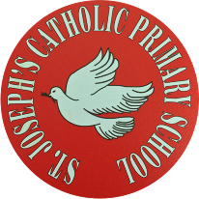.
St Joseph’s Catholic Primary School - LEARNING AT HOME PLANNING
YEAR 6
Date 25.05.20
(Aim to do 1 per day) | Weekly Reading Tasks  (Aim to do x1 per day)
- Daily 5 minute starters:  https://corbettmathsprimary.com/5-a-day/  Platinum level: 25th – 29th May  TTRS: 5 minutes daily practice. We have set up a tournament between the two Y6 classes. Can you help your classmates to win the battle? Currently, 6C are in the lead!  Any issues with TTRS - email or Tweet us, and we will sort it out for you.  - Learn: Convert miles into kilometres.  You will need to know that 1mile = 1.609km and 1km = 0.621miles  Create a table to show the unit equivalence of miles to km to 1 decimal point.  Miles (m) Kilometres (km)  1 1.6  2  What rule can you apply?  Repeat the task showing the equivalence of km to miles.  km m  1 0.6  2  What rule can you apply?  Maths Genie questions:  https://www.mathsgenie.co.uk/primary/M6.pdf  Answers:  https://www.mathsgenie.co.uk/primary/M6ans.pdf  Maths Challenge Puzzle:  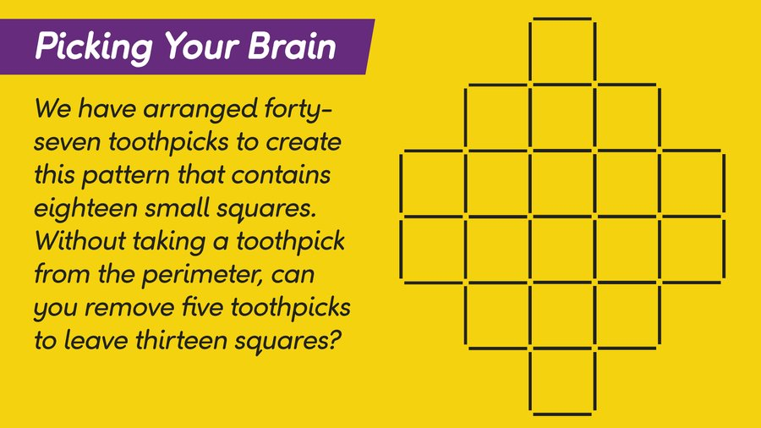  Preparation for Year 7  Choose topics from here to help prepare you for September:  https://www.mathsgenie.co.uk/homeschool.html | Reading:  - Aim to read independently for at least 30 minutes each day. Then, summarise what you have read to someone in your family. Can you predict what you think will happen next? You can choose to do this orally or write it down.  - Read aloud to someone in your family. Include appropriate intonation and expression.  - Read and complete an Oxford Owl reading comprehension based on ‘Rainforests’:  https://cdn.oxfordowl.co.uk/2020/03/13/08/49/58/68816f2c-c1e7-4020-af21-afdfd7f27819/BondSATsSkills_Comprehension10-11_Unit2.pdf
Weekly Spelling and Grammar Tasks  (Aim to do 1 per day) | Weekly Writing Tasks  (Aim to do 1 per day)
- Spelling  Creating diminutives (a word that implies something is small) using the prefix micro- or mini-  minibus miniskirt miniscule minibeast minicab minimum microscope microchip microphone microwave  Use your preferred strategy to learn these words, then use them in sentences.  Can you find other ways of creating diminutives?  Grammar  Here are tests to finish, and new ones are set for you to complete:  https://www.spag.com/ | Read the poem ‘Swimming with Seals’, by Gillian Clarke.  http://www.gillianclarke.co.uk/gc2017/swimming-with-seals/  Questioning: What is happening in this poem? Is this an experience that Jacques may have had as a boy? Make a list of questions you want to explore using: what/ who/ might/ could?  Poetry graffiti - underline words and phrases that you like, add comments at the side and ask questions - use different coloured pens to create poetry graffiti.  Vocabulary investigation: make a list of new words, and find their meaning. Explore the effect of phrases from the poem using a grid like this:  (Fill in the gaps with your thoughts, and then add your own to the list)  Consider themes, ideas and moods the poet is trying to convey: The poet describes her own experience of two people diving and meeting a seal. She contrasts the worlds above and below the water and describes it as ‘Two horizons’, that is, the blue line of the horizon where the sea meets the sky and the ‘submarine’- meaning underwater.  Written task: Can you analyse the poem in your own words? Use all of the ideas you have explored, and explain the story from beginning to end.  Lockdown Journal: Keep writing in your diary - one day you will enjoy sharing this experience with others!

Foundation subjects and Learning Project - to be done throughout the week
Underwater Adventure
Art/ DT: Design and make an underwater adventure collage to illustrate your analysis of ‘Swimming with Seals’.

Music: YUMU Charanga at Home website
Follow the next few lessons in the Songs 9-11 unit. Use your login that we have given you.

Science topic: Electricity lesson 6:
Use your own knowledge and understanding, and the learning from this unit, to design an information/ safety poster for other children so they can understand the importance of electricity and how to keep safe when using it.

Let’s get physical!

- Joe Wicks PE lesson (daily on his YouTube channel - Body Coach
- Have a go at some of these dance ideas that link with our Science topic on Electricity.
https://documentcloud.adobe.com/link/track/?uri=urn%3Aaaid%3Ascds%3AUS%3A81817b0c-f5c5-4302-ae53-85968e6258f1&pageNum=1

- Re-create a famous piece of sporting action in your house or garden. You may want to film yourself and add commentary!

Pray together
Lord God,
We pray especially for health care workers, that you may guide and protect them.
We pray that your Spirit might inspire those researching new medicines and treatments.
And in the midst of this, keep us strong in faith, hope and love. Grant us the courage and perseverance to be good neighbours.
Amen.

How can you be a Zero Hero? Use this link to research over the next few weeks and find out how you can help to look after God’s beautiful world.

https://cafod.org.uk/Education/Primary-teaching-resources/Zero-Hero

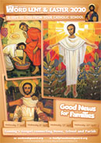
This week’s Wednesday Word:
http://www.wednesdayword.org/stopgap/Temporary-Special-Edition.pdf

Sunday 31st May is Pentecost Sunday and the end of Eastertime.
Take a look at this video which explains Pentecost:

https://www.youtube.com/watch?v=J5tr4pqWIo4

Additional learning resources parents may wish to engage with
Watch Newsround each day and discuss the day’s events together
Blue Peter is a great magazine programme covering lots of interesting topics.
Follow the instructions and teach someone how to play a board game.
Amazing authors share their top writing tips: https://www.bbc.co.uk/cbbc/watch/bp-wring-tips-book-awards-20?collection=cbbc-top-picks-today
Free sites and logins for parents:
Classroom Secrets Year 6 home learning pack: https://classroomsecrets.co.uk/
Twinkl: UKTWINKLHELPS
Third Space Learning: https://thirdspacelearning.com/blog/home-learning-resources/
More ideas are listed on https://www.lessonable.com/

Teacher Tips
Use every opportunity to practice and improve your handwriting - slow it down, sit comfortably with your feet on the floor, don’t tense your hand, hold your pen/ pencil correctly.
Talk through your work to someone in your family. This will help you to understand what you are learning about in more detail.
Try and get up early each morning to work through your tasks. Remember to have regular breaks and drink plenty of water throughout the day.
Thought for the week
“Not all storms come to disrupt your life, some come to clear your path.” - Paulo Coelho

