St Joseph’s Catholic Primary School
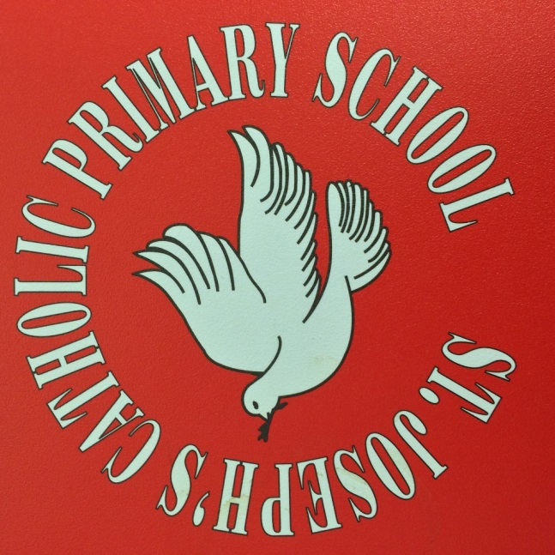

School Uniform
Information for Parents
Background
This booklet is intended to inform parents regarding the school uniform at St Joseph’s Primary School.
Department for Education guidance states :
It is for the governing body of a school to decide whether there should be a school uniform policy and if so what that should be. This flows from the duties placed upon all governing bodies by statute to ensure that school policies promote good behaviour and discipline amongst the pupil body.
It is also for the governing body to decide how the uniform should be sourced. The Department strongly encourages schools to have a uniform as it can play a valuable role in contributing to the ethos of a school and setting an appropriate tone.
Here at St Joseph’s we strongly encourage the wearing of our school uniform. As stated above by DfE, having a school uniform promotes good behavior, discipline and pride in our school. We want our children to be proud members of our school community and understand that by wearing our uniform, they identify themselves as a member of school, and represent our vision and ethos.
Wearing of the uniform at Primary School also sets a good grounding for Secondary schools, where uniform policies tend to be more rigid and sanctions can be issued for breeches of the policy, as well as preparing them for future, where the wearing of a ‘uniform’ may be compulsory, such as in employment or for certain conventions.

We thank you for your support in assisting us implement our uniform policy.
From September 2018
From September 2018 the following uniform will be available.
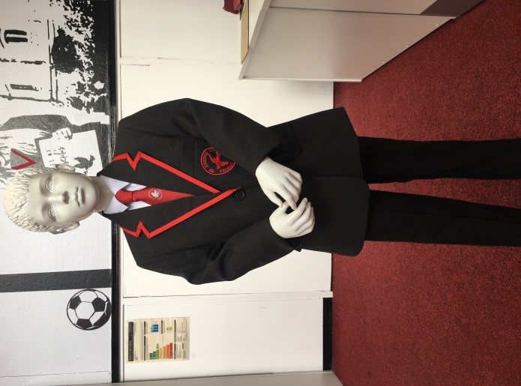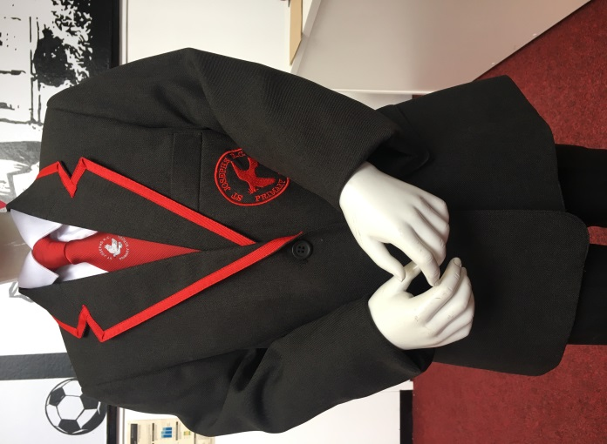
Junior (Y3,4,5,6) Uniform
For children in Y3 upwards, a school blazer will be available for your child to wear. We decided on only introducing the blazer for our junior children, as we acknowledge that the younger children are more likely to get it dirty, and more likely to misplace it. We also feel that having the blazer in the ‘upper’ part of the school marks them out as being ‘junior’ as well as preparing them early for Secondary schools, which do insist on a blazer being worn.
The children do not have to wear a blazer, but we ask that the following items are worn –
- a red school tie featuring our dove logo (this is available as a ‘clip on’ for safety reasons.),
- a plain white shirt or blouse,
- a grey/charcoal jumper, cardigan or tank top (these are all available from the Uniform Shop embroided with our school badge,
- black or charcoal grey trousers, shorts or skirts.
- we also request that black shoes (not trainers or boots) be worn.
- school blazer (optional)
A child in Y3 upwards does not have to wear a blazer, but may instead opt for a combination of skirt/trousers, white shirt/blouse, tie, tank top or school jumper. (For the jumper it will be a charcoal jumper with school badge. The red sweatshirts may be worn for now, but ultimately it would be best if these were kept to the infant children.)
The children do not have to wear the blazer all day and of course may take it off if they get hot or to play outside.

Infant (F2, Y1,2) Uniform
For the children in infants (Y2, Y1, Reception), the uniform is –
- black or grey trousers, shorts or skirts,
- white shirt, blouse or polo shirt
-red sweatshirt or cardigan with school badge
- school tie (optional)
-Black shoes
For PE, please can all children have black pumps, trainers and a red polo shirt/t-shirt and black shorts. These can be embroidered with the school logo, but do not have to be.

Purchasing the uniform
All items of uniform, including blazers, ties and tank tops are available from the Uniform Shop.
If your child is in receipt of Pupil Premium, we can assist in the buying of school uniform. If this applies, please let the office know and which items you require. If you are unsure if your child is eligible, please follow the link below, enter your details and we will then be informed if you qualify.
https://www.wirral.gov.uk/schools-and-learning/funding-and-financial-support/free-school-meals-pupil-premium

Summary Table of available combinations
The following is a summary table of available options for each year group from September 2018 onwards

Y  3,  4,  5,  6 | Blazer | White shirt/  blouse | Red tie | Black/  grey trousers/  skirts/  shorts | Grey jumper/  cardigan/  tank top
Y  1,  2,  F2 | White shirt | White polo shirt | Red Sweat  shirt | Black/  grey trousers/  skirts/  shorts | Red tie

For all – black school shoes
For PE – Red polo shirt/t-shirt, black shorts, trainers/pumps

