St Joseph’s Catholic Primary School
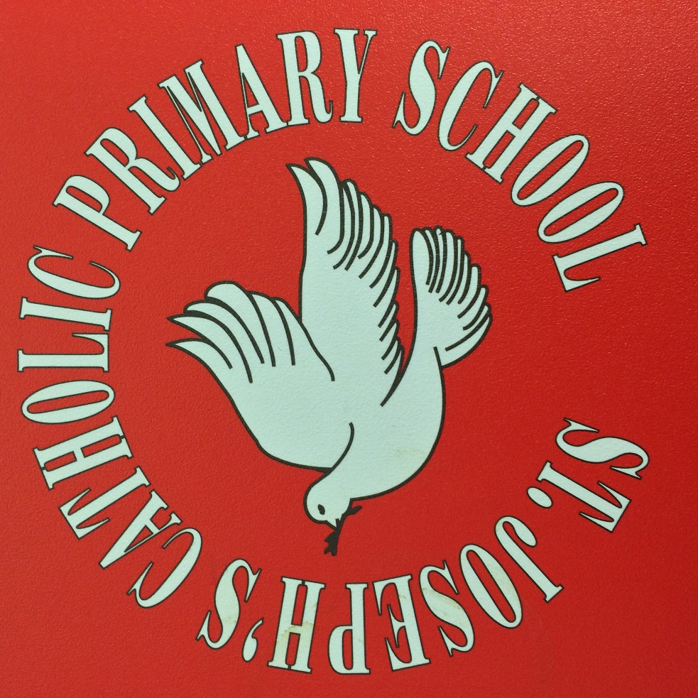
Behaviour system Y1-6
Introduction
This booklet is intended to inform parents the behaviour system at St Joseph’s Catholic Primary School. I hope you find it informative, and agree that we want behaviour at St Joseph’s to be exemplary. I thank you for your support and for working with us to ensure the best possible start in life for your children.
Mr. Turner
Our Vision
We want all children at St Joseph’s to demonstrate the highest levels of good behaviour. All staff are to have high expectations and incidents of poor or disruptive behaviour will not be tolerated. We want the children in our care to learn the value of following rules, showing self -restraint and courtesy to others in order to go on to function in society and create a future world of co-operation, peace and good will.
At St Joseph’s we wish to create an atmosphere conducive to learning to allow each pupil to achieve their full potential. We therefore give high regard to pupil behaviour and link this with attitude and mind-set. Each pupil at our school is expected to follow our behaviour code and we ask parents to support us in this endeavour. Each pupil is taught about the rights of others to come to a school which is safe, calm, free from harassment or bullying and where values, good manners and politeness are strengths to admire. Each pupil is made aware of their responsibility in creating and living out this vision.
Our School Mission Statement is borne from the words of Jesus in the Gospel of John: “Love One Another”. As a school we live out this vision by treating each other as we ourselves would wish to be treated, behaving in a kind and considerate way to all. Love is at the heart of all we do.
Please refer to the School Behaviour Policy for more information regarding our principles and beliefs

Good behaviour is the expected in this school.

I am unapologetic in my ultimate drive to move this school to ‘Outstanding’. This is, after all, the type of school your children deserve. In the OFSTED School Inspection Handbook, for behaviour Inspectors are looking for the following:

Pupil’s impeccable conduct reflects the school’s effective strategies to promote high standards of behaviour. Pupils are self-disciplined. Incidents of low-level disruption are extremely rare.
More important than this though, are the values, manners and attitudes we wish to promote for our children. Behaviour is something that is learnt and it is our job, as parents and teachers, to ensure that children are taught well in order that their lives can be fulfilled and happy and they are able to make our future world one of peace and tolerance.
Teachers have worked with the children to discuss what our behavior code should be. The brief was to come up with some guidelines which, if everyone followed, would make our school happier. All of the ideas the children have generated have been compiled and edited in to the following:
Our Behaviour Code
Jesus told us to Love One Another. We do this by following his example of love, peace and tolerance
- Be kind and helpful to others. Don’t deliberately hurt people.
- Be polite – say please and thank you. Smile and greet people. Hold doors. Say sorry and mean it. Always be honest. Take turns. Show respect.
- Use kind hands, kind feet and kind words.
- Work hard, listen carefully and always try your best. Don’t give up. Don’t stop others from learning.
- Take care of our building and equipment – don’t damage it, keep it clean and tidy.
- Respect and appreciate the differences that make me, me and you, you.
- Keep safe. Help keep others safe.
- Do the right thing

Our system
The system is based on a traffic light method. In each class from Y1-6 there is a display of our behaviour code and each child has their own card storage pocket.
- Children start each day with a green card.

- If a child is displaying signs of going against one of the agreed principles of our agreed behaviour code, their attention is drawn to this. This gives the child the opportunity to stop the behaviour.

- If the child continues to go against the code, a yellow card is moved to their name. This is a visual reminder that they are going against our code (this may be for example that they are persistently calling out during a lesson, breaking the code about taking turns and showing respect). A yellow card carries no sanction but is a warning.

- We want the children to be in control of their own self-regulation so at this point, the child is given different strategies to help them stop this behaviour e.g. “I can see you are finding it hard to concentrate sitting there. Is there somewhere else you could sit which would help you focus?”

- The yellow card can be turned back to green if the behaviour improves immediately. Parents are not informed about yellow cards.

- If the behaviour persists despite warnings and prevention strategies, or if the behaviour has already happened and is proved e.g. a child did hurt or upset someone else, then they are given a red card.

- A red card results in the child going to “Red Reflection Room”. Red room is the name for missing break time and staying in a designated room with supervision. If a child receives a Red card, they miss the next available break.
-Red Room is a reflective room. When in Red Room the children write and talk about why they are there, how their behaviour has impacted on others and what they could do to prevent it happening again. A dated register is taken by the supervising member of staff. Depending on the reason why the child has had to go to Red Room, parents are not necessarily notified at this point. If it is a serious reason e.g. deliberately hurting someone, then the class teacher will inform the parent. However, going to Red Room may be a ‘one off’ as a result of, for example, calling out several times during a lesson. We do not believe that parents would need to be told if this was the case. However, see further below for when parents are told about their child in Red Room.

- It is important that once this sanction has happened, the child goes back to Green card. This teaches them that there is a consequence for their action, but that forgiveness is important and that everyone deserves a chance to ‘start again’.

- If a child is sent to Red Room three times for any reason, a letter is then sent home to parents to inform them.

- At the end of each half term, any child who has a ‘clean sheet’ i.e. no sessions in Red Room, gets a certificate of consistent good behaviour.

-If a child who has already had a letter sent home is sent to Red Room on another three occasions, parents are requested to come to school to meet with the Headteacher to discuss the behaviour. If poor behaviour continues, the Headteacher may have to consider alternative sanctions such as exclusions.

- Again, it is important that children know that the following half term, if they get a ‘clean sheet’ for that period, they are still eligible for the certificate.
-At the end of the year, any child who has had fewer than 5 sessions in Red Room and has had consistent good behaviour for the whole year is taken on a ‘treat day’ e.g. cinema trip etc.
- At the moment, the Red Room will not operate during lunch time, therefore children will always have the opportunity to be outside at some point during the day.
Applying this across Years 1-6
Our behaviour code is the same across the school, and we expect the same high standards. However, we do appreciate that younger children often find it harder to demonstrate the level of self-control we are aiming for. The staff therefore are sensitive to this when issuing any necessary reminders or cards. The younger children will have different thresholds against the codes and longer periods before a Red card is issued. However, certain acts may still result in an immediate Red card. As the children get older and further up the school, expectations rise and there will be a lower tolerance before a Red card. Staff will also take account of any children who have a diagnosed medical condition which may affect their behaviour. Staff will support these children so that they may still work within the expectations of our behaviour code, but may require further strategies to help them. Our F2 classes adhere to our behaviour code, but have a different sanction process to support the children in their developing understanding of why we have such codes. Therefore the Red Room does not apply to F2.

Other
I give incredible high regard to manners and politeness. I therefore will be giving these traits substantial weight in creating the ethos of our school. I also believe that appearance contributes to a general feeling of good attitudes and pride, so I appeal to you to help us by ensuring your children come to school wearing full school uniform and not any items which are not part of our uniform. Please note however, at the moment there is not a ‘sanction’ relating to uniform standards, but I do want to encourage our children to wear our uniform with pride so ask for your assistance in this.

