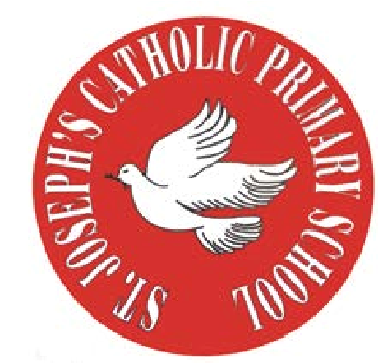

T.
0151 652 6781
www.stjosephscatholicprimarybirkenhead.co.uk
E. schooloffice@stjosephs-birkenhead.wirral.sch.uk | @stjosephsbh

St Joseph’s Catholic Primary School
Woodchurch Road, Birkenhead CH43 5UT
Headteacher.
Mr A. Turner
Dates for 2023-2024
Dear parents,
To help with your planning, we wanted to give you an overview of some of the key dates and events for this year. As far as we can, we hope to keep to these, however, some factors are beyond our control and may cause some dates to be amended. Where this is the case, we will endeavour to give as much notice as possible.
For some of these events, further details will be sent closer to the time.
There are other whole school dates and events on the school calendar, but the ones below are the key ones we wanted to make you aware of. The PTA have also planned an exciting year of events, so these will be shared separately.
For an overview of term dates, please visit our website home page, where you can download the term dates for the year.

Class Mass

During the year we celebrate mass following the Liturgical Calendar and have set the dates below with Fr Niall. Each year group leads a Mass. This includes having children write the Universal Prayers, choose the hymns, read the readings, make a display for the altar, conduct the offertory etc. Parents of that year group are invited, but please be aware that it is a Mass and not an assembly - your child may be reading on the day, or might not be ‘doing anything’ on the day, but they will have helped in the set up etc.

Year group | Date | Theme
Year 6 | Wednesday 1st November 9.15am | All Saints
Year 6 | Friday 19th July 1.00pm | Leavers
Year 5 | Thursday 9th May 9.15am | Ascension
Year 4 | Friday 19th April 9.15am | Eastertide
Year 3 | Friday 19th January 9.15am | FHC Enrolment
Year 2 | Friday 1st December 9.15am | Advent
Year 1 | Wednesday 1st May 9.15am | St Joseph the Worker
Year 3 | Saturday 11th May Times TBC | First Holy Communion

Parents Evening

16th and 17th October | 3.50 – 6.00pm | In School
12th and 13th February | 3.50 – 6.00pm | In school
After reports go out in the Summer Term |  | Phone calls/meetings as requested

Concerts/Productions

KS1 Nativity | Production for parents | 12th December Afternoon
KS1 Nativity | Production for parents | 13th December Afternoon
Choir Carol concert | Evening carol concert | 19th December Evening
KS2 Concert | Afternoon Performance | 26th June
KS2 Concert | Evening Performance | 27th June
Y6 Leavers’ Mass and Assembly | Mass for parents, followed by whole school assembly | 19th July Afternoon

Sports

KS1 Sports Day | 4th July Morning
KS2 Sports Day | 5th July Morning

Testing periods

Year 6 KS2 SATS | WC 13th May
Year 1 Phonics screening | WC 10th June
Year 4 Multiplication check | WC 3rd June and WC 10th June

End of Year Reports

5th July | End of year reports to parents

Other

 | PTA events to follow
15^{h} December | Christmas Dinner
7th March | World Book Day

