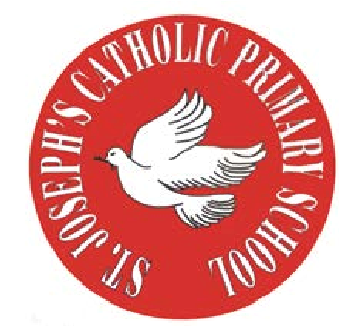
T.
0151 652 6781
www.stjosephscatholicprimarybirkenhead.co.uk
E. schooloffice@stjosephs-birkenhead.wirral.sch.uk | @stjosephsbh
St Joseph’s Catholic Primary School
Woodchurch Road, Birkenhead CH43 5UT
Headteacher.
Mr A. Turner

Dear Parents,
Our Governing Body met recently to discuss and vote on proposals to amend our admissions policy for the academic year 2023-24, so I wanted to write to you to explain what the outcome was, why this was necessary and what it means.
At the meeting, the Governors voted unanimously in favour of initiating the required Local Authority consultation period in order to reduce our Pupil Admission Numbers (PAN) for the school year 2023-24. This was then agreed by MAT Directors.

Schools must consult with the LA and local schools if they wish to make changes to their admissions policy, and this must be done a year in advance and conclude by 31st January. We have therefore begun this process by informing the LA.
Wirral as a geographical area has had a falling birth rate over recent years. As a result of this, forecast for the next few years is a reduced number of primary aged children. This then picks up again based on forecasts over a five year period.
Our current admissions policy states that we have a PAN of 60. However, the Wirral data and trends tell us that we are unlikely to see 60 children of Reception age looking for a school place in September 2023. But, if we kept the PAN as 60, but only took in 30 children for example, we would technically have surplus spaces of 50% in that year. A surplus of that amount would cause issues with viability modelling. In Early Years, we are only permitted to have class sizes of 30 maximum, so again, if 31 did apply and we had a PAN of 60, we would have to have two very small classes, which is then not financially viable.
In order to avoid both of these situations (having a surplus, or being over staffed) we need to reduce our PAN to 30 for 2023-24. Based on Wirral numbers of children, that is a more realistic number of applications, and would ensure we do not have surplus spaces in that year, nor exceed slightly the class size limit. Other Wirral schools are also currently consulting on the same basis.
However, as our building size does not change, if we find that in the year 2023, the LA do contact us to say that applications have increased (which is unlikely, but potentially plausible for example owing to another school closing, like Redcourt did a few years ago, or an influx of new families to the Wirral) then we could reverse this reduction and offer spaces, assuming the number of applications was then financially viable.

I want to reassure you that this is a proactive response to a Wirral picture, based on forecasts for the year 2023-24 (and until the birth rate picks up and those children become school age) and is just about ensuring our viability during those years where the number of primary school aged children has reduced. In order to follow due process, we have to open this LA consultation period immediately and conclude by 31st January 2022 in order to take effect for September 2023.

I hope that gives you a good understanding of what is occurring, why, and the reasons behind it.

Yours sincerely

Mr A Turner
And
The Governing Body of St Joseph’s Catholic Primary School

