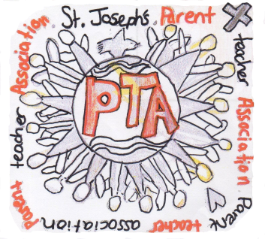
St Joseph’s Oxton PTA
St Joseph’s Oxton PTA stjosephspta@outlook.com

Welcome to our PTA Newsletter.  As a parent, carer or teacher of a child in our school you are automatically a member of our PTA. We work together to raise money to support the education of our children and to strengthen the school community.  This year you have  raised £4907!!  Well done everyone!  Things are hopefully getting back to normal and we were able to run some fantastic events.  As well as our Summer Fair and amazing Easter Bingo, we had our very popular Make the Rules Day, a Krispy Kreme sale, Wreath Night, Elfridges, Eco Balloon Race as well as ongoing schemes such as AmazonSmile, Easyfundraising and our School Lottery.  The money raised has been used across the school; contributing to leavers’ activities for every Year 6 child, providing a globe for each classroom, lots of new books for class libraries, Christmas activities and lots more.  We all want to do our bit for the environment, raising funds for our school at the same time makes that even better, so we now have a few ways to help.  Roberts’ Recycling have provided us with a clothing bin. This reduces the need for plastic bags and means that you can donate your clothes when it’s convenient for you.  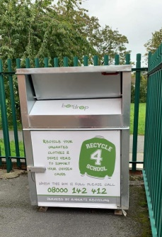  The bin is on the KS1 playground next to the side gate at the bottom of the steps that lead to the KS2 playground. A list of what you can and can’t put in is on all of our social media platforms.  Uniform cannot be put into the recycling bin but we collect that separately for our Wirral FUPS.  We have an ink cartridge recycling bin. The cartridges get recycled and we get cash for collecting them. The bin takes most ink cartridges and some toner cartridges.  We should be getting new collection bins for Wirral FUPs and cartridge recycling soon. In the meantime please leave at the main reception. | Next, we are hoping to help fund a complete refurbishment of the stage including the sound and lighting.  All the better to see and hear our little darlings!!!  We have lots of ideas for the coming year and welcome any more you may have.  We would love to run all of the successful events from past years; we have already had our Welcome Back Disco, which went really well, and we are planning lots more including Quiz Night, Elfridges , Grotto, Christmas Bingo etc,.  We will be looking for helpers, even if you only have ten minutes to spare. Jobs range from folding raffle tickets to running a stall. We are always grateful for any help and we promise that the kettle will be on.  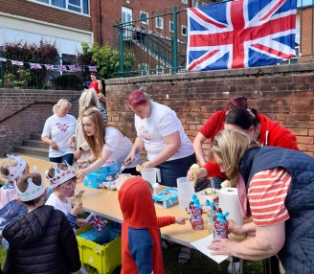  It may only be October but Christmas plans are well underway. The children will be creating artwork ready for you to purchase as Christmas cards, gift tags etc. We hope you will love them.  There are ways you can help us to raise funds without moving from your armchair. Sign up to AmazonSmile or EasyFundraising and we get a percentage of what you spend. It costs you nothing so please remember to sign up before you start your Christmas shopping!  EasyFundraising  easyfundraising.org.uk/  causes/stjptaprenton/  AmazonSmile  Search 1020024-0  or  St Joseph’s Primary School Fairview Road Parent Teacher Association  Now available on the Amazon App  Your chosen Charity will need to be updated occasionally on the app so please double-check.  School Lottery  https://www.yourschoollottery.co.uk/  lottery/school/st-josephs-catholic-primary-school-birkenhead  Facebook  St Joseph’s Oxton PTA  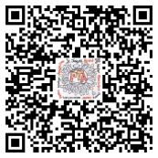  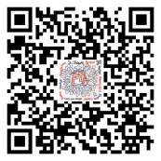  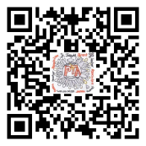  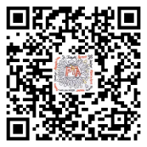  https://www.facebook.com/groups/426820594003044/ | Did you know?  If you do help at one of our events, some companies will allow you time off and others will match-fund any money raised as our PTA is a registered charity. Please ask us or your employer for further details?  Our AGM was October 7th, if you are interested in a committee role or just want to see what the roles involve, please get in touch.  Meetings  - once a month, details on social media and ParentMail  - 3rd floor meeting room  - Tea/coffee/biscuits (and sometimes cake)  - all welcome  Please come and join us.  Contact/Follow us  - St Joseph’s Oxton PTA  @joseph_pta  st_josephs_pta  stjosephspta@outlook.com  Dates for the diary  New Parents Welcome – 14/10/22  World Cup Non-uniform- 25/11/22  Elfridges – 30/11/22  Christmas Bingo – 8/12/22  Grotto – 15/12/22  Quiz Night –tbc  And Finally  A special goodbye and thank you to all our Year 6s and their parents who have supported us over the years.  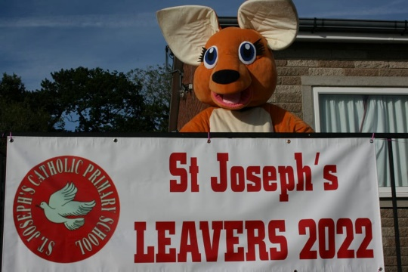  Thanks to the school staff, particularly Max, Ange and Natalie in the office, for all their help.  Also, thank you to you. Without your support we wouldn’t be able to do all the wonderful things we do for our children.

