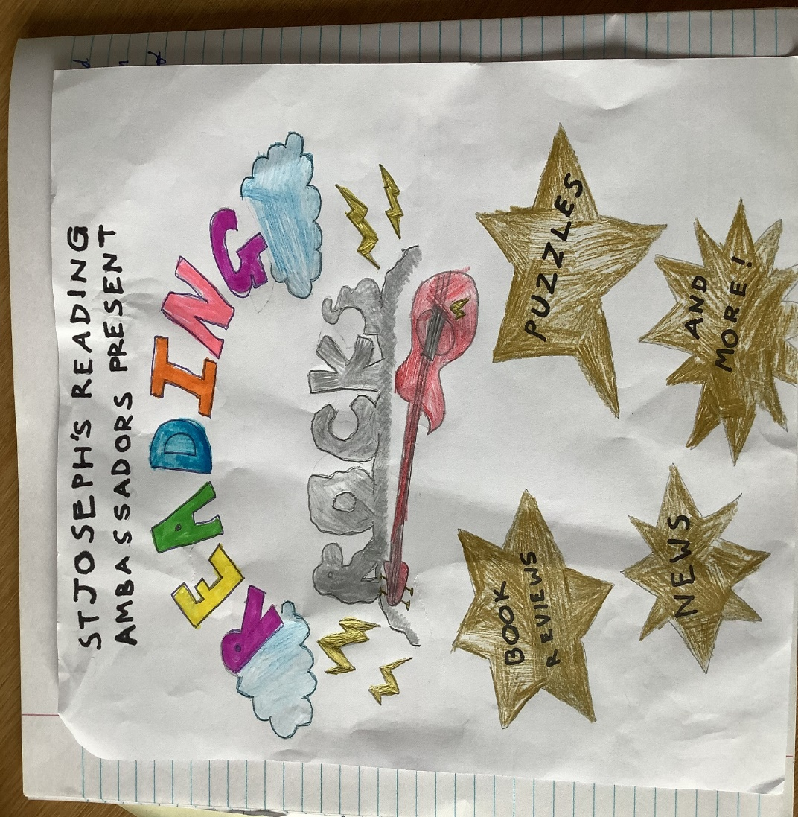

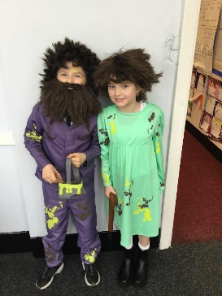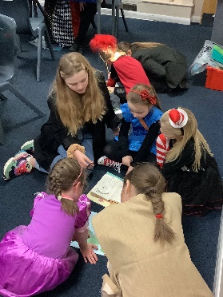

READING IS SO IMPORTANT…

Reading for pleasure opens up new worlds to us. It gives us the opportunity to use our imagination to explore new ideas, visit new places and meet new characters.

Reading for pleasure also improves our well-being and empathy. It helps us to understand our own identity, and gives us an insight into the world and the views of others. Research shows that reading for pleasure can be directly linked to our success throughout our time at school and even into adulthood.

Because reading is so important, our Reading Ambassadors have decided to create a termly reading magazine for the children at St Joseph’s. They have planned and written all of the features and articles included.

We hope that you enjoy reading our new magazine as much as the children did creating it and that it gives you lots of inspiration to read, read and read some more!

Mrs Burley

**Meet the Editors**

We are Bella and Grace and we are in Year 5. We LOVE to read and enjoy reading every day. We like to get lost in faraway places and magical worlds. Using our imaginations, it’s almost like being in the story! Our favourite books are the Dork Diaries series and we are hoping that they will be made into a TV series soon!

We hope that you enjoy the first edition of Reading Rocks and learn lots.

From Bella and Grace

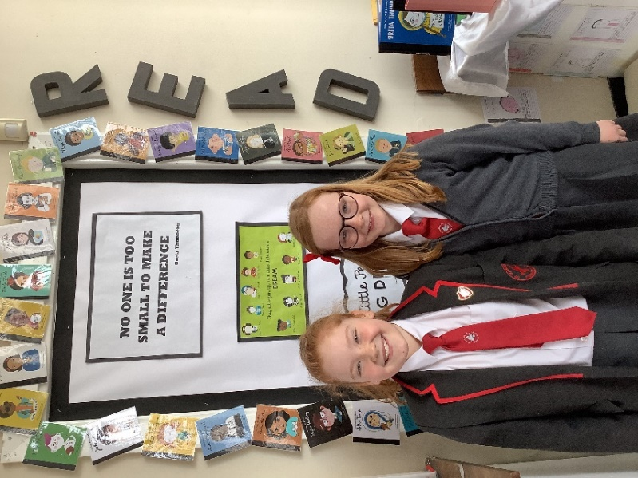

**We would like to say a MASSIVE THANK YOU TO OUR WONDERFUL PTA for helping to fund some lovely new books for our children. Our Reading Ambassadors attended a PTA meeting and asked for a donation to replenish our Class Libraries. The children then created Wish Lists with their teachers. The books are being well read by the children at St Joseph’s and we are ever so grateful to our marvellous PTA for helping to promote the love of reading in our children with interesting new books to enjoy.**

**Thank you!**

**Some of our children with a selection of books that were kindly donated by our fantastic PTA…there were LOTS more!**

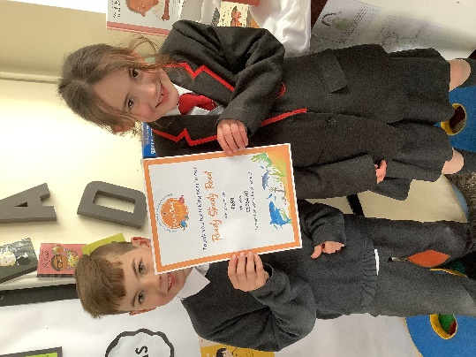

**We would also like to say THANK YOU TO OUR FABULOUS PARENTS for donating books to our school and for supporting our various book events throughout the year.**

**Your ongoing support really is appreciated!**

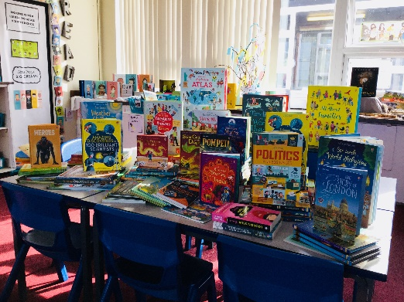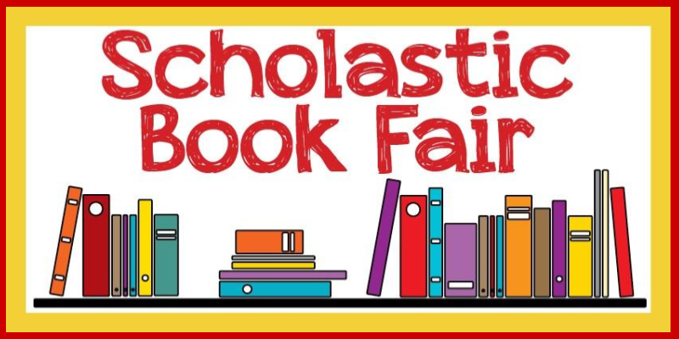

We raised **£1501.66** at our recent Scholastic Book fair. This means that we now have **£901 commission** to spend on more books for our school.

We raised **£659** in our autumn term sponsored read. We were able to then spend **£1054.40** on books for our topic areas in class.

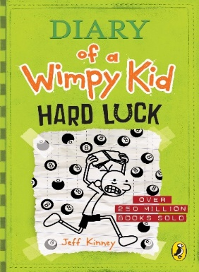

Book Quote Quiz

Guess the character and book that these famous quotes are from…

1. *We do not need magic to change the world. We carry all the power we need inside ourselves.*
2. *You’re braver than you believe and stronger and smarter than you think you are.*
3. *We are the music makers. We are the dreamers of dreams.*

By Blake Rodrigues Y5

& Bella Bradley Y4

**I enjoy reading so much because every book is a new adventure and for a minute, you might not like it and then you are like WOW! It’s good because you can read a book and then swap it for another. If you like a book in a series, you can read more of them and just keep reading forever!**

**By Jonathan Johnson Y3**

My favourite books are the *Diary of a Wimpy Kid* series because they are funny and have lots of detail in them. My favourite one is *Cabin Fever* because it is the scariest of them all and I like scary books.

My favourite character is Greg Heffley because he is hilarious and makes me laugh.

I am currently reading *Hard Luck.*

By Thomas Gill Y2

**WOW Words –Use them in a sentence and WOW your grown-ups! Use a dictionary to help you.**

**cavernous swerve crevice relish**

**By Fleur Murphy, Katie McClusky and Rixon Roy Y6**

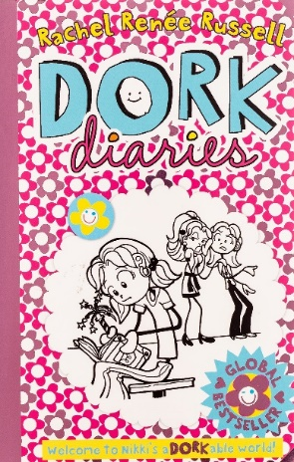

In the *Dork Diaries* series, there is a girl called Nikki Maxwell and she joins a new school and people make fun of her because of her dad’s embarrassing job. She gets picked on by a mean girl but with the help of her friends and her diary, can this amazing dork see it through? This book is AMAZING because you get lost in the story and it is so much fun. This book is suitable for ages 8+.

By Grace Meenan Y5

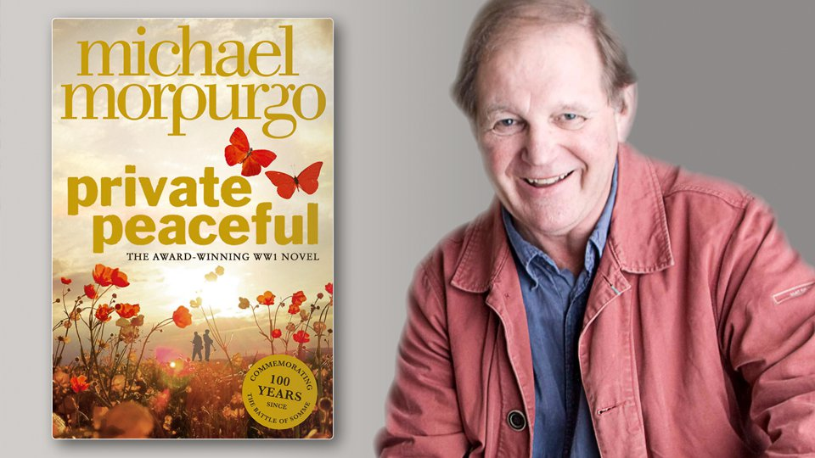

Author Focus – Michael Morpurgo

Michael Morpurgo’s favourite book is the *Elephant’s Child* by Rudyard Kipling because it is the book that his mother read to him when he was a child. He is 78 years old and was born in St Albans Hertfordshire. Michael’s favourite animal is an elephant and he enjoys reading about them too. He has written over 120 books. His 100th book was *Private Peaceful* and was published in 2003. His best-selling book was *The Butterfly Lion* which was first published in 1996 and won the 1996 Smartie’s book prize.

By Luke Shaw Y6

**Masked Reader and Book Art Competition Winners**

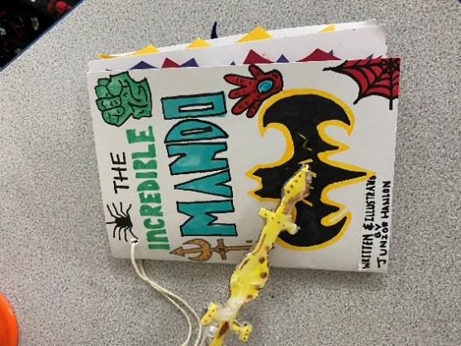

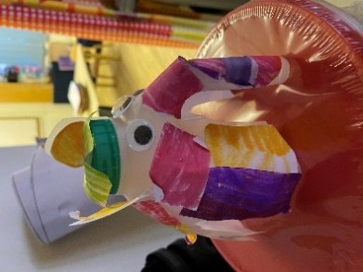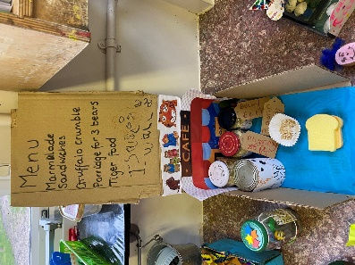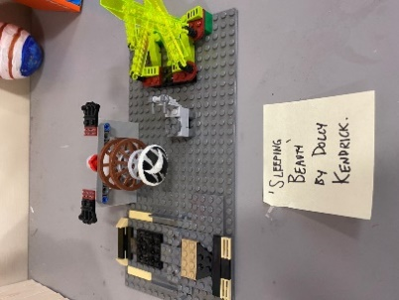

Junior Hanlon Y5 Dolly Kendrick Y4 Eva Birchall EYFS Isaac Wallace EYFS

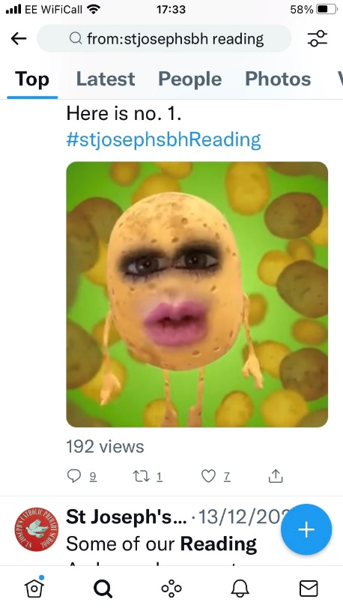Ben Eizdi Sheshpiri Y1 and Violet Brady Y4 were the winners of the Masked Reader competition during World Book Week.

**All of the winners will be visiting Waterstones**

**after the Easter Break with Mrs Burley and**

**Mr Turner and will be able to**

**choose a book as a prize.**

**Answers to Book Quote Quiz: JK Rowling, Winnie the Poo, Willy Wonka**