A Message from Mr Turner
In our school curriculum design, we said that “we believe that reading is a gateway to the world” and we remain true to these words. Reading has the power to educate, to inform, to teach, to touch us all. Whether a non-fiction instruction text to help us with a skill, an information book to help us lean about ancient civilizations, or a story book that transports us to far off worlds, there is something for everyone. And this year, we hope that we have introduced you to fabulous authors, helped you discover new stories and given you the opportunity to listen to and enjoy a class novel at the end of each day. It has been wonderful to see all the reading going on across our school, in all lessons and at all times of day! We have even more in store for next year, including a fantastic poetry spine to introduce the wonderful world of poems.
One of my favourite things to do over summer is to sit in my garden, with a cold drink and a good book, so I have just placed my order with Waterstones and can’t wait to see you in September and talk about the books we have all read over the holidays. Happy reading, Mr Turner x

A MASSIVE thank you to our fantastic Reading Ambassadors. Your dedication to the role, attending weekly meetings and helping to promote the love of reading across the school has been really appreciated. We would also like to thank our wonderful PTA who have funded the replenishment of our class libraries. We would also like to thank our fabulous teachers for helping the children to develop a love of reading and to all of our parents and carers who have donated books or money to our sponsored events and Book Fairs.
Finally, a massive THANK YOU to the amazing children who enjoy reading!

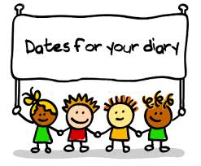
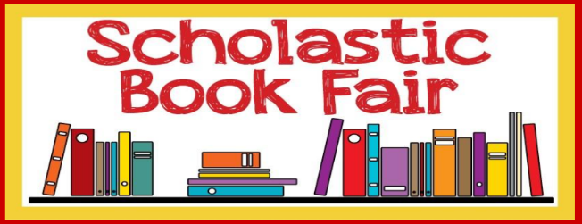

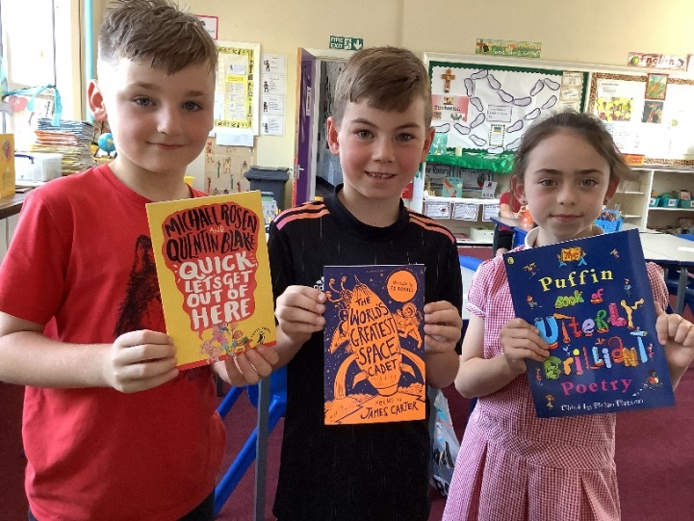
We have purchased additional poetry books for each class for your children to enjoy using this year’s Scholastic Book Fair Commission.
We are also in the process of ordering some science non-fiction books to complement our science lessons.

Date | Event
Thursday 6th October | National Poetry Day
10th-14th October | Usborne Sponsored Read
2nd November | National Non-Fiction Day
14th -18th November | Nursery Rhyme Week
27th Feb- 3rd March | World Book Week
20th – 26th March | Shakespeare Week
26th June – 30th June | Scholastic Book Fair
3rd – 7th July | Poetry Recital
10th July | Launch of Summer Reading Challenge

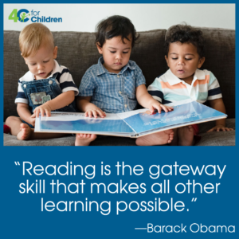

- Parents’ Library
- Parents’ Book Club
Become a …
Reading Role Model!

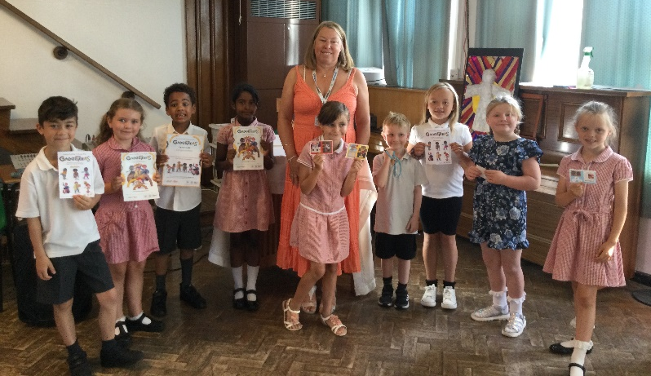
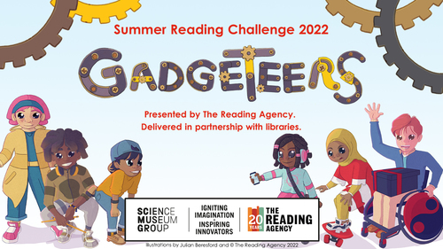
Summer Reading Challenge 2022
We’re so excited to reveal the theme for the Summer Reading Challenge 2022!
Get ready for Gadgeteers, arriving online and in your local library this summer.
Science is all around you! What do you love doing? Are you a brilliant baker? Or a mega music fan? Are you the tech wizard amongst your friends? Join the Gadgeteers for the Summer Reading Challenge to discover the amazing science and innovation behind the world around you, including some of your favourite things!
Curious? Perfect! Your imagination can unlock endless possibilities… Your local library has teamed up with Science Museum Group for a very special science-themed challenge that will inspire you to use your imagination and creativity!
Gadgeteers will feature amazing books, awesome rewards, and plenty of ideas for cool experiments and activities to discover the science all around you. The challenge will be brought to life by top children’s writer and illustrator Julian Beresford.

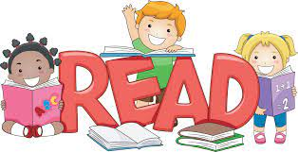
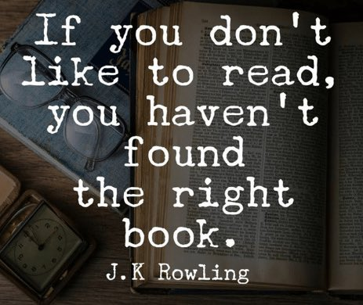

Lots of great books are turned into amazing films. Here are a few of our favourites…
Book Jokes
What vegetables do librarians like?
Quiet peas!

Why is a maths book always unhappy?
Because it has so many problems!

Why was the book about mountains so interesting?
Because it had so many cliff-hangers!

What do you say when your thesaurus is stolen?
Nothing, you'll be lost for words!
By Jonathan Johnson Y3

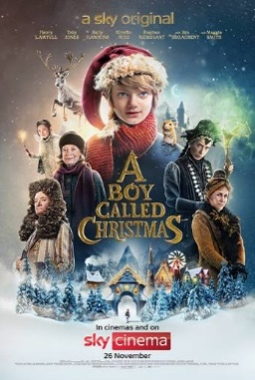
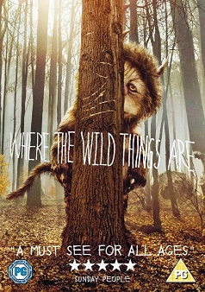
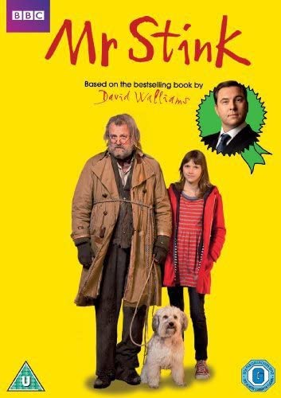
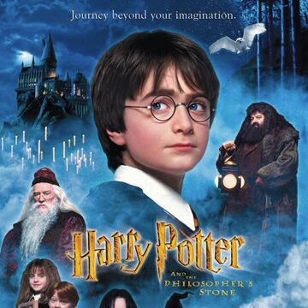
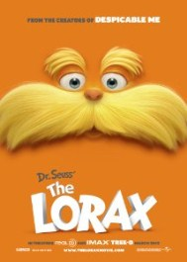
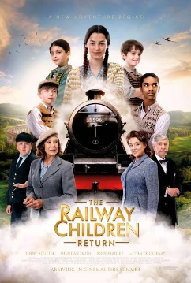
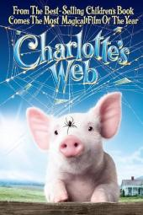
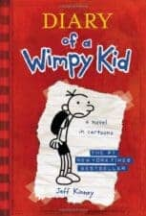
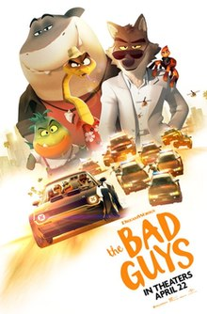
Can you guess what books these quotes belong to?
“Happiness can be found even in the darkest of times. When one only remembers to turn on the light.”
“It is when we are most lost that we sometimes find our truest friends.”
“There is no place like home.”
“You have been my friend. That in itself is a tremendous thing.”
“Be who you are and say how you feel because those who mind don’t matter and those who matter don’t mind.”
By Katie McClusky Year 6
“Dog Man is a simple, long comic book which I LOVE! I think it’s great that these books are suited to any reading age. Dog Man was a stray dog who helped people. The stories are funny. This inspired me to write a review.”
By Blake Rodrigues Y5

Graphic Novels
Graphic Novels are stories that are presented in comic-strip format and published as a book. They help to improve your reading skills like any other book would, and they are fantastic choices for reading outside of class.
1. Graphic novels are full of text. Sure, they have drawings, illustrations, and sometimes photos, but they also have text that readers must actually decode, analyse, and comprehend.
2. Graphic novels are engaging. They tend to be particularly captivating for children, and the combination of text and pictures help children to understand stories that they may otherwise not completely understand.
3. Graphic novels are high-quality reading material. Just like traditional novels, graphic novels have exciting and complex plots, characters, and conflicts. The plots have twists and turns. Characters are developed and dynamic. Conflicts are presented, unwound, and resolved like they are in other texts. The only difference is that graphic novels have more images to support the development.

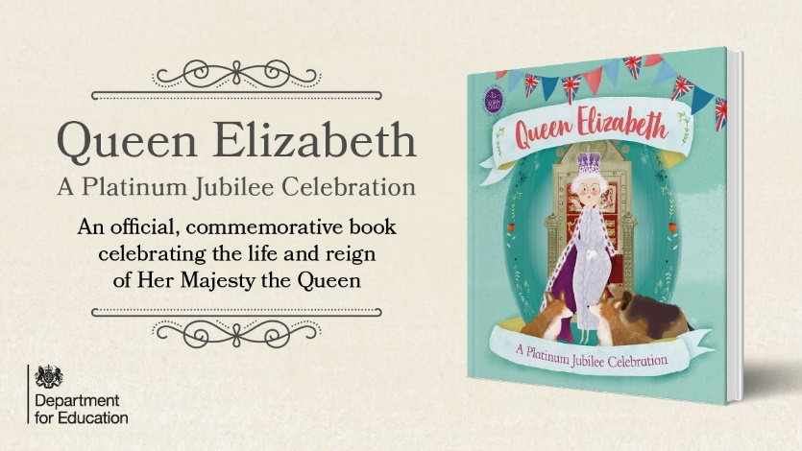
We hope that you enjoy your FREE commemorative book to mark Queen Elizabeth’s Platinum Jubilee, a gift from the Department for Education.
The book has been designed as an official once-in-a-lifetime commemoration of the Platinum Jubilee and was written in collaboration with royal experts and historians. It tells the story of a young girl, Isabella, visiting her Great Granny Joyce who tells her about the Queen and this year’s Jubilee.
In the story, Isabella sifts through Great Granny Joyce’s treasure box of souvenirs, which acts as introductions to the contents of the book. These include recent and historical events across the United Kingdom and Commonwealth, inspirational people, landmark innovations and inventions, and a selection of the best art, design, and culture.
The book also includes famous quotes from the Queen, facts on the coronation ceremony, content on the lives of famous Commonwealth figures such as Nelson Mandela, notable kings and queens and a timeline of Queen Elizabeth’s life.
Unfortunately, we are still waiting for a few more copies of the book to arrive so have decided to give every family one copy each. Once the extra books arrive, we will make sure that we get them to the children who didn’t get their own copy…watch this space!

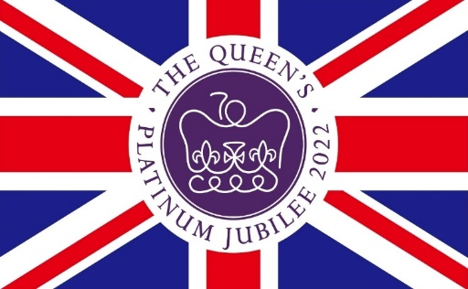
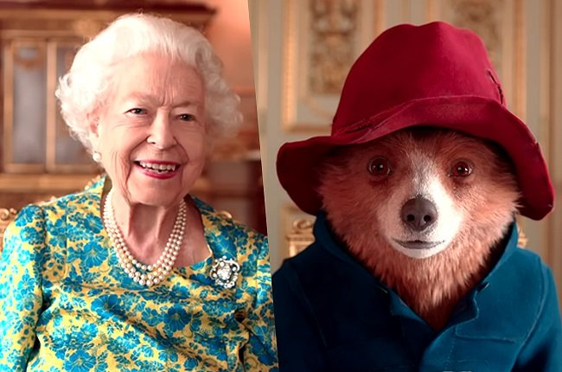
The Queen
LOVES to read.
Do you know the name of this famous book character who the Queen met at her Platinum Jubilee celebration?

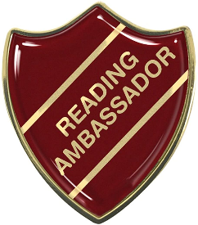

Do YOU have what it takes to be a
St Joseph’s Reading Ambassador?
Being a Reading Ambassador is all about reading for pleasure and sharing the deep enjoyment of reading a great book with others. Reading Ambassadors are voted for by their class based upon their love of reading and their enthusiasm for sharing this. Now is the time to start thinking about whether YOU would like to apply for this exciting role in September 2022.

Our Reading Ambassadors:
- Ensure that books in class book areas and around the school are looked after and are always tidy, inviting and up to date
- Create displays around the school, encouraging other children to find out about new authors, celebrated authors and different books
- Run reading assemblies to remind children to read at home regularly
- Attend meetings to share ideas about reading with others
- Help to run school book fairs and organise World Book Week
- Help to purchase new books using the funds raised from our reading events and generous PTA
- Read and review books and help other children through their recommendations – via our school Twitter account

If you are interested in becoming a Reading Ambassador next year:
- Create an A3 poster over the summer holidays that shows what you are like as a reader, what you enjoy reading, when you usually read and where you like to read
- Prepare a short presentation for your class and be prepared to answer their questions about reading
- Take part in an election – your class will then vote for their Reading Ambassadors.

