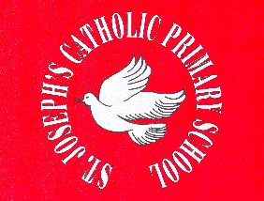

St. Joseph’s Catholic Primary School
Roll of Honour: Inter-form

 | Football | Cricket
2015/16 | ? | ?
2014/15 | 6B | 6B
2013/14 | 6F | 6F
2012/13 | 6F | 6F
2011/12 | 5C | 6N
2010/11 | 6F | 6F
2009/10 | 6F | 6F
2008/09 | 6N | -
2007/08 | 6C | -

