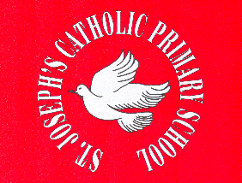

St. Joseph’s Catholic Primary School
Roll of Honour: Sports Day
2015/16 | ?
2014/15 | St. Francis
2013/14 | St. Francis
2012/13 | St. Margaret
2011/12 | St. Francis
2010/11 | St. Maximillian
2009/10 | St. Maximillian
2008/09 | St. Bernadette
2007/08 | St. Margaret
2006/07 | St. Margaret
2005/06 | St. Bernadette
2004/05 | St. Bernadette
2003/04 | St. Francis
2002/03 | St. Francis
2001/02 | St. Margaret
2000/01 | St. Maximillian
1999/00 | St. Margaret
1998/99 | St. Margaret

