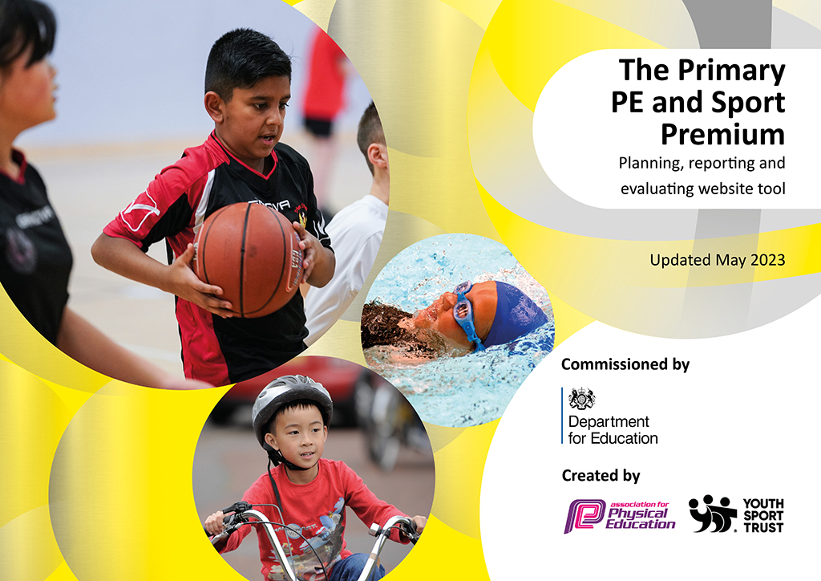
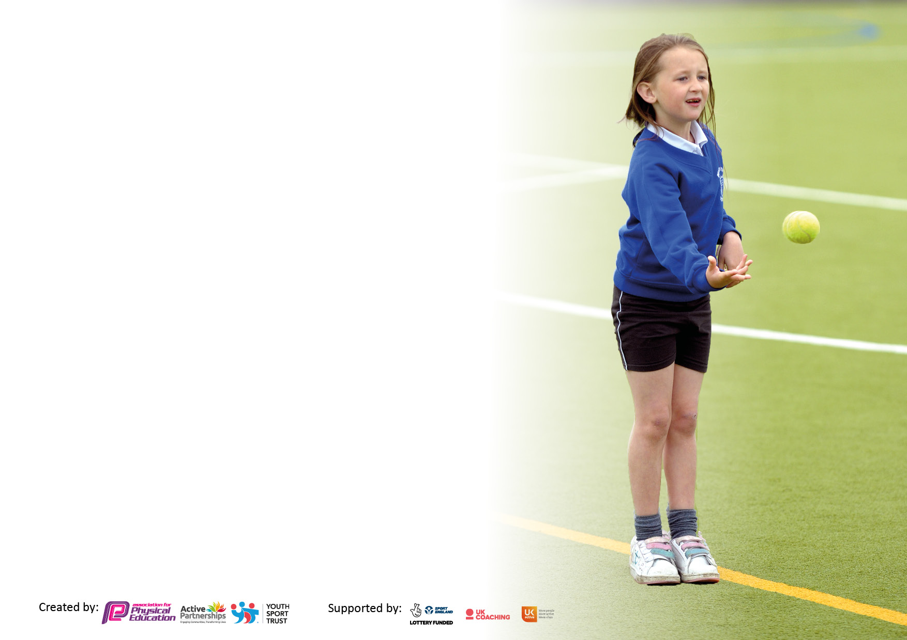

It is important that your grant is used effectively and based on school need. The Education Inspection Framework makes clear there will be a focus on ‘whether leaders and those responsible for governors all understand their respective roles and perform these in a way that enhances the effectiveness of the school’.

Under the Quality of Education Ofsted inspectors consider:
Intent - Curriculum design, coverage and appropriateness
Implementation - Curriculum delivery, Teaching (pedagogy) and Assessment
Impact - Attainment and progress

To assist schools with common transferable language this template has been developed to utilise the same three headings which should make your plans easily transferable between working documents.

Schools must use the funding to make additional and sustainable improvements to the quality of Physical Education, School Sport and Physical Activity (PESSPA) they offer. This means that you should use the Primary PE and sport premium to:

- Develop or add to the PESSPA activities that your school already offer
- Build capacity and capability within the school to ensure that improvements made now will benefit pupils joining the school in future years
- The Primary PE and sport premium should not be used to fund capital spend projects; the school’s budget should fund these.

Pleasevisitgov.ukfortherevisedDfEguidanceincludingthe5keyindicatorsacrosswhichschoolsshoulddemonstrate animprovement.Thisdocumentwillhelpyoutoreviewyourprovisionandtoreportyourspend.DfEencouragesschools to use this template as an effective way of meeting the reporting requirements of the Primary PE and Sport Premium.

We recommend you start by reflecting on the impact of current provision and reviewing the previous spend.

Schools are required to publish details of how they spend this funding, including any under-spend from 2021/2022, as well as on the impact it has on pupils’ PE and sport participation and attainment. All funding must be spent by 31st July 2023.

We recommend regularly updating the table and publishing it on your website throughout the year. This evidences your ongoing self-evaluation of how you are using the funding to secure maximum, sustainable impact. Final copy must be posted on your website by the end of the academic year and no later than the 31st July 2023. To see an example of how to complete the table please click HERE.

Details with regard to funding
Please complete the table below.

Total amount carried over from 2021/22 | £0
Total amount allocated for 2021/22 | £0
How much (if any) do you intend to carry over from this total fund into 2022/23? | £0
Total amount allocated for 2022/23 | £18,720
Total amount of funding for 2023/23. To be spent and reported on by 31st July 2023. | £0
Swimming Data
Please report on your Swimming Data below.

Meeting national curriculum requirements for swimming and water safety.

N.B. Complete this section to your best ability. For example you might have practised safe self-rescue techniques on dry land which you can then transfer to the pool when school swimming restarts.
Due to exceptional circumstances priority should be given to ensuring that pupils can perform safe self rescue even if they do not fully meet the first two requirements of the NC programme of study
What percentage of your current Year 6 cohort swim competently, confidently and proficiently over a distance of at least 25 metres?  N.B. Even though your pupils may swim in another year please report on their attainment on leaving primary school at the end of the summer term 2022.  Please see note above | 34%
What percentage of your current Year 6 cohort use a range of strokes effectively [for example, front crawl, backstroke and breaststroke]?  Please see note above | 49%
What percentage of your current Year 6 cohort perform safe self-rescue in different water-based situations? | 39%
Schools can choose to use the Primary PE and sport premium to provide additional provision for swimming but this must be for activity over and above the national curriculum requirements. Have you used it in this way? | No

Action Plan and Budget Tracking
Capture your intended annual spend against the 5 key indicators. Clarify the success criteria and evidence of impact that you intend to measure to evaluate for pupils today and for the future.

Academic Year: 2022/23 | Total fund allocated: | Date Updated:
Key indicator 1: The engagement of all pupils in regular physical activity – Chief Medical Officers guidelines recommend that primary school pupils undertake at least 30 minutes of physical activity a day in school |  |  |  | Percentage of total allocation:
 |  |  |  | 14%
Intent | Implementation |  | Impact
Your school focus should be clear what you want the pupils to know and be able to do and about  what they need to learn and to  consolidate through practice: | Make sure your actions to achieve are linked to your intentions: | Funding allocated: | Evidence of impact: what do pupils now know and what can they now do? What has changed?: | Sustainability and suggested next steps:
Investment / replenishment of sports equipment.  Create leadership opportunities  for Year 6 Play Leaders to plan and deliver a programme to increase the amount of physical activity at lunchtime through the ‘Active Playground’.  Encouragement of children who forget kit to participate.  Opportunity for regular, non-timetabled use of outdoor play / balance equipment. | Purchase of new and up-to-date equipment for PE and after-school clubs.  Upkeep of balance equipment on KS2 playground.  Training for pupils to deliver playground games.  Purchase of playground equipment.  PE Leader to observe Play Leaders delivering sessions with KS1 children.  MN to be released to train lunchtime staff and Play/Sports leaders  Spare kit items (shorts / t-shirt / pumps)  New staff trained in safety and use of equipment. | £865  £1180  £30  £1420 | Brand new balls (various), playground play equipment, gym balance equipment etc.  All pupils in KS2 accessing fixed exercise equipment both at break and during outdoor PE session.  - Photographs  - Pupil voice  - Teacher support  Kit provided to children unable to access lessons without kit.  All KS2 pupils with opportunity to use play equipment at lunchtime / breaktime / PE time. KS1 pupils opportunity to use the equipment on Friday afternoons. | Reorder items that go missing / do not last (balls, ropes etc) in 2024.  Source alternative providers of quality, inexpensive sports equipment. Y6 monitors to store and ensure equipment is safe and looked after.  Regular pupil voice to develop programme and engagement.  Replenish next year 2023/24.  Y6 Play Leaders trained to create exciting and age appropriate physical games.
Key indicator 2: The profile of PESSPA being raised across the school as a tool for whole school improvement |  |  |  | Percentage of total allocation:
 |  |  |  | 19%
Intent | Implementation |  | Impact
Your school focus should be clear what you want the pupils to know and be able to do and about  what they need to learn and to  consolidate through practice: | Make sure your actions to achieve are linked to your intentions: | Funding allocated: | Evidence of impact: what do pupils now know and what can they now do? What has changed?: | Sustainability and suggested next steps:
To link PE to aspects of the whole-school curriculum map.  Increase in physical well-being through non-competitive activity.  Re-development of new PE page of school website  Celebration of school sporting success.  Staff understanding and confidence in delivering PE lessons from the adapted curriculum. | PE lessons linked to ‘Pathways’ scheme to develop interest in PE.  Renewal of ‘Change for Life’ sports equipment for reluctant participants in PE and for children at wet breaks.  Website / Twitter development  Purchase of glass trophy cabinet; engraving of gold medals and mini trophies for Sports Day. Engraving of new Sports Day shield.  MN subject leadership time to assist staff in delivery of the curriculum. | £300  £1450  £360  £305  £770 | Use of PE alongside ‘Pathways’ scheme where applicable.  Continued positive feedback from bowls supervisors. Mini-intra-class table tennis at wet breaktimes.  Continuing purchasing of new outdoor equipment to ensure increased physical activity.  Development of new ‘Sports’ page on the St. Joseph’s website.  Maintenance of ‘trophy area’ in 6N, celebrating achievements.  Increase in popularity of darts championship – past pupils returning.  All children exposed to high quality PE sessions from all teaching staff. | Look for links between PE and Humanities subjects.  Continue to develop outdoor equipment and develop intra-form competition (table tennis) during wet breaks.  Regularly update in 2023/24.  Maintain ‘trophy area’ in new central area.  Repeat with new staff for 2023/24 with new EdSential scheme.

Key indicator 3: Increased confidence, knowledge and skills of all staff in teaching PE and sport |  |  |  | Percentage of total allocation:
 |  |  |  | 31%
Intent | Implementation |  | Impact
Your school focus should be clear | Make sure your actions to | Funding | Evidence of impact: what do | Sustainability and suggested
what you want the pupils to know | achieve are linked to your | allocated: | pupils now know and what | next steps:
and be able to do and about | intentions: |  | can they now do? What has
what they need to learn and to |  |  | changed?:
consolidate through practice:
Improved quality of PE provision across EYFS, KS1 and KS2 to ensure all teaching staff are competent and confident.  New skills demonstrated to / gained by staff in a range of sports.  First Aid in Sport skills consolidated by Lead member of staff, enabling pupils to learn.  Development of Mental Health / links with sport through ELSA programme and resources. | Arrangement and payment of external PE experts (eg: Cricket, Tennis, Football) to teach alongside staff to further develop knowledge and skills – purchase of equipment for school and extra-curricular sessions.  Provide CPD opportunities (ie: TRFC Primary Stars / Prenton Tennis Club, alongside staff) in Upper KS2.  First Aid skills course available to all children in Key Stage 2.  Coordination between ELSA Lead (ML) and MN to identify children with specific needs and provide training for physical activity to support. | £2,950  £2,100  £110  £430 | Regular after-school slots for, Tennis and Football – coaches fully integrated into the school with selected school staff able to cover for lateness, introduce skills in their own curriculum-time lessons.  Selected staff now more competent / confident in the delivery of tennis and multi-skills.  All children across Key Stage 2 accessing weekly First Aid training in class.  Successful partnership with PE Lead and ELSA Lead to pinpoint children who have benefitted from time out of class to engage in physical activity to aid mental health issues. | Maintain links with Birkenhead Park Rugby Club, Prenton Tennis Club, TRFC. New Netball links with Wirral Secondary Netball coach for KS2 clubs.  Repeat for Autumn 2022 –extend to KS1.  Continue in 2023/24 with new member of staff.
Key indicator 4: Broader experience of a range of sports and activities offered to all pupils |  |  |  | Percentage of total allocation:
 |  |  |  | 19%
Intent | Implementation |  | Impact
Your school focus should be clear | Make sure your actions to | Funding | Evidence of impact: what do | Sustainability and suggested
what you want the pupils to know | achieve are linked to your | allocated: | pupils now know and what | next steps:
and be able to do and about | intentions: |  | can they now do? What has
what they need to learn and to |  |  | changed?:
consolidate through practice:
To offer a wide range of extra-curricular activities for children.  Children to attend a live sporting event to encourage participation.  To provide children with basic First Aid training.  Ensure that every child in Year 6 is able to access Outdoor Adventurous Education (OAA) curriculum. | Organising of Freddy Fit sessions; Prenton Tennis Club; Cheshire Cricket Club sessions  Organisation of Basketball trip to Cheshire.  LE – St John Ambulance to deliver basic first aid sessions across the school with the purchase of a doll for class-based First Aid sessions.  Subsidise travel and part of the accommodation for OAA residential at Conwy Centre, Anglesey. | £1300  £110  £60  £2060 | Every child in the school attended a ‘New Year Fitness’ session with Freddy Fit. Children from every class in KS2 with the opportunity to access after-school clubs.  Over 50 children attended the ‘Basketball Clinic’ and match.  All children in KS2 received session and uptake of all available spaces (15) for after school sessions.  Only one child did not attend (upon consultation with parents – not finance related) the residential in Anglesey. | Book Freddy Fit in for January 2024. Book Cheshire Cricket and Prenton Tennis throughout 2022/23. Add Cross Country club and other potential clubs.  Maintain links with Cheshire Phoenix Basketball Team; Birkenhead Park Rugby Club, Prenton Tennis Club.  Repeat for 2023/24 with new member of staff.  Repeat in Spring 2024 for next Year 6 visit.

Key indicator 5: Increased participation in competitive sport |  |  |  | Percentage of total allocation:
 |  |  |  | 17%
Intent | Implementation |  | Impact
Your school focus should be clear | Make sure your actions to | Funding | Evidence of impact: what do | Sustainability and suggested
what you want the pupils to know | achieve are linked to your | allocated: | pupils now know and what | next steps:
and be able to do and about | intentions: |  | can they now do? What has
what they need to learn and to |  |  | changed?:
consolidate through practice:
Continue to enter Wirral football competitions / other Wirral School Games festivals).  Increase participation in intra-school competition, with a focus on KS1.  Maintain and attend all events in ‘Birkenhead South PE Cluster’ competitions and tournaments calendar.  All pupils to practise track and field for Athletics strand of PE plus Sports Day. | Release time to travel and coach team.  Cover for PE leader to have noncontact time to organise PE events and competitions.  Mark ‘running track’ on field twice. | £640  £840  £1440 | Competed in Wirral Schools Houlihan Cup / Corgi Cup / TRFC Cup / Birkenhead South Swimming Gala / Y2 Football tournament / Wirral Cross Country meetings.  Interform competition entered by over 30 pupils across Y5/6. KS1 Sports Day extended.  Every child in Key Stage 1 and 2 used the track in practice for PE and on Sports Day. | Re-enter tournaments in 2022/23.  Increase number of competitions through different sports next year.  Annual meeting with Birkenhead South Cluster PE Co-ordinators to create competition calendar for 2022/23  Liaise with office / gardeners in 2023/24.

Signed off by
Head Teacher:
Date:
Subject Leader: | Matt Nayland
Date: | July 2023
Governor:
Date:

