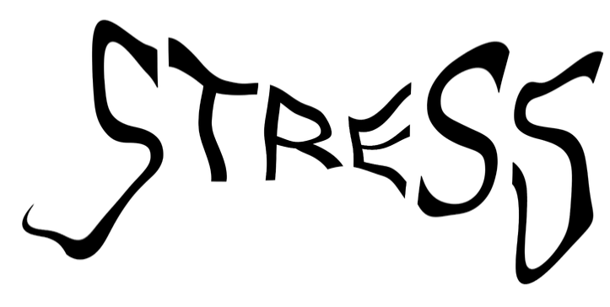
Relaxation techniques
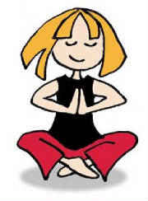
When you are feeling stressed, there are several activities you can do to relieve some of this pressure.
All of the exercises described below can be repeated as often as necessary until you are feeling more relaxed and calm.
Body tenses
Breathe in and tense (make tight) all the muscles in your body and hold this whilst slowly counting to five, then relax your muscles as you breathe out.
Shoulder shrugs
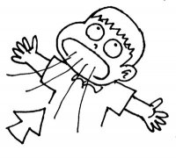
Try to raise your shoulders up to your ears and hold this position for the count of four, then drop your shoulders back to a normal position. Similarly, rotating your shoulders forwards and back, one at a time and then both together, can help to relieve tension.
Deep breathing
Close your eyes, breathe in through your nose, hold for the count of three, and slowly exhale.
Alternate breathing
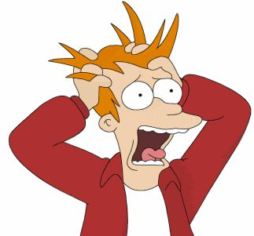
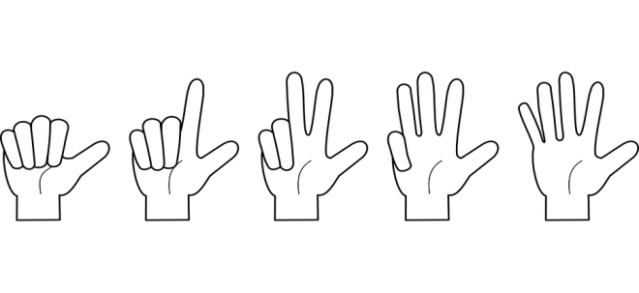
Block one nostril with your hand and inhale deeply using the other nostril for the count of five, then block both nostrils and hold your breath for five. Next, repeat this action for the other nostril.
Counting
Take a second to yourself and, ignoring all distractions, count to ten. If you still feel stressed, slowly count from ten down to one, taking a breath with each number.
Get creative
Drawing or writing can help you to express your feelings in a healthy and positive way. Other creative activities which you may find relaxing include dancing, origami and sport.
Where to get help
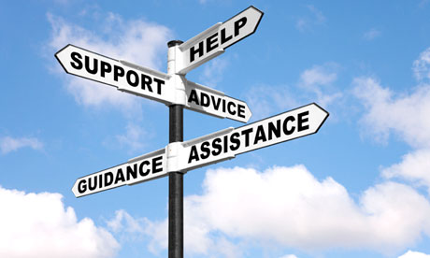
If you’re feeling stressed or like you can’t cope, talk to your classroom teacher or school nurse. They will be able to advise what can be done to reduce the stresses and pressures in your life.
3 April 2017

Feeling angry or over-whelmed? This guide explains why you may feel that way and how to cope with those emotions.
What is stress?
Stress is your body’s physical and emotional reaction to circumstances that frighten, irritate, confuse, endanger or even excite you. Everybody experiences stress and it is a perfectly normal bodily reaction.
Positive stress encourages and pushes you to do something.
Negative stress acts as a barrier and gets in the way of you doing something.
What is stressful to one person may not be stressful to someone else. There are different kinds of stress, including stress which can help you respond to emergency situations, meet deadlines or make you mentally more alert for exams.
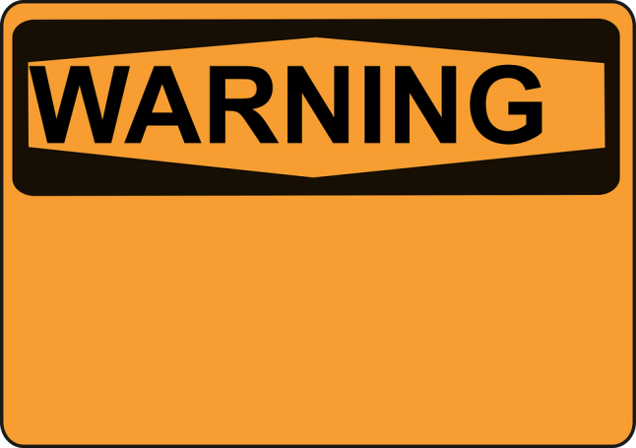
Effects of stress
Stress can affect your physical and mental health, as well as your behaviour, causing you to experience any of the following:
As more things happen, we get more stressed – this can lead to you not being able to think properly or becoming tired.
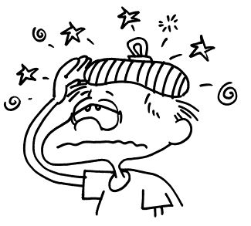
- Shaking
- Dizziness
- Heartburn
- Dry mouth
- Headaches
- Teeth grinding
- Feeling flushed
- Loss of appetite
- Trouble sleeping
- Heart beating faster
- Trouble concentrating
- Cold or sweaty hands
- Tapping fingers or feet
- Nausea, diarrhea or cramps
- Tensing and tightening of neck, back and muscles
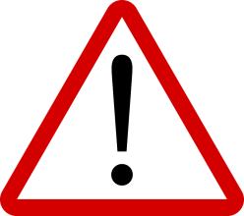
Causes of stress
Stress can be caused by several things, including the following:
- Family life – are your parents fighting? Is a family member ill?
- School work – got a lot of deadlines? Worried about an exam?
- Social life – have you fought with friends? Having problems in a relationship? Worried about an event?
- Being overly busy – are you constantly on the go? Do you get little time to rest?
When you are stressed…
Don’t:
- Take it out on yourself – remember that there is support available.
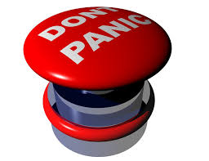
- Panic and get upset. Do whatever helps to keep you calm, such as go for a walk, listen to music, write in a diary etc.
- Be negative – most stress is temporary and things will get better.
Do:
- Seek support and reach out to the people who care about you.
- Talk to a friend or adult about the problem.
- Plan work and social events on a calendar. This can help to clarify what action is needed and when, ensuring that you don’t fall behind.
- Set goals to help clarify objectives.
- Exercise frequently – this releases endorphins which improve your mood and increases energy.
- Remain calm, identify the problem and try to resolve the issue.
Reducing stress
To minimise stress, it is important to find the right balance of work, friends, family, hobbies, rest etc., in your life.
Don’t take too much on – don’t say ‘yes’ to something if you’d rather say ‘no’, this will help to reduce worry.
Sometimes when you get stressed, it may be time for change by doing something different. This could be achieved by trying a new hobby, setting yourself goals, socialising with a different group of people or stopping an activity which you don’t enjoy.
To find a good balance, you should always keep your SELF in mind:
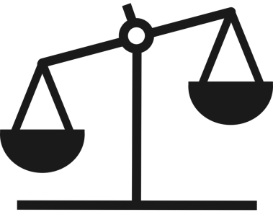
S is for sleep
E is for exercise
L is for leisure
F is for food
If you take care of yourself and get the right amount of sleep, food and exercise, you’ll be able to concentrate better and feel less stressed out, leaving more time for fun!

